LAKE EAU CLAIRE EASTERN FLOODPLAIN RESTORATION AND PROTECTION NAVIGATION PLAN

Prepared in Cooperation with the Lake Eau Claire Protection and Rehabilitation District and the Wisconsin Department of Natural Resources
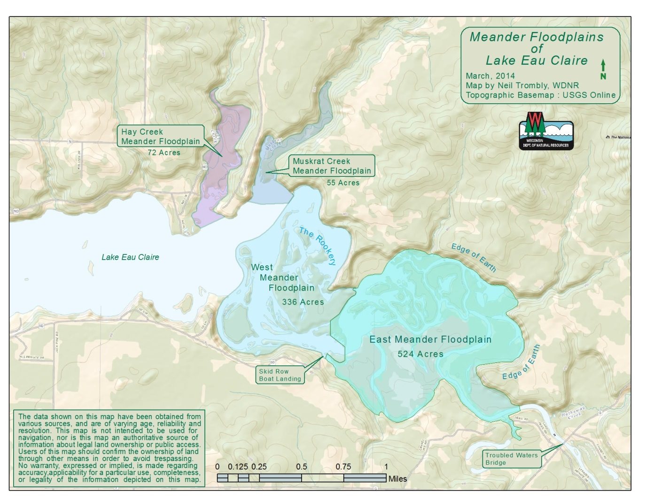
Prepared By:

Dr. Rod G. Zika, Emeritus Professor in Marine Science and Engineering, University of Miami/RSMAS & LEC District Management Plan Coordinator, (305) 586-4248, rzika@miami.edu

Mike Lea, Board Chairman of the LEC Protection and Rehabilitation District, (715) 286-5423, armlea@centurytel.net

EXECUTIVE SUMMARY

The Lake Eau Claire Management Plan of 2012 was developed for the purpose of restoring lost and degraded habitat and developing and implementing a long-term protection plan for the lake and its tributaries. A major component of the Management Plan addressed the specific issues of sedimentation and erosion which have since the Lake’s inception in 1937 led to a substantial reduction in the navigable waters available to boaters. Prior to 1960 there were 5 functional boat ramps, which today have been reduced to two with another two threatened with becoming non- functional soon because of sedimentation infilling. If the sedimentation problem is not stabilized in the next 10-15 years the lake may be left with only one functional boat landing.

There are three major tributaries that are the major contributors to sediment loading and they are shown in the Meander Floodplain figure above. Each of these floodplains has undergone major modifications since the lake was flooded in 1937. Each has led to a significant loss of lake access and navigable water area over the years. This is most true for the Eastern Meander Floodplain shown in green in the above figure. It is this area that the Lake District is seeking financial assistance to address the sediment infilling problems.

Sedimentation transport reduction and restoration for the Eau Claire Lake Eastern Meander Floodplain was initiated in the spring of 2013 with the dredging of 3 major sediment traps, the construction of two river access roads, and the preparation of three dredge spoils sites for removed river sediments. The design principle of the three traps is based on having the farthest one upriver, the Troubled Waters Bridge Trap, to be the first line of defense. This trap is in an ideal location because there are no alternative paths for the sediment to follow and the location is one the best locations where machines can dig the trap deep and wide. The benefit of this trap is that the river can begin to scour itself out naturally and begin to recreate its original channel over the coming years, first down to the Gravel Pit Trap and later the Skid Row Trap and eventually all the way down stream to the lake.

Calculations of the average sediment influx into the Eastern Meander Floodplain since 1937-2010 are 6100 to 8500 yd³/year. Since annual dredging began in 2013 an average volume of 21,284 yd³/year has been removed. In practice the District has removed 170,269 yd³ or roughly 27 to 38% of the calculated total sediment loading into the Eastern Meander Floodplain. The good news is that the trap design theory has been proven to be successful and we are well on our way to achieving our goals for lake and river restoration. The river has been deepened and expanded by over 170,269 cubic yards of sediment volume which used to lie between Troubled Waters Bridge and the Gravel Pit Trap and waters down stream of it. Much of this stretch is once again navigable by boating because the scouring has gone right down to bedrock in some places in the river, and as long as the Troubled Waters Trap is maintained that sediment will not be replaced by new sediment.

The improvements in navigation have now extended all the way to just above the Skid Row Trap. The next step is to dig out a navigation channel connected the now navigable portion of the Eastern Flood Plain with the Skid Row boat landing and the main body of Lake Eau Claire. Hence we are requesting funds to complete this task by dredging out a roughly 54,000 yd³ connection channel from the area in front of the existing boat landing to just upstream of the already permitted SRT Trap. At the upstream end of this channel a permanent sediment trap will be constructed including a service road into it so that this trap can be emptied as needed to protect the downstream navigation channel, boat landing access, and the lake from future sediment infilling.

The Eastern Floodplain Restoration and Protection Plan described in this proposal will achieve a number of goals:

- Restore an operational Skid Row boat landing.
- Open a 3.5 mile long navigable main river channel from the Skid Row boat landing upstream to the trap a Troubled Waters Bridge and downstream to Lake Eau Claire.
- Open access to miles of backwater channels and small lakes in the Eastern and Western Floodplain areas.
- Continued maintenance of the Skid Row Trap, the Gravel Pit Trap, and the Troubled Waters Bridge Trap will provide ongoing protection from further sediment infilling.
- Provide two new boat launching sites at the upstream traps.
- Habitat and navigation improvements by adding roughly 4 acre-feet of water volume/year since 2013 and beyond throughout the eastern floodplain region.

These goals will be achieved and maintained through a combination of projects included the grant requested in this proposal. The Lake District government and the Lake Association are committed through taxation and fund raising efforts to continue to support lake restoration projects like the one described here. Eau Claire County and other local governments also support these efforts through financial and other means.

The feasibility and elements of the plan description are provided in more detail in the following.

JUSTIFICTION ARGUMENTS FOR NAVIGATION RESTORATION AND PROTECTION PLAN

1. Strategy Behind Navigation Restoration and Protection Management Plan

- Background and Feasibility

Lake Eau Claire is an impoundment lake that was created in 1937 by placing a dam on the Eau Claire River about 7 miles north of Augusta and just east of Highway 27. The dam was built across a deep ravine which made it possible to flood the lake to a depth of approximately 30 feet. When flooded the lake surface waters backed up into the 4 flood plain regions shown in the previous figure. The colored regions in each flood plain were largely inundated to depths as much as 25 feet. Most of these flood plain regions were navigable and used by various kind of watercraft. These conditions persisted into the 1960’s but evidence of gradual shallowing was becoming evident particularly near the river entrance into each flood plain. This degradation of these waterways continued and recently even accelerated until by the 1990 to 2010 period navigation, access to boating and fishing, and riparian access to water frontage was greatly diminished.

Prior to the damming of Lake Eau Claire and Lake Altoona in 1937 sediment transport in the Eau Claire River was relatively simple with the sediment loading transported at a rate dependent on river discharge rate down the course of the river into the Chippewa River and beyond. There was no sediment accumulation until the dams were constructed at which point each impoundment lake became a large sediment trap and infilling began. The source of most of the sediment transport in the Eau Claire River is coming from the huge glacial Wissota Terrace sand deposits will fill the lakes indefinitely.

So to develop a plan to cope with this ongoing problem requires developing a knowledge of the amount of sediment being transported into the lake annually, the nature of the sediment, where it deposits, and the conditions which lead to and quantify transport. With this knowledge it is possible to determine the feasibility of sediment reduction schemes, there likelihood of long-term success and the cost of carrying them out.

Addressing sedimentation and erosion concerns have been a top priority that people from the local community and users have expressed an urgency need for mitigation measures. As a result the Lake Eau Claire Protection and Restoration District was established and works closely with the Lake Eau Claire Association and local governments to provide the mitigation measures the community has strongly supported over the last 15-20 years. Starting about 20 years ago a long term strategy was developed and implemented. The major emphasis was to develop sediment reduction control measurements for the three main tributary flood plain areas where extensive sediment loading is damaging property frontage access, fisheries habitat and navigational access. As a result three dredging projects have already been tackled: Muskrat and Hay Creek tributaries on the north side of the lake and the area in front of and up river from the Skid Row boat landing.

For years the common wisdom was that much of river and main body of the lake had been filled in by sedimentation since the lake was flooded. The extend of that filling as determined by Ayres in their 1997 report is shown in Table 1. Ayres used maps from the early 1960’s and 1990’s to examine this trend and concluded that a major amount of sediment had filled in much of the lake. In preparing for the 2009 steering committee meeting a problem was discovered with the earlier maps that Ayres used in their analysis. First the geographic coordinates were seriously in error on one of the maps and resolution was inferior to a more recent map from 2007. One of the earlier maps was apparently used by Navionics, Inc. to produce their commercial GPS fishing map for Lake Eau Claire, however details on the map were found not to be close to matching the actual lake bathymetry. In addition if the lake had filled in to the extent believed and suggested in the Ayres report the flooded river channels in the lake and particularly on the east end would no longer be distinguishable and yet they are clearly defined throughout the lake, as are other distinct features such as logs, fish cribs and stumps that are not yet buried in the sediments. Not only would these features have been buried, but the navigable regions of the lake would have largely disappeared with the addition of 6,000,000 yd3 of sediment to a lake basin with an estimated total volume of less than 10 million yd3. If the Ayres estimates were correct there would be clear evidence of substantial progressive shallowing in bathometric charts from 1952, 1960 and 2007. This clearly is not the case.

TABLE 1: DREDGING VOLUMES IN CUBIC YARDS FROM AYRES REPORT 1997

AREA RESTORED | TOTAL RESTORATION TO RETURN TO 1937 | LIMITED RESTORATION TO RETURN TO 1960
Total Lake* | 6,000,000 | 3,000,000
SE Boat Landing | 18,500 | 5,000
Hay Creek Estuary | 70,000 | 24,000
Muskrat Creek Estuary | 120,000 | 33,000
EC River Upstream of SE Boat Landing | 300,000 | 163,000
* Includes dredging all lake areas, including the sub-projects, to the 1937
condition and the 1960 condition.

The discrepancies in sediment deposition estimates made by Ayres is also supported by the characteristics of sediment dredged from the mouth of tributaries, sediment coring, and seismic profiling studies of the main body of the lake. Table 2 provides information on particle size and elemental composition of dredged sediments from a tributary deposition area
It is clear that most (98.5%) of the deposit is silica sand with particle sizes greater than 0.1 mm and the remainder is mostly clays. This data implies that most of the sedimentation from tributaries is sand of particle size greater than 0.1 mm which should be removed immediately adjacent to the point where water flow velocity drops below 1 cm/sec (from Hjulstrom Plot). This data suggests that only 1.5% of the total sediment load from the tributaries would penetrate into the lake. Of course there is no way of telling how much of the sediment load not collected at the dredge site did deposit in the lake. However other data indicates that this is a minimal process. A core sample from a low energy area of the lake and seismic profiles indicate somewhere between 30-40 cm of fine slits have collected over a 50 year period. The high organic content of this layer suggests that much of it is accumulating as the result of internal trophic production. Because of the characteristics of the sediments in the Eau Claire River it appears that most of the sediment transport is from the bed load. Therefore the bottomset (fine) sediment is minimal relative to the foreset (coarse and heavy) sediment beds. This is the opposite of rivers like the Mississippi where a large delta of fine bottomset layers precede the foreset layers. The sediment advance in the Eau Claire floodplain region displays a sharp steep frontal wall of sand built over a thin bottomset layer of fine sediments. Therefore there is little shallowing of the river or lake ahead of the progressing frontal wall. This process has been clearly evident for many years.

TABLE 2: ANALYSIS OF DREDGED SEDIMENTS
It is likely that much of what is believed to be sediment filling is due to shoreline erosion and slumping of steep sand drop-offs along the shorelines and islands that were created in the 1950’s excavation project. Today the primary threats to the lake come from the 5 small tributary streams along the north shoreline and the Eau Claire River input on the east.. In these cases the problem can be dealt with by installing sediment traps that are cleaned out regularly. This has been done for three of these tributaries and three remain to be completed: one in the NW corner of the lake, Muskrat Creek, and the Eau Claire River.

The primary objective is to stop further intrusion of sediment into the lake and the eastern flood plain through the use of sediment traps, erosion protection through bank and shoreline stabilization, and where possible reducing the tributary’s flow velocity. The composition of the sediment from each tributary appears to be mainly silica sand (>90%) in a size range where rapid settling is the primary removal mechanism. The fact that the main body of the lake has seen relatively little sediment deposition over 83 years in supports the arguments mad above that the sediment deposition has until recently been restricted to the meander flood plains. Since those have largely been filled to capacity sediment intrusion into the lake began having serious impacts on navigation the fisheries habitat starting in the 1990’s. The fact that the flood plains have been so effective in removing sediment there capacity needs to be restored and maintained. These characteristics suggest that sediment traps should be an efficient means of removing the bulk of the bed load transport.

b. Eau Claire River Flood Plane Area

The Eau Claire River remains as the main threat for sedimentation in the eastern part of the lake. There are two main paths for the sediment flow into the lake: (1) filling the main river channel along Skid-Row and (2) the channel through Lost Lake into the critical habitat area of the Rookery. To access the sources for this sedimentation a review of aerial images of the headwaters region of the lake was made back to 1938, one year after the lake was created. In addition field surveys of the flood plain area were used to better define the progress and extent of erosion and sedimentation. Bathymetric data was obtained from charts from 1952 and 1960 and from personal interviews with people familiar with the area prior to and after 1960. Analysis of this data and observations led to developing a plan which calls for adding three sediment traps along the river course and slowing the flow velocity of the water.

Figure 2: Sediment Storage Area’s Primary Sources

i. Determination of Sediment Influx Since 1938

Since the lake reservoir was flooded in 1937 the region just above the Skid Row Boat Landing has served as a sediment storage reservoir (see Figure 2) where most of the sediment from upstream has accumulated. The overall storage area is roughly 138 acres or 668,000 yd² in size and is clearly defined in today’s aerial images and from existing features such as characterization of topographic elevations and from vegetation which exists in the fill areas that have formed since 1938. The existing dry areas such as islands and elevated river banks are clearly delineated from what was the river bed 50 and more years ago and today. Such dry areas total 42.9 acres. When this area is subtracted from the overall 138 acres the estimated flooded area in 1938 reduces to 95.1 acres or 460,300 yd².

The mean water depth of this flooded 95.1 acres was determined by estimating the relative percentages of the overall area that fell into different depth ranges between 1 and 12 feet. Bathymetric data was obtained from charts from 1952 and 1960 and from personal interviews with people familiar with the area prior to and after 1960. These different depth ranges are shown in Table 7. The area with an average depth of 8 feet was estimated at 22.5 acres. The area with a mean depth of 6 feet was estimated at 13 acres. The area with a mean depth of 5 feet was 8.2 acres. The area with a mean depth of 3 feet was estimated at 51.4 acres.

TABLE 3: 1938 APPORTIONED MEAN DEPTH OF STORAGE AREA

AREA IN ACRES | AVERAGE DEPTH, FEET | APPORTIONED DEPTHS | CALCULATED AVERAGE DEPTH FOR 95.1 ACRES  HIGH VALUE | CALCULATED AVERAGE DEPTH FOR 95.1 ACRES  LOW VALUE
22.5 | 8.0 | 22.5/95.1X8 = | 1.89 | 1.89
13.0 | 6.0 | 13.0/95.1X6 = | 0.82 | 0.82
8.2 | 5.0 | 8.2/95.1X5 = | 0.43 | 0.43
51.4 | 3.0 | 51.4/95.1X3 = | 1.62 | ------
51.4 | 1.5 | 51.4/95.1X1.5 = | ------ | 0.81
Average Depth |  |  | 4.76 | 3.95

Because this area is by far the largest and is the most uncertain in terms of assigning an average depth, a range between 1.5 and 3 feet was determined. This provided a high and low average depth range for the storage area in 1938, 4.76 feet to 3.95 feet, respectively.

The next step is to determine the volume of sediment that has accumulated in the storage area since 1938. Since much of this area (43.7 acres) today is still covered with a thin lens of water, it is necessary to subtract the average depth of this water today from the average depths in 1938 for the 95.1 acres. Also the average depth of water over the 43.7 acres today is 1.5 ft as determined by field surveying. Also assume that the remaining 51.4 acres is 0 ft at normal flood stage. Using these approximations the correction for sediment deposition can be calculated as follows:

(43.7 acres/95.1 acres X 1.5 ft) + (51.4 acres/95.1 acres X 0.0 ft) = 0.69 ft.

Applying this correction, the mean amount of sediment filling over the 95.1 acres of the storage area since 1938 is the following.

High value: 4.76 ft - .69 ft = 4.05 ft or 1.35 yards

Low value: 3.95 ft - .69 ft = 3.26 ft or 1.09 yards

To determine the average annual volume of sediment influx to the storage area since 1938 the following calculations were performed:

High value volume of sediment = 95.1 acres X 4840 yd2/acre X 1.35 yd = 621,000 yd3
Therefore the Annual Average = 621,000 yd3/73 years = 8,512 yd3/year

Low value volume of sediment = 95.1 acres X 4840 yd2 / acre X 1.09 yd = 502,000 yd3
Therefore the Annual Average = 502,000 yd3 / 73 years = 6872 yd3/year

This same approach was applied to determining annual averages in the period between 1960 and 2010 with the result that a roughly 4600 yd3/year annual average was determined. In another similar estimate (Ayres 1997) found a value of 4000 yd3/year. These recent averages for annual sediment load should be more accurate, but the differences between the 73 year and 50 year averages could also indicate that sediment transport was significantly higher prior to 1960. Whatever the reasons for these differences it is safer to err on the side of caution and use the higher sediment influx values for determining sediment trap volumes.

ii. Sediment Sources and Volumes

The rational for determining the volume of the three proposed river sediment traps (Figure 5) is largely based on estimating the sediment sources to the storage area over the last 73 years. To do this, aerial images from 1938 and after (primarily 2010) were used to determine what significant changes have taken place to the course of the river, new channel and sandbar formations, river width and any other features which indicate potential sediment sources. Overlays of the 1938 onto the 2010 aerial images indicate that there have been 6 potentially significant sediment sources over the last 73 years. These are shown in Figure 2 as source A to F. Supplemental and confirmation information on each of these sources was established through field observations and site surveys.

A brief description and analysis of findings for each of the identified potential sources follows.

Source A: Today this is the main channel of the river. It began forming in the early 1950’s and grew to its current width and depth over many years. A GIS and field analysis of this new stretch of river indicates that roughly 38,000 yd3 of sediment was supplied to the storage area.

Source B: The main river channel between Troubled Waters Bridge (TWB) and the storage area. Overlays from 1938 and 2010 indicate the course of the river over this stretch has not changed much. The river is today somewhat wider than in 1938, but the most potentially significant sediment sources in this stretch are bends with high banks were high erosion rates might be expected. However from the GIS and field analysis this apparently has not been the case. This is confirmed by the fact that large trees and an old logging road along the river edge are still intact. The fact that these features are at least 60 years old suggests little substantial erosion. Assuming that river bedload transport has been at steady state for many years the primary source of sediment to the storage area comes from bank erosion. This was estimated to be between 23,000and 69,000 yd3 over 73 years. (Update Note: An October 2012 field survey, roughly 3 years after the original survey, revealed that the a large tree and a portion of the logging road mentioned above were lost to erosion. This probably happened during the multi-year event in 2010.)

Source C: An old oxbow of the river which during high water events transports significant volumes of water and sediment towards the storage area. About half of the length of this old stretch of river has depths similar to what they were 60 years ago. There is a clearly delineated sediment front moving down this channel towards the storage area, but since it has not yet reached there the assumption is that its source of sediment is zero.

Source D: An oxbow that was closed between somewhere between 1970 and 1990. This appears to have been sealed off by multiple large log dams, formed during high water events. Prior to 1970 this was the main channel of the river that was diverted to what is now the main channel or source A in Figure 2. There is an oxbow lake in this stretch which still has depths of > 8 feet. So the sediment front as in source C above has not yet begun to fill the storage area. However during flood conditions sediment is being transported into the storage area through gulleys across the oxbow terrain. This is estimated at 20,000 to 30,000 yd3 total.

Source E: A sealed off stretch of old river bed with multiple small ponds and lakes that are isolated during normal flow, but transport water and sediment during flood conditions. As in the case of source C the sediment front has not yet reached the storage area but is with each passing year destroying excellent aquatic habitat.

Source F: The main river channel east of Troubled Waters Bridge on County Highway G. This is by far the main source of sediment to the storage area with between 365,000-484,000 yd3 of sediment supplied to the storage area since 1938. This number was obtained by difference and not by GIS and field analysis upstream of TWB.

TABLE 4: SOURCES AND VOLUMES OF SEDIMENT TO STORAGE AREA

SOURCE | WEST OF TWB  CUBIC YARDS | EAST OF TWB  CUBIC YARDS
A | 38,000 | ---------------------
B | 23,000-69,000 | ---------------------
C | 0 | ---------------------
D | 20,000-30,000 | ---------------------
E | 0 | ---------------------
F | ------------------ | 365,000-484,000
TOTALS | 81,000-137,000 | 365,000-484,000

Summarizing the results of TABLE 8 it was found that sources below TWB supply somewhere between 81,000 and 134,000 yd3 and sources above (to the east) of TWB supply 365,000 to 484,000 yd3 of sediment. So the annual average volumes of sediment coming from east of TWB is 5000-6630 yd3 and from west of TWB is 1110-1880 yd3. These estimates are averages based on 73 years of change. It is important to realize that these volumes are directly related to annual and event river discharge rates. Since the year 2000 and particularly between 2010-2000 the river discharge rates are much higher than in the previous century.

2. Proposed Sediment Control Strategy

The analysis of dredged sediment samples (see Table 2) indicates that the composition is mainly silica sand with particle diameter greater than .1 mm. Therefore this material has high settling velocities and sediment transport will be highly dependent on flow velocities in the river. Sediment transport towards the lake can be reduced by increasing channel displacement volume through the delta portion of the flood plain. This is being accomplished by reducing the influx of new sediment with a sediment trap at the entrance to the lake flood plain (i.e. TWBT), and removal of sediment within the flood plain using strategically placed sediment traps (i.e. GPT and SRT).

Also it appears from observations that changes to the river bed have occurred (see Figure 2 D, C, and E) over the years and that these changes correlate to large tree jams that force the river to change course, particularly during high volume flows. If this is the case, removing these jams would be beneficial in stabilizing the main river channel and recovering much of valuable wetlands and fish spawning areas which have been isolated from the main river system over the last 50 years.

a. Justification of Sediment Traps and Descriptions

i. Troubled Water Bridge Sediment Trap (TWBT)

An analysis of aerial images revealed that much of the sediment that has accumulated over the past 50 to 70 years came from east of Troubled Water Bridge. Therefore a sediment trap at the bridge (see Figure 3 and 4) will limit the intrusion of further new sediment into the flood plain area west of the bridge. This is a strategic site for a trap since the roadbed and bridge structure eliminates the possibility of river channel rerouting and the fixed narrows creates a choke point for increasing flow velocity and therefore sediment transport a distance below the bridge. These characteristics have led to a rapid restoration of the river below the bridges and have provided river frontage benefits to property owners along this stretch of river. The elevation of the riverbed below the TWBT is roughly 4-6 feet lower than before dredging was begun. According to a recent LIDAR survey this places the riverbed elevation at near the normal lake flood plain level of 900 feet. So increases in lake level above 900 feet mean the lake waters expand all the way to Troubled Waters Bridge. This reduces the pitch across the flood plain and therefore restricts the sediment transport.

ii. Gravel Pit Sediment Trap (GPT)

Another sediment trap was added in the main river channel upstream from the Skid Row site at a location near an abandoned gravel pit. The nearby gravel pit has been used as the deposit site for the river sediments (Figure 3). This site is close enough to the proposed river sand trap so that sediments can easily be transported to the gravel pit. Since there is also an existing road to the gravel pit and to the river at this location, access to the river is straight forward. The Gravel Pit Trap (Figure 3) is used to stop additional sand from further upstream from entering into the sediment storage area. Removing sand from this trap on a regular basis should gradually deepen the river channel between the GPT and the SRT sites by natural river bed load transport. The GPT trap will also serve to stop sediment transport into source C (Figure 2). This is important because it eliminates a new source of sediment to the storage area above SRT and should allow restoration of the old source C river channel to begin. This process could be accelerated by clearing log dams and other flow blockages along the source C channel. This would in short order restore a substantial acreage of prime aquatic habitat and reconnect it to the lake and main river channel.

iii. Skid Row Sediment Trap (SRT)

A sediment trap (SRT) at the Skid Row boat landing was designed to stop further intrusion of
sediment into the upper region of the lake. It is important that this trap be effectively maintained to stop further loss of frontage access for riparian property owners in Skid Row. The location of the trap is shown in Figure 3. It is the illustrated in light blue shaded area in the river and is labeled as SRT Upper and Lower traps, which is the way it was first constructed in 2013. In the 2010 version of this proposal the SRT Trap was elongated and extended the full distance between the traps SRT and LLT in shown in Figure 3. The terrain immediately south and north of SRT and LLT have elevations that confines the flood plain to the distance between them. It is within this distance that new delta channels could form (particularly during flood events). There is evidence that this is already taking place at several sites along this stretch of river. The most pronounced of these is the channel that is developing between LLT and Lost Lake (see Figure3). At elevated flows about 25-30% of the river is being diverted from the main river through Lost Lake and into Rookery. The Rookery is a critical habitat area with relatively shallow water and with the increase in sediment load it could be lost in a short period of time. The Rookery is still navigable, but this will rapidly change is sediment transport to it is not eliminated.

This trap was to be cleaned out by hydraulic dredging and this would still probably be the best although most expensive approach. In the 2012 plan a principal objective was to lower costs and hence the use of mechanical sediment removal methods such as backhoes and draglines was proposed as a cheaper alternative. The idea is to temporally divert the river using chauffer dams and haul the excavated sediments to nearby dredge spoil sites. This does not appear to be a problem at SRT, but its utility for building an elongated trap between SRT and LLT has yet to be determined.

A recent proposal has been to expand the permitted SRT trap to include an upstream component referred to as the SRT Extension trap in Figure 3. This would be dug mechanically and moved via truck to the shown GPT and SRT spoils sites in Figure 3. It is estimated that about 20,000 yd³ would be extracted from this trap. The entire 20,000 yd3 trap would only be completed the first time, and there after only the upstream end of the trap would be dredged deeper and serve like the GPT and TWGT as a clean out as needed trap. It would be referred to as the SRTE trap.

iv. Skid Row Navigation Channel

A major objective of the Floodplain Restoration and Protection Plan has been to restore the 3.5 mile formally navigable stretch of main river channel. This restoration is well under way for approximately 2.5 to 3.0 miles downstream stretch below Troubled Waters Bridge. To connect this stretch to the Lake Eau Claire existing downstream boat ramps will require completing a navigable 1.0 mile channel above the Skid Row Boat Landing. The extend and location of this channel is shown in Figure 4 and labeled as the SRT Navigation Channel. The dimensions of this channel are 50 feet wide by 6-8 feet deep at mid-channel by 5280 feet in length. It is estimated that the overall sediment removal will be roughly 54,000 yd³

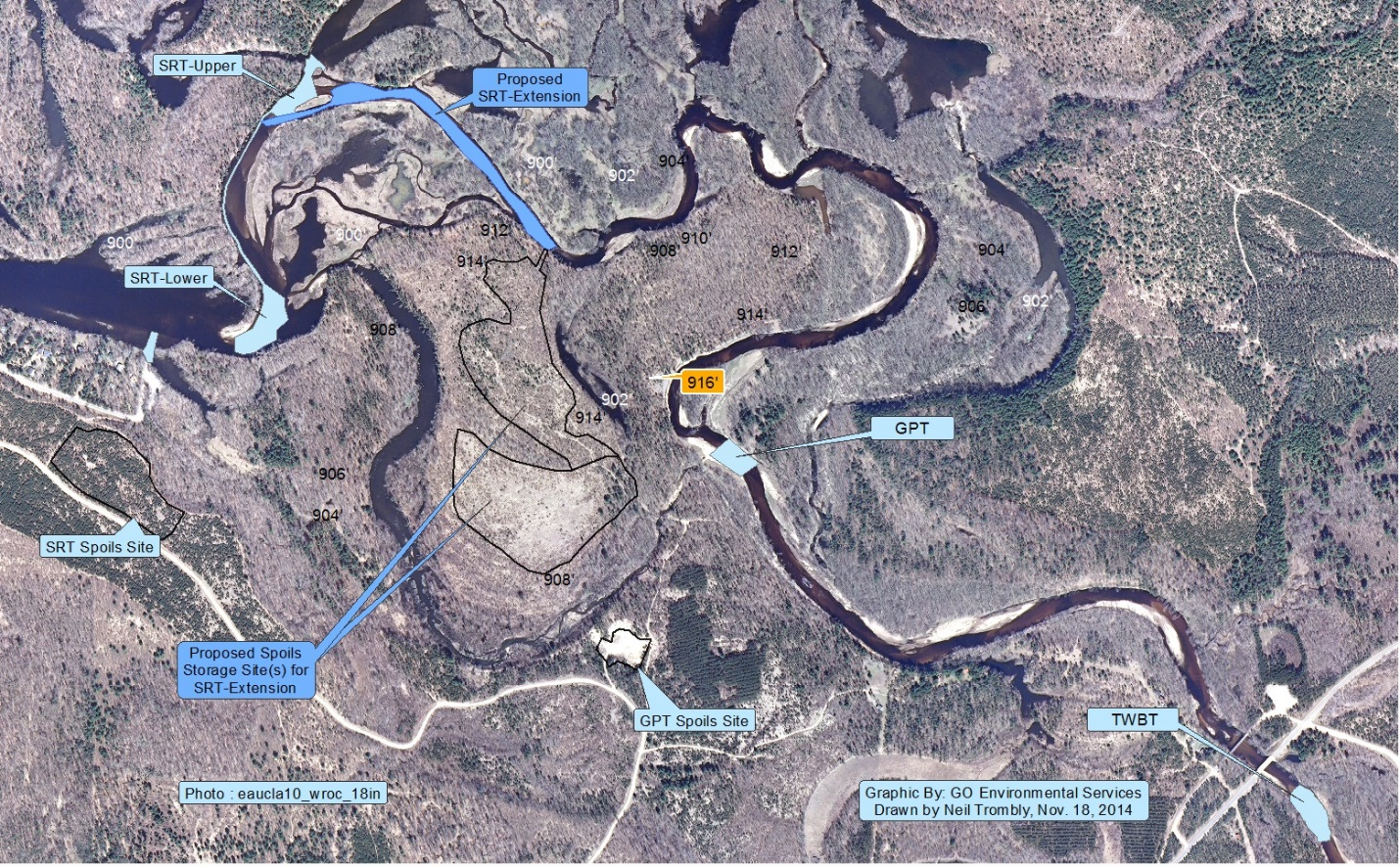

Figure 3: Details of Existing Sediment Control Strategy for Eastern Flood Plain

b. Original Proposed Sediment Trap Volumes

The recommended minimum trap volumes and estimated clean times for these minimum volumes are listed in Table 5. If the assumptions are correct and most of the sediment is coming from east of TWB as bed load than roughly 5000 to 6700 yd³ on average per year will need to be removed from a trap at TWB. At a minimum a trap of 7,000 yd³ will be required at the bridge. To provide a reasonable safety factor the trap should be at least 15,000 yd³ to provide protection from 10 year flood episodes. This would then provide a two year window at average influx rate. More than likely the sediment transport is variable from year to year and episodic with much higher levels being transported during flood events and high precipitation years. Therefore required trap clean out times could vary from a year to multiple years depending largely on precipitation in the river water shed area above the lake. As a rule of thumb, it is best to make the sediment traps as large as the budget can reasonably accommodate at the project outset.

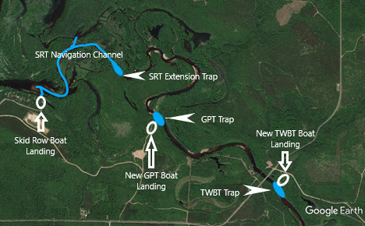

Figure 4: Proposed and Existing Sediment Trap Locations

The GPT trap should be a minimum of 7000 yd³ to start with and after several years the size of the trap could be reduced. It is difficult to estimate with any certainty how fast the sediment supply to the second trap at GPT will fall off. A 10,000 yd3 trap should provide at least a couple years between clean outs and this span should increase to 10 years or more with time.

It is difficult to estimate the minimum trap volume for the SRT trap because of the large amount of sediment in the storage area immediately above the trap. Also by opening old river channels and backwater areas stream velocity should drop substantially which could reduce sediment influx to the SRT trap. This is a complex and non-linear process, however with time as the river channels deepen and the stream velocity decreases the influx to the SRT trap will certainly decline. This will reduce frequency of clean outs and operating costs. Sediment reduction in the storage area and restoration of the aquatic habitat there will be a slow process. It took 73 years to fill the area and it will certainly take a long time to naturally remove the stored sediment. To facilitate a faster recovery of the area, means should be sought to accelerate the sediment removal processes, for instance through mechanical sediment removal.

TABLE 5: RECOMMENDED TRAP VOLUMES AND CLEAN OUT TIMES

TRAP | PROPOSED INSTALLATION DATE | MINIMUM VOLUME YD3 | VOLUME TO ACCOMMODATE 10 YEAR FLOOD* | CLEAN OUT TIME FOR AVERAGE SEDIMENT INPUT
TWB | 2012 | 7,000 | 15,000 | annual
SRT | 2012-13 | 7,000 | 15,000 | annual
GPT | 2012-13 | 7,000 | 10,000 | annual
TOTAL |  | 21,000 | 40,000
- Volumes are based on sediment accumulated between June 2010 and June 2011. This year long period had one of the highest measured flood crests and was one of the longest periods of continuous flood conditions on record. The area at SRT was surveyed before and after the flood conditions subsided and the sediment influx was determined to be 12,000 yd3 for this one exceptional year.

c. Sediment Trap Update After 8 Years

Calculations of the average sediment influx into the Eastern Meander Floodplain since 1937-2010 are 6100 to 8500 yd³/year. Since annual dredging began in 2013 an average volume of 21,284 yd³/year has been removed. In practice the District has removed 170,269 yd³ or roughly 27 to 38% of the calculated total sediment loading into the Eastern Meander Floodplain. The good news is that the trap design theory has been proven to be successful and we are well on our way to achieving our goals for lake and river restoration. The river has been deepened and expanded by over 170,269 cubic yards of sediment volume which used to lie between Troubled Waters Bridge and the Gravel Pit Trap and waters down stream of it. Much of this stretch is once again navigable by boating because the scouring has gone right down to bedrock in some places in the river, and as long as the Troubled Waters Trap is maintained that sediment will not be replaced by new sediment.

Since dredging began in 2013 ground, bathymetric, aerial and drone surveys have been used to track the progress and changes occurring in the Eastern Meander Floodplain due to sediment extraction. It some places the changes are subtle but real when measured, in other examples they are evident. Figure 4 is a comparison of what the river looked like before dredging (Figure 4A) and a year after dredging the TWBT (Figure 4B). Both pictures were recorded in August and with the same flow. The bed of the river as shown in Figure 4B is gravel and rock whereas previously this bottom topography was covered with mainly sand.

Similar changes can be observed miles down the river with tings such a decreasing river bottom elevation, changes in slope, and changes in side channel flow velocities and even stream flow reversals.

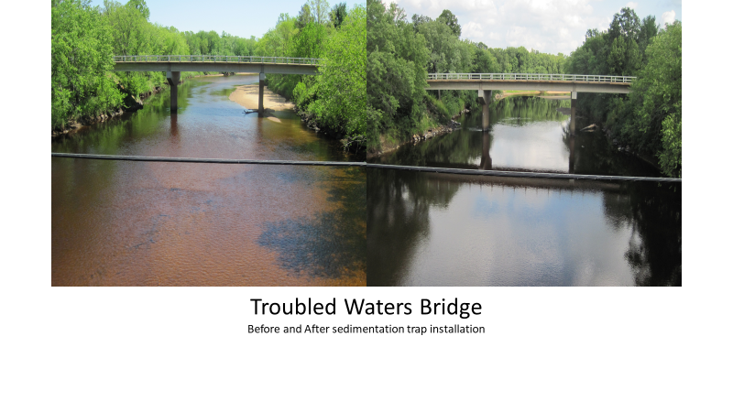
A B

Figure 5: Troubled Waters Bridge: (A) Before Dredging (B) After Dredging Sediment Trap (TWBT), about 200 yards the other side of bridge

3. Projected Long-Term Benefits of Sediment Traps and Flood Plain Channel Restorations

If average sedimentation levels remain as they have over the first 73 years this would amount to a 6,900-8,500 yd3/year reduction in sediment entering the storage area. Since the storage area is largely full, this would also be the amount entering the main body of the lake. With the sediment traps installed at TWB, GPT and SRT, the bed load supply of sediment would gradually be reduced between the traps and between SRT and the lake. This is primarily the result of the river deepening as sediment is removed by the traps. As the sediment is removed the flow velocity will diminish and sediment transport will decline below the TWB trap. This will eventually expand navigable areas of the river and also restore original aquatic habitat areas within the flood plain. As an example, the main river channel between TWB and GPT would amount to an average annual deepening of the entire width of the river channel of 3.2 to 4.3 inches between these end members. Within three years this could increase the depth of the river by as much as a foot. This should also help to restore some of the valuable fisheries wildlife habitat in the headwaters area of the lake, since the deepening of the main channel could make these areas accessible again.

The improvements in navigation have now extended all the way to just above the Skid Row Trap. The next step is to dig out a navigation channel connected the now navigable portion of the Eastern Flood Plain with the Skid Row boat landing and the main body of Lake Eau Claire (Figure 4). To complete this task the phase is dredge out a roughly 54,000 yd³ connection channel from the area in front of the existing boat landing to just upstream of the already permitted SRT Trap. At the upstream end of this channel a permanent sediment trap will be constructed including a service road into it so that this trap can be emptied as needed to protect the downstream navigation channel, boat landing access, and the lake from future sediment infilling.

The Eastern Floodplain Restoration and Protection Plan described in this proposal will achieve a number of goals:

- Restore an operational Skid Row boat landing.
- Open a 3.5 mile long navigable main river channel from the Skid Row boat landing upstream to the trap a Troubled Waters Bridge and downstream to Lake Eau Claire.
- Open access to miles of backwater channels and small lakes in the Eastern and Western Floodplain areas.
- Continued maintenance of the Skid Row Trap, the Gravel Pit Trap, and the Troubled Waters Bridge Trap will provide ongoing protection from further sediment infilling.
- Provide two new boat launching sites at the upstream traps.
- Habitat and navigation improvements by adding roughly 4 acre-feet of water volume/year since 2013 and beyond throughout the eastern floodplain region.

These goals will be achieved and maintained through a combination of projects included the grant requested in this proposal. The Lake District government and the Lake Association are committed through taxation and fund raising efforts to continue to support lake restoration projects like the one described here. Eau Claire County and other local governments also support these efforts through financial and other means.

