LAKE ALTOONA SEDIMENTATION STUDY PROJECT REPORT

G.O. ENVIRONMENTAL SERVICES
1295 NW163 Street
Miami, FL 33163
(305)586-4248
rzika@rsmas.miami.edu
5/1/2015
ROD G. ZIKA AND NEIL TROMBLY
This report was prepared for the Lake Altoona Rehabilitation and Protection District to develop new conceptual strategies for sediment mitigation. The most important first step in this process was to establish a picture of the historical trends in sources and sinks of sediment supply and establish an accurate estimate of the annual magnitude of sediment loading of the lake. With this information new mitigation measures are discussed and future sediment data initiatives are recommended.

INTRODUCTION

THE PROBLEM

Sedimentation to Lake Altoona has been an on-going problem. The cost to control sedimentation is prohibitive, and control efforts have had only short-term effects. Sedimentation to the lake from its primary tributaries also has negative impacts on water quality and fish habitat. High levels of nutrients are often associated with sediment supply and storage as benthic sediment in Lake Altoona. The problems of sediment mitigation face complex and technical challenges. The Lake Altoona District has tried many actions to address the challenges and problems that will be addressed in this planning report.

Sedimentation is a significant problem within the watershed due to the highly erodible sand deposits and past and current land uses. The situation is further exacerbated by the fact that the lake is fed by many tributaries cutting through these easily eroded glacial outwash sands. The continual input of sand into the lake negatively impacts the environmental condition of the lake and tributary streams. Since the Lake Altoona Dam was constructed in 1938, the upstream sediment has been encroaching on the lakebed.

The main issues associated with this sediment infill are:
- Loss of critical habitat areas and fish nursery habitat due to disconnection/infilling
- Limitation/loss of recreational venues and uses
- Reduction of aquatic species diversity and abundance
- Reduction/loss of lake size and depth
- Increasing temperatures due to shallowing in a large percentage of the lake
- Reduction in water quality because of both bacteria and algae
- Increase in duration and extent of blue-green algae blooms
- Reduction of the navigable depths in the waterway

In order to address the primary issue, sedimentation, dredging has been completed 4 times over the last 19 years, with two larger scale projects and three maintenance cleanings of the sediment trap. Moving forward, the District intends to spend $400,000-$500,000 for dredging of the sand trap once every four years based on current taxation capabilities. It important to note that estimates indicate that this dredging schedule would take care of only 13-25% of the sediment, which needs to be removed to maintain current lake conditions based on previous estimates. Estimates of current sediment volumes coming into the lake are between 50,000-111,000 cubic yards per year. The capacity of the current trap is 56,000 yards, and the current level of funding supported 100% by District member contributions limits the ability to empty the trap to every 3-4 years. The life expectancy of the trap is shortened considerably if a flood event occurs within that time frame.

Past studies, data, and procedures used to manage and improve the lake left the District with the opinion that there were limited affordable options for prevention of the sediment in-fill. GOES was contracted to review past studies and in light of what was learned has developed plans to:

- consider alternative strategies which are new or have not been tried in the past
- quantify a perceived degree of urgency
- improve and maintain the health and viability of this resource
- ensure both continuity of management and periodic reviews of current objectives
- ensure management decisions are supported by adequately recurrent field data collection

PREVIOUS STUDIES

Recently GO Environmental Services conducted an extensive review of previous studies and reports devoted to characterizing sediment transport and deposition of the Lower Eau Claire River and Lake Altoona. The results of those studies have been used to develop sediment mitigation strategies over the last 25 years. One of the major questions that is addressed was the relevance of the past studies to the recent trends in river and lake sedimentation processes. If the recent trends proved to be significantly different than in the past does that mean that different mitigation procedures might be applicable?

The scope of the Lower Eau Claire River erosion and Lake Altoona sedimentation problems are perhaps more related to extensive changes in forestry and agricultural management practices than to river stream bed characteristics. Extensive reviews of the various studies and reports from 1975 to 1988 (WCWRPC 1988 and Simons et al., 1988) leads one to believe that the infilling of Lake Altoona with sediment is inevitable and will largely take place in the next 50 years. Regardless of what solutions were considered to avert the loss of the lake the only semi-workable conclusion was that massive and continuous dredging of the lake and delta were necessary. To keep the lake’s sediment problem in check these studies quantified that 111,000 yd³ or possibly more needed to be removed annually (Finley 1975, Simons et al. 1988).

The Finley Engineering report has been the benchmark for most of the studies and mitigation recommendations that came after the report was completed in 1976. This report was the only thorough analysis that provided estimates for the annual sediment load supplied to the lake. The breakdown of the various sources of sediment that Finley Engineering reported are shown in Figure 1. Of most importance was their estimate for the amount of total sediment arriving at the lake annually. Based on differences in the lake’s bathymetry between 1938* (before filling with water) to a DNR bathymetric survey in 1966 they concluded that the lake’s volume was disappearing at a rate of 111,000 yd³ per year on average.

Finley actually reported this average up to 1975, but this was not based on any new data and was simply an extrapolation from 1967 to 1975 with the same rate of delivery. They also concluded from sediment size distribution and an evaluation of upstream sediment sources that 21,000 yd³ of the 111,000 yd³ was deposited in the east end of the lake in the delta region and the remaining 90,000 yd³ was deposited in the rest of the lake.

*Note: Altoona Lake, original bottom, based on 1938 SCS Aerial Photographs, compiled and drawn by R.S, Giles, Finley Engineering Co, Inc. 1975

Figure 1: The 1975 Finley Report Break Down of Sediment Sources and Sinks

To validate the 111,000 yd³/year estimate from bathymetry differences Finley Engineering and follow on studies (Ayres, 1979 and Simons et al., 1988) attempted to justify the amount by considering upstream sources of sediment from upland sheet flow and river bank erosion.

Figure 2: All sediment size distributions collected along the Lower Eau Claire River Study Reaches by Finley 1975 and Simons et al. 1988.

It is important to realize that not all sediment is equal. What arrives at the lake are the fractions referred to as bedload, suspended load and wash load. Bedload is material usually of larger size and higher density whose motion involves frequent or continuous contact with the stream bed. Suspended sediment are particles that are maintained in suspension in flowing water because of the turbulence. Their numbers per unit volume will increase dramatically as a function of current flow and turbulence in the river. It is bedload size fractions and larger suspended load fractions that collect in the eastern lake delta region and that are trapped efficiently by sediment traps. The wash load is composed of finer particles than those found in the bed of the river and characterized in Figure 2 for various reaches of the river above Lake Altoona. In the case of the lower Eau Claire River most of the wash load comes from upland sources associated with human activities. The primary sources of wash load are associated with sheet flow of drainage water from agriculture fields, roads, forests, and various urban areas. The Eau Claire County distributions for various upland sediment sources are shown in Table I. The value of 53,254 yd³ is based on the Eau Claire County objective goal of 4.0 tons/acre/year in 1988 for croplands. The Simon et al. report also considered a high and low realistic operational value for croplands at the time of 7.2 and 5.6 tons/acre/year. Using those values they estimated the annual wash-load supplied to Lake Altoona as 88,454 and 70,854 cubic yards/year as bulked sediment. Recent cropland acreage usage for the Lower Eau Claire River according to NLCD 2006 is estimated to be 46,602 acres or roughly 13% less than used in the 1988 wash-load supply estimate (Table I).

TABLE I: Wash-Load Supply Estimate (reproduced from Table 3.7 Simons et al., 1988)

LAND USE | % WATERSHED | AREA (ACRES) | EROSION RATE  Tons/acre/year | EROSION VOLUME  Tons/year
Cropland | 57 | 53,460 | 4.0 | 213,840
Woodland | 17 | 16,060 | 0.13 | 2,088
Pastureland | 11 | 10,391 | 1.1 | 11,430
Other (Misc. Uses) | 11 | 10,391 | 1.9 | 19,743
Urban | 4 | 3,778 | 3.1 | 11,712
Total Watershed Area |  | 94,080
Total Erosion Rate |  |  | 2.8
Total Erosion Volume |  |  |  | 258,813
Wash-Load Supply to Lake Altoona assuming 25% delivery ratio = 53,254 yards /year bulked volume

HISTORY OF LAKE ALTOONA DISTRICT’S INTERVENTION INTO THE SEDIMENTION PROBLEM

The District has undertaken numerous planning and implementation activities to combat sedimentation challenges facing the lake. Between 1975 and 1981, three studies were completed by three separate entities regarding this problem. Two of those studies recommended dredging the lake but did not offer useful alternatives for reducing sediment supply. Finley Engineering predicted that there would only be 2 feet of water in the lake by 2025 if no action was taken against the sedimentation (Finley, 1975 & 1976). Finley estimated that 111,000 yd³ of sediment are being deposited in the lake by way of the Eau Claire River each year - the equivalent of 30 large (10 yd³) dump trucks of sediment per day.

In the years 1983-84 the Lake District’s mill rate was raised to 2.5. Since that time action has been undertaken to protect the lake. In 1983-84, the Eau Claire County Land Conservation Division completed an experiment to rip rap an area on the south side of the Eau Claire River where it enters Lake Altoona. Cement structures 30 ft long and 5 ft wide were constructed to reduce erosion
; the experiment failed when the structures soon broke apart.

In 1988, the District hired the West Central Regional Planning Commission to prepare an Implementation Plan for Lake Altoona. The plan proposed a four-part program to reduce sedimentation:

- riverbank stabilization at erosion sites on the Eau Claire River between Lake Eau Claire and Lake Altoona
- bed load stabilization over the same stretch of the river
- construction of a sediment trap in the river just upstream of Lake Altoona
- maintenance dredging of the upper end of the lake and a portion of the river immediately upstream of the lake

Because there were many unanswered questions concerning riverbank stabilization, the Wisconsin Department of Natural Resources requested that the Lake District hire engineering help to evaluate whether riverbank stabilization of the Eau Claire River between Lake Eau Claire and Lake Altoona would have any effect on the rate of sedimentation in the lake. The District hired Simons, Li & Associates to do this study. Results of the study were discouraging. The engineering firm concluded that there would be little effect on the rate of sedimentation in Lake Altoona despite comprehensive efforts to stabilize the banks since the river would attempt to move the same amount of sediment, robbing it from the bottom of the river if necessary. Since the glacial sands over which the river runs are estimated to be 200 to 300 feet deep, they concluded there would virtually be an unlimited supply of sediment from which to draw.

After exploring a number of other alternatives for sediment reduction, the only real remaining opportunity was to construct a sediment trap and engage in a dredging program to periodically remove accumulated sediments before they reach the lake. The proposed location of the sediment trap and dredged boat channel from the trap to the lake is shown on the map in Appendix D. In 1995, the District looked to the State of Wisconsin for funding for dredging and found that there were funds available for lake rehabilitation, but the funds did not include dredging. Funds were available for rip rap, but this had previously proved ineffective. The DNR deemed dredging would be cost effective, and after significant lobbying in 1996 by the District, the governor deleted the line from budget that excluded dredging. Subsequently, the District was awarded $500,000 from the state to begin the dredging project. In order to begin dredging, the District had to have a site to deposit the sand from the project. Eighty nearby acres of County Forest land between Bullhead Pond Road and County Road Q was deemed a desirable location. After significant negotiations, the County agreed to lease the land to the District for one dollar a year and the trade of additional forest land owned by the District in another location. The county cleared the land for the sand disposal site and the District put in the outlet for return water flow, and the piping for the delivery of the sand and water from the dredge to the site. At the request of the county, the District has since paid for a berm around the sand "spoil" site and fencing, and complied with a requirement to put soil and seed to grow grass on the berm. The District has attempted to sell the sand in the "spoil" site with some success. It is hoped that this sand may become more valuable in the future. When the state awarded the District with $500,000, the District matched the amount, but the first dredging project cost about $1,500,000. The District borrowed money to complete the first dredging project. The second dredging project was done in 2008-2010. The District again borrowed money to complete this project. Just as that dredging project was completing in 2010, a major storm and subsequent flooding again brought increased sand deposits into the lake. As part of the first dredging project, a sediment trap was constructed, which has been dredged out in 2001, 2009, and 2011. The history of the various sediment reduction activities, the cost, and the results are summarized in Table II.

In another effort to minimize shoreline erosion along the Eau Claire River 1,000 willow trees were planted by the District 1995 in an attempt to stabilize the banks. Eau Claire County Land Conservation provided the trees and the District provided the labor. This effort failed when beavers cut down the willow trees shortly after planting.

For additional background information, see also:
- Finley Eng. Company (1975abc, 1976)
- Owen Ayres and Associates (1979)
- Office of Inland Lake Renewal - DNR (1980)
- River Country Resource Conservation & Dev. Council (1980, 1987)
- Mead & Hunt (1981)
- West Central Wisconsin Regional Planning Commission (1988)
- Simons, Li & Associates (1988)
- Implementation and post-implementation surveys 1983 to 2013

Table II. History of sediment reduction activities in Lake Altoona

Year | Action Completed | $ Spent | Results
1975 | Established Lake District and implemented 1/8 mill rate | n/a | Raised funds to perform initial studies
1975- 1981 | Three studies focused on sediment management | unknown | Recommendations to dredge
1983-84 | Mill rate increased to 2.5  Installed rip-rap on south side of river near lake inlet | unknown | Experiment failed as structures soon broke apart
1995 | 1,000 willow trees planted by the District to minimize erosion on banks of the Eau Claire River | unknown | Effort failed when beavers cut down the trees shortly after planting
1996 | First dredging | $1.5M | Channels dredged and “sand trap” created 410,000 yd³ of sand removed.  Infrastructure for hydraulic sand removal established
2001 | Sediment trap cleaned | $345K | 80,000 yd³ of sand removed
2008-2010 | Second dredging  Sediment trap cleaned | $1.8M | 200,000 yd³ of sand removed.
2011 | Sediment trap cleaned | $472K | A second cleaning of the sediment was required due to a major storm in 2011.  55,000 yd³ more of sand were removed.

A FRESH LOOK AT THE SEDIMENTATION PROBLEM

GO Environmental Services (GOES) was asked to take a new look at the sedimentation problem and to try to come up with alternative workable mitigation measures. A most important aspect of this new look is to determine the accuracy of the previously determined sediment loading estimates for Lake Altoona (Finley 1975, Ayres 1979, and Simons et al. 1988) and compare those to current values. Determining the trend and the magnitude of the sediment problem are imperative for developing mitigation measures and estimating their cost. It should be said that GOES has significant advantages available to it today because of the advent of GPS, GIS mapping technologies,
bathymetric mapping, LIDAR and aerial imagery, and far more sophisticated computer capabilities. In Table III the outcomes of the comparisons between Finely, Ayres and GOES recent work is shown.

The results in Table III for the Finley and Ayres bank erosion data was taken directly from their reports and without modification. There was limited meta-data accompanying the reported numbers so there is uncertainty with respect to the details of the approach used in the calculation of volumes. All of the GOES data was produced using geo-rectified imagery where bank heights and slopes were determined or validated using 2012 LIDAR maps from Eau Claire County. A recent low altitude aerial photograph with some example erosion site labels is shown in Figure 3. A more detailed directory of river erosion sites can be found in Appendix B along with a compendium of location maps for the sites and geo-rectified images of each site for those produced by GOES.

What is most striking about the results is the differences between the total annual erosion values for the three studies: namely 56,027 yd³ for Finley, 122,000 yd³ for Ayres, and 20,743 yd³ for GOES. The differences between GOES and the other studies could be real and represent real differences in erosion rate values, since they are for different time periods. The extreme difference between the Finley and Ayres results is more difficult to explain because the calculations were done for the same period, 1938 to 1975, although more sites were identified by Ayres. With these large discrepancies between the three annual erosion values it is difficult to ascertain trends in river bank erosion. However from the GOES erosion values for 1999-2013 two things stand out: (1) there are more new erosion sites identified then in 1938-1975 and (2) the amount of erosion for sites identified and measured by Finley and Ayres and GOES is substantially less for the period 1999-2013 for all common sites. Perhaps this is due to a common procedural or calculation error or perhaps the river erosion values have declined over the years. There is evidence that the latter is true based on aerial photographs taken in the 1930’s and recently (see Figures 4a, 4b, and 4c).

The recent history, last 160 years, of the Lower Eau Claire River and the watershed in general went through some dramatic transformations which must have had significant impacts on riverine sediment transport. Prior to 1850 large scale agriculture and forest harvesting were minimal activities. In fact, according US forestry records virgin forests were still untouched in the west central region of Wisconsin in 1850. However by 1875 the onslaught on the forested land proceeded until the whole region was clear cut between 1875 and 1925. Putnam Park in Eau Claire was dedicated to the remembrance of this era (see Figure 5). The scars on the landscape are still evident in Figure 4a along the bluffs on the north side of the river in 1939. A closer look at the landscape (see Figure 6) shows how extreme the effects of deforestation in these years were
Table III: Directory of Erosion and Aggradation Sites Along Lower Eau Claire River, 1938 to 2013
Site Identification Key: B1F B represents River Reach, #1 is river Site and F(Finley), A(Ayres) or G(GOES)
 |  |  | 1938 -1970s summary Totals(Not Annual) |  |  |  | 1970s - 1999 | GOES 1999 - 2013 Detailed
 |  | GOES | [Finley] (Ayres) | 1938-1975 | 1938-1975 | 1938-1972 | 1972-1999 | 1999-2013 | 2013 LiDAR | 1999-2013 | 1999-2013
 |  | Site | Site Name | Finley Yd3 | Ayres Yd3 | GOES Yd3 | GOES Yd3 | Area Yd2 | Ave. Bank | GOES Yd3 | Yd3 / year
 |  | Name |  | (Per page 21) | (Per Map 6) |  |  |  | Height Yd | Totals
1 |  | A1G |  |  |  | TBD | TBD | 5050 | 3.36 | 16,951 | 1130
2 |  | A2G |  |  |  | TBD | TBD | 540 | 4.00 | 2,160 | 144
3 |  | A3F | [7] | - - |  | TBD | TBD | 825 | 4.67 | 3,850 | 275
4 |  | B1F | [8] | - - |  | TBD | TBD | 5880 | 4.00 | 23,520 | 1680
5 |  | B2F | [9] (2-10) | 99,000 | 99,000 | TBD | TBD | 3150 | 1.67 | 5,250 | 375
6 |  | B3F | [10] | - - |  | TBD | TBD | 3455 | 2.33 | 8,062 | 576
7 |  | B4F | [11] (2-13) | 198,000 | 198,000 | TBD | TBD | 3440 | 3.00 | 10,320 | 737
8 |  | B5F | [12] (2-14) | 147,000 | 147,000 | TBD | TBD | 8480 | 3.00 | 25,440 | 1817
9 |  | B6F | [13] (2-17) | 65,000 | 65,000 | TBD | TBD | 3575 | 2.67 | 9,533 | 681
10 |  | B7F | [14] (2-18) | 43,000 | 43,000 | TBD | TBD | 540 | 1.33 | 720 | 51
11 |  | B8F | [15] (2-20) | 93,000 | 93,000 | TBD | TBD | 1145 | 2.00 | 2,290 | 164
12 |  | B9A | (2-22) |  | 942,000 | TBD | TBD | 5110 | 2.00 | 10,220 | 681
13 |  | B10G |  |  |  | TBD | TBD | 3990 | 1.00 | 3,990 | 266
14 |  | B11F | [16] (2-25) | 44,000 | 44,000 | TBD | TBD | 1015 | 1.33 | 1,353 | 90
15 |  | B12A | (2-27) |  | 1,220,000 | TBD | TBD | 3430 | 1.67 | 5,717 | 381
16 |  | B13F | [17] (2-28) | 54,000 | 54,000 | TBD | TBD | 1680 | 21.00 | 35,280 | 2352
17 |  | B14F | [18] (2-30) | 741,000 | 741,000 | TBD | TBD | 995 | 21.33 | 21,227 | 1415
18 |  | B15G |  |  |  | TBD | TBD | 2145 | 3.67 | 7,865 | 524
19 |  | B16G |  |  |  | TBD | TBD | 2655 | 1.67 | 4,425 | 295
20 |  | B17G |  |  |  | TBD | TBD | 7600 | 2.00 | 15,200 | 1013
21 |  | B18G |  |  |  | TBD | TBD | 5400 | 1.67 | 9,000 | 600
22 |  | B19A | (2-36) |  | 8,000 | -8000 | TBD | TBD | TBD | TBD | TBD
23 |  | B20A | (2-37) |  | 116,000 | < 20,000 | TBD | TBD | TBD | TBD | TBD
24 |  | B21A | (2-38) |  | 31,000 | TBD | TBD | 1300 | 1.67 | 2,167 | 144
25 |  | B22G |  |  |  | TBD | TBD | 1580 | 2.00 | 3,160 | 211
26 |  | B23G |  |  |  | TBD | TBD | 930 | 2.67 | 2,480 | 165
27 |  | B24F | [19] (2-43) | 119,000 | 62,000 | TBD | TBD | 2715 | 1.33 | 3,620 | 241
28 |  | B25G |  |  |  | TBD | TBD | 5460 | 0.67 | 3,640 | 243
29 |  | B26G |  |  |  | TBD | TBD | 2290 | 1.00 | 2,290 | 164
30 |  | B27F | [20] (2-47) | 11,000 | 11,000 | TBD | TBD | 1010 | 1.83 | 1,852 | 132
31 |  | D1G |  |  |  | TBD | TBD | 6885 | 1.33 | 9,180 | 656
32 |  | D2G |  |  |  | TBD | TBD | 470 | 1.67 | 783 | 56
33 |  | D3F | [1] (3-5) (3-6) | 236,000 | 236,000 | 17,160 | TBD | 875 | 14.67 | 12,833 | 917
34 |  | D4F | [2] (3-8) | 62,000 | 62,000 | 56,115 | 467 | 52 | 9.67 | 503 | 36
35 |  | D5F | [3] (3-9)(3-10) | 79,000 | 79,000 | 3,253 | 183 | 2210 | 1.33 | 2,947 | 210
36 |  | D6F | [4] (3-12) | - - |  | 56,503 | 873 | 6230 | 3.67 | 22,843 | 1632
37 |  | D7G |  |  |  | -17,453 | 346 | NIL | 3.67 | NIL | 0
38 |  | D8F | [5] (3-13) | 22,000 | 22,000 | -2,365 | 218 | 305 | 1.83 | 559 | 40
39 |  | D9G |  |  |  | 1,037 | 23 | 1890 | 0.67 | 1,260 | 90
40 |  | D10G |  |  |  | 4,792 | 136 | 1818 | 1.67 | 3,030 | 216
41 |  | D11G |  |  |  | 4,217 | 128 | 1115 | 1.67 | 1,858 | 133
42 |  | D12G |  |  |  | 380 | 124 | 2925 | 1.00 | 2,925 | 209
43 |  | D13A | (3-21) |  | 241,000 | 6,360 | 193 | NIL | 1.00 | NIL | 0
44 |  | D14F | [6] (3-22) | 60,000 |  | 60,008 | 718 | NIL | 5.79 | NIL | 0
45 |  | D15G |  |  |  | 16,795 | 242 | NIL | 1.00 | NIL | 0
46 |  | E1G |  |  |  | TBD | TBD | TBD | TBD
 |  |  | TOTALS | 2,073,000 | 4,514,000 | TBD | TBD |  |  | 300,303
 |  |  |  | Finley | Ayres | GOES | GOES |  |  | GOES
 |  |  |  | 56,027 | 122,000 | TBD | TBD |  |  | 20,743
 |  |  |  | Yd3 / year | Yd3 / year | Yd3 / year | Yd3 / year |  |  | Yd3 / year
 |  |  |  | 1938-1975 | 1938-1975 | 1938-1972 | 1972-1999 |  |  | 1999-2013
on surface erosion.

Although we cannot be certain of what the Eau Claire River looked like prior to the 1800’s it is likely that the erosion was minimal because of the erosion stability of what was largely virgin forest lands (see Table I). The low supply of sediment to the river means that the river bed was continually scoured down to bedrock, boulders, cobble, and gravel since these would be far more resistant to transport by turbulence than silt and sand. There is evidence from recent dredging sites in the Eau Claire River above Lake Eau Claire that this is the nature of the sub-floor of the river beneath aggraded sand (Zika and Trombly, 2015). A large supply of these erosion resistant materials is expected along the river basin because the subsurface structure is composed largely of pre-Cambrian granite with numerous outcrops all along the lower Eau Claire River (Finley 1975).

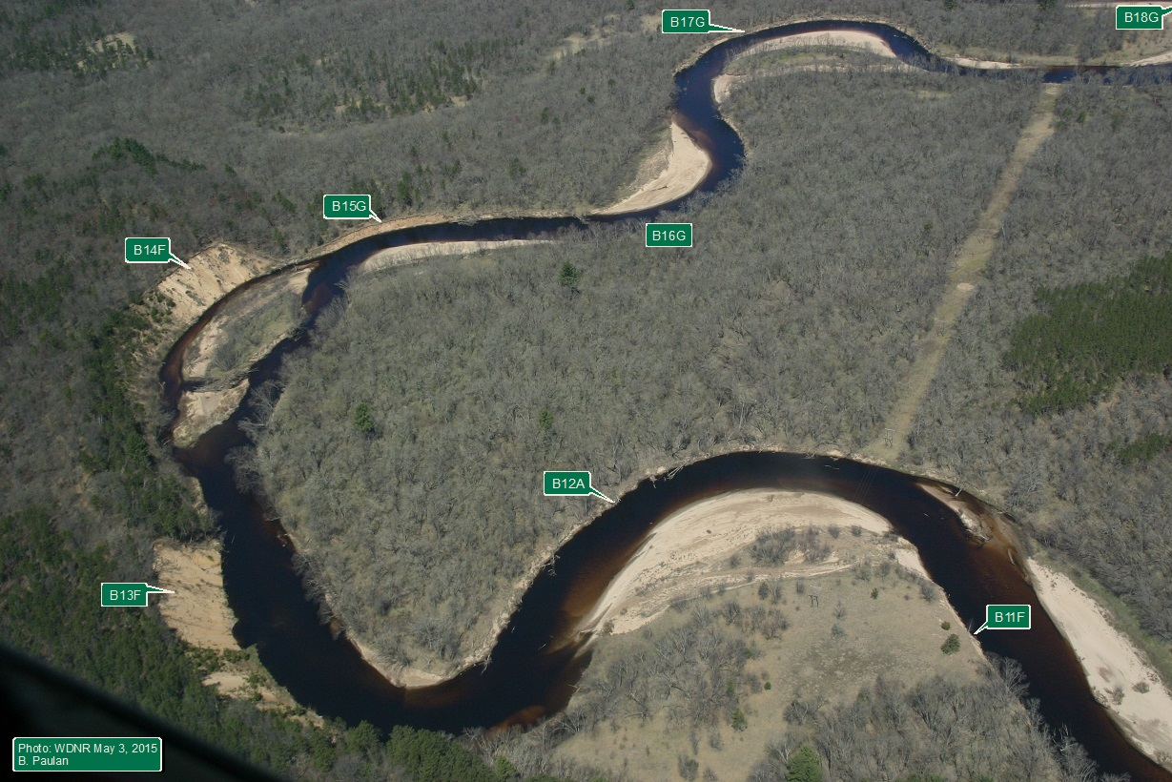

Figure 3: Low Altitude Aerial Photograph of Stretch of Lower Eau Claire River with Identified Erosion Sites from Table III
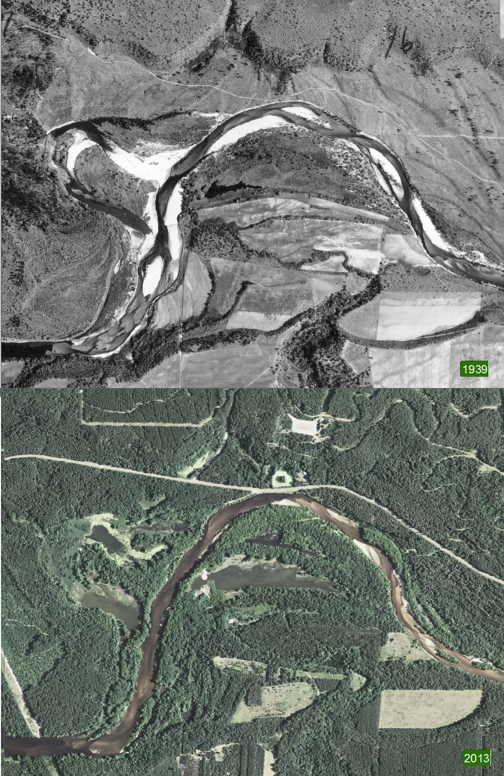

Figure 4a: Photographic Comparison between 1939 and 2013. Note the absence of forest land in and the Extensive Fresh Active Sand Points and Bars Alone the River in 1939.
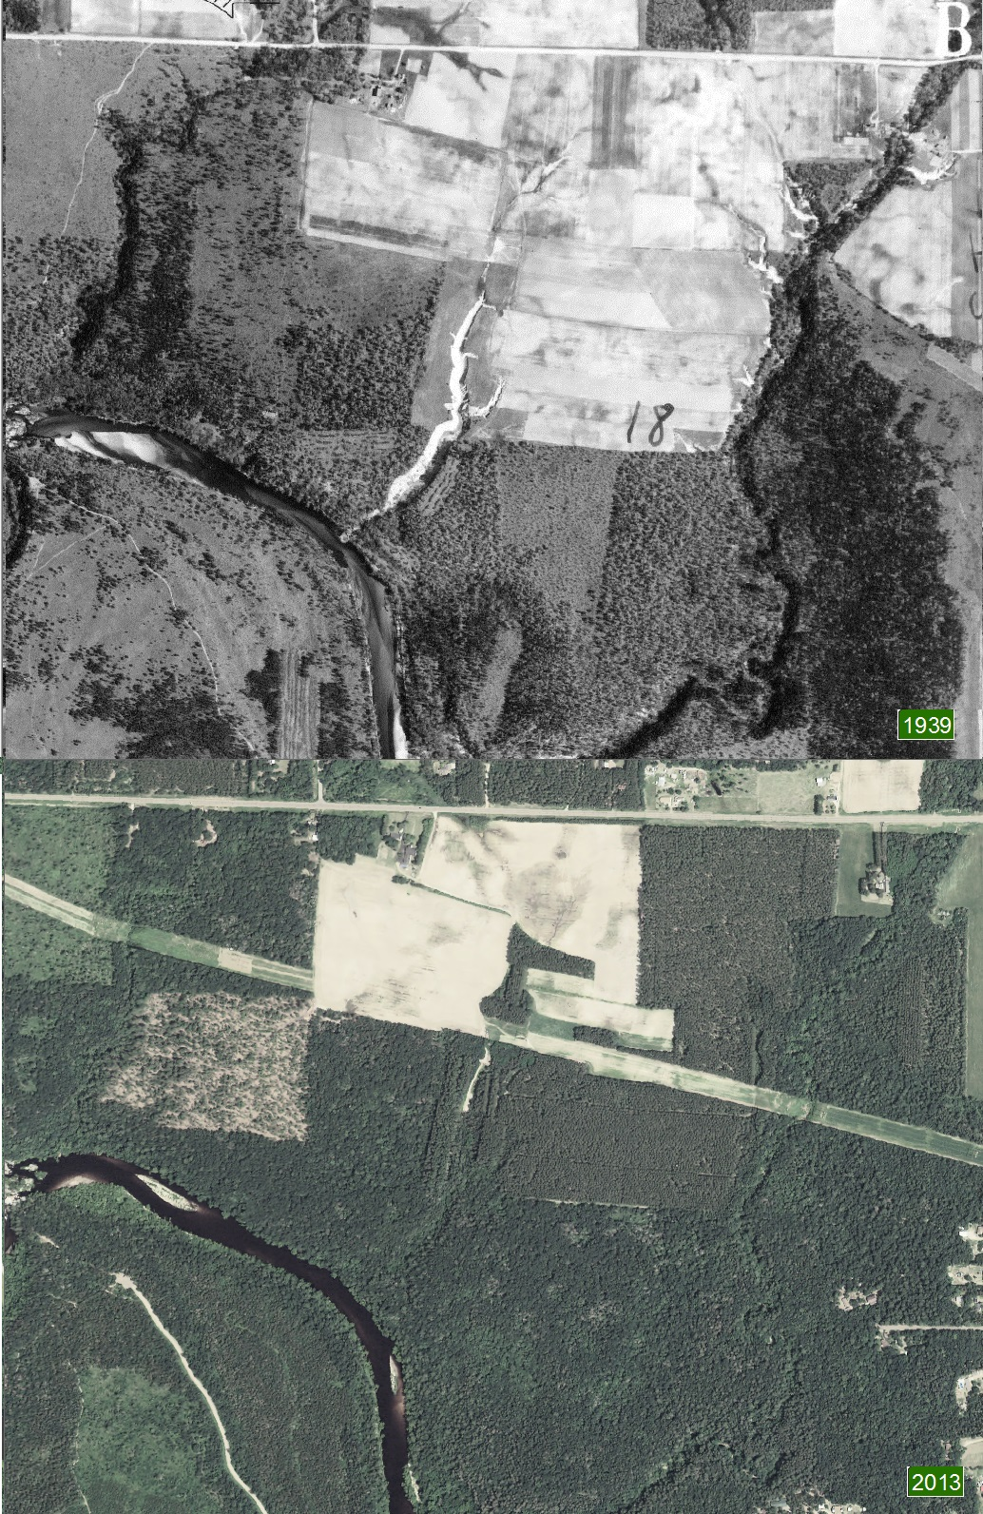

Figure 4b: Photographic Comparison between 1939 and 2013. Note the Extensive Cropland Erosion and Ravine Sediment Transport and Lack of Forest Buffer along River.

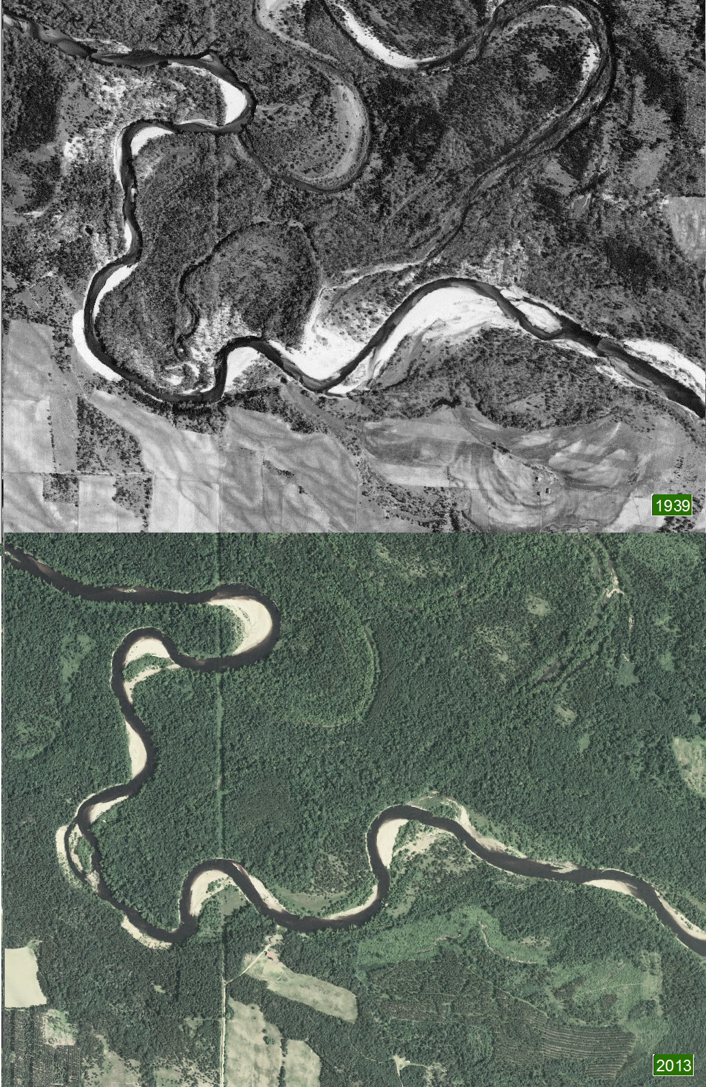
Figure 4c: Photographic Comparison between 1939 and 2013. Note the Very Active Field Erosion and Large River Active Point Bars and White Sediment Deposits Away from the River’s Edge
Simultaneous with the deforestation of Wisconsin was the introduction of extensive agricultural practices that created massive upland sheet flow erosion as can be seen in Figures 4b and 4c.
Although since 1939 agricultural cropland erosion conservation measures have been made it is still an important component of sediment supply to the Eau Claire River. This will probably only be controllable to a limited extend because it is the profit from crops that determines cropland acerage more than any other factor.

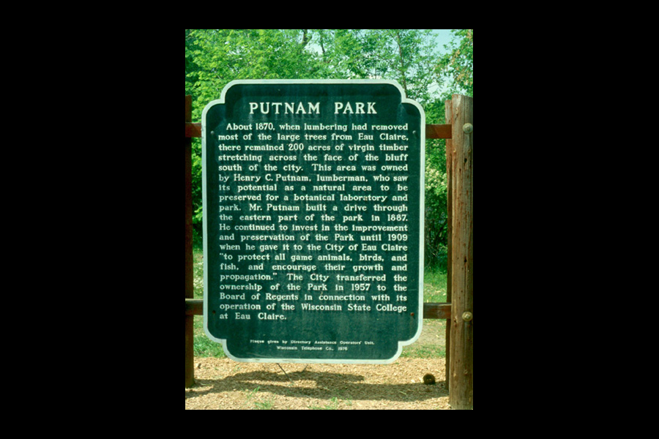
Figure 5: Putnam Park Sign in Eau Claire Dedicated to the Virgin Forests of the Past
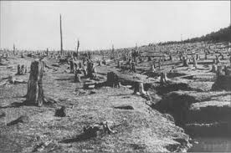
Figure 6: Deforestation Erosion Damage Photo from US Forestry Service 1909
MITIGATION OPTIONS

The following are some of the mitigation options that are available for sediment transport reduction to Lake Altoona. Each has advantages and disadvantages that are briefly covered in the following sections. It is important to realize that when it comes to mitigation choices there are two different dominant sediment types in the Lower Eau Claire River that behave very differently and are not easily controlled using one procedure. They are the bedload to larger suspended load and the fine suspended load and wash load. These different sediment types have characteristics that vary in size, density, and composition, but what is most important for this discussion is their settling rate in water. For the bed load to larger suspended load they settle very rapidly so that even modest reductions in turbulent flow will cause them to settle to the bottom (see Appendix C). In the case of the Eau Claire River this coarser sediment fraction is readily removed with shorter length shallow sediment trap designs, (Zika and Trombly, 2015). For the wash load and fine suspended sediments large reductions in flow velocity and long settling times are required to achieve efficient removal. Therefore what is an effective strategy for one sediment type may have little impact on the other, so more than one approach may be required for long term lake protection from sedimentation.

The following options were considered in this report. There are other possibilities, but they are probably unrealistic for various reasons and therefore were not addressed here.

- Continue with current strategy – dredging delta and channel
- Instead use multiple traps upstream
- Change dredging method from hydraulic to mechanical excavation
- Apply stream flow reduction strategies
- Use energy reduction in specific expanded flood plain areas like zone B
- Sediment Disposal/Storage Options

1) CURRENT STRATEGY – DREDGING DELTA AND CHANNEL
The current strategy of removing sediment before it arrives in the lake using a 60,000 yd³ trap and occasionally dredging the delta region is providing a long term benefit to extending the useful lifetime of the lake (Figure 7). However the process as carried out now is expensive and has

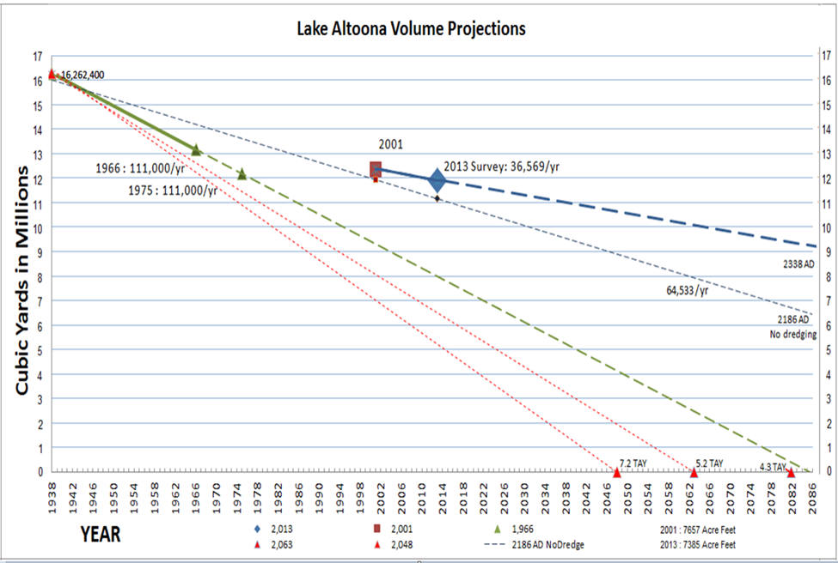

Figure 7: Lake Altoona Lifetime Projections Based on Different Lake Deposition Rates. Lifetime means complete filling of the lake with sediment to the top of the dam

detrimental consequences for the quality of life and recreational aspects for lake residents and users. Taking into account all the dredging done between 2001 and 2013 there has been a 43% reduction of the sediment deposition in the lake. This is certainly significant, but comes at high cost and offers only a temporary and highly variable fix for navigational and habitat characteristics of the eastern lake channel. Also during periods of high river discharge rates (i.e. 2010 to 2014) the trap capacity appears insufficient and the backup to the overflow of sediment is the delta. The annual average aggradation rates are shown in Figure 8. The bottom line is that a 60,000 yd³ sediment
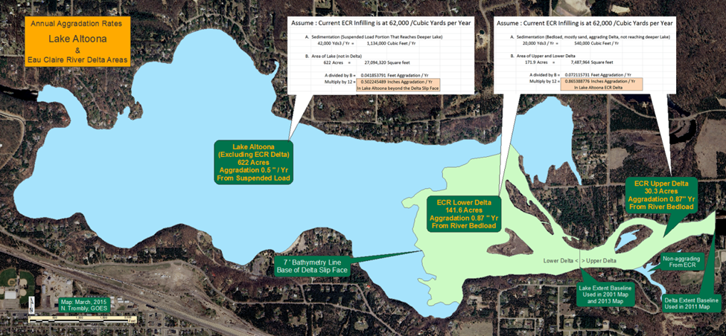

Figure 8: Annual Lake and Delta Aggradation Rates for Sediment Load from River

trap in the channel is reducing the 171.6 acre delta of the lake by 0.87 inches per year on average and has almost no impact on sediment reduction in the other remaining 622 acres of the lake. Fact of the matter is the lake is filling at an annual rate of 0.5 inches/yr on average with or without this sediment trap.
These calculations are based on bathymetric (depth contour) maps from 1938 and 1968 and recent bathometric maps from 2001 (Harrett, 2001) and 2013 (Lepsch and Trombly, 2013) , sediment size fractions from points in the delta (Finley 1975 and Simons, 1988), and HEC-6 computer modeled sediment trap efficiency analysis (Table IV). For a trap of the

Table IV: Sediment Deposition and Trap Efficiency Estimated Using HEC-6 Model from Sediment Trap Assessment, Saginaw River, MI, USACE Detroit District Report 2002

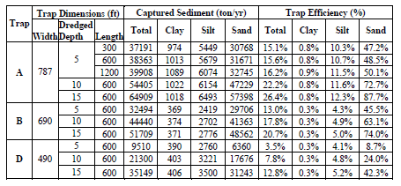
approximate width, depth and length dimensions of the trap used in Lake Altoona the efficiency of trap is probably no better than 10% for the suspended load and wash load when the trap is new and efficiency declines from there as the trap fills. For the bedload sediments, the material that rolls along the bottom, the trap efficiency should be high and approaching 100%. Consequently what is being trapped is the medium to coarser sand and fine gravel which would otherwise be collected in the delta region.
2) MULTIPLE SEDIMENT TRAPS UPSTREAM

If the sediment trap is moved upstream from its current location there are significant benefits to be gained. By placing a sediment trap in the river in the right location the trapping volume for the river sediment load will grow with time. What this means is that when you dig a sediment trap, let's say 30,000 yards, in a river the continuity of the sediment transport of the river will be maintained. So until the trap fills with sediment again the sediment downstream of the trap will continue to move downstream as a function of the current velocity and duration of the event. Therefore because the river downstream of the trap is starved for new sediment the trap is recreated (duplicated) downstream, so when the trap fills and is emptied of the 30,000 yd³ again the new river trapping volume has in effect doubled assuming no new significant erosion sites are created. The first dug 30,000 yd³ capacity is now not within the bounds of the original trap, but has moved downstream of the trap and effectively lengthened the original trap area. So if you start with a 30,000 yd³ trap you have a 60,000 yd³ trapping capacity after the first clean out and a 90,000 yd³ trapping capacity after the second clean out and so on. Because of the location of the current 60,000 yd³ sediment trap this kind of trap expansion does not work very well because there is a large delta area immediately below the trap where the river's energy drops off and aggradation of the sediment occurs on the delta.

Another advantage that is gained by moving sediment traps upstream from the current location is the expansion process described above will deepen the river along its course and reduce the river's energy and hence potentially reduce sedimentation transport (Figure 9). There are other advantages as well such as improved fisheries habitat and navigational improvements. Although the sediment in the trap and the bed surface of the river and delta appears to be almost entirely sand the bed of the river in higher energy regions will surely contain a significant aggregate of coarse gravel, coble and boulders. In these regions of the river the surface bedload transport of sand will leave behind a stable river bottom of these larger less mobile aggregates (Appendix C). The average bed material sediment size distribution for the lower Eau Claire River has been measured to be 90% between 1.0 mm and 0.18 mm (Figure 2), but in numerous samples fine gravel between 5 and 20 mm was found (Simons et al., 1988).

There are many potential site locations and trap design scenarios that could be employed; as an example the one shown in Figure 9 provides a working illustrative example. In this example one location is shown for the down stream trap and two alternatives are shown for the upstream trap. The measure of success with a sediment trap is demonstrated by measuring the impact the trap has on the characteristics of the downstream thalwig (the line down a stream bed defining the deepest channel or lowest elevations). The characteristics of the thalwig are typically not uniform in dimensions and vary with degree of turbulence and composition of bed material. If a sediment trap is efficient at removing sediment the river downstream will increase the cross-sectional area of the main channel and in effect increase the volume of water in the river at a given stage height. As an example with each 60,000 yd³ removed by the two traps shown in Figure 9 a stretch of 1.14 miles of the main channel will, for example, be deepened by 1 yard over a 30 yard channel width. The process of river deepening would not, of course be this uniform, but it is clear that substantial progress would be made with each cleanout of the two traps provided that significant new contributions of eroded sediments between the traps did not appear.

3) HYDRAULIC VS MECHANICAL DREDGING
Trap design is an important consideration when designing up stream traps that can reduce per yard costs and because of reduction in mobilization costs make more frequent trap clean outs feasible. According to model calculations such as those from HEC-6 model for efficient trapping of sand, short length deep traps are just as effective long traps. So mechanical dredging of a shorter trap from one shoreline is a possibility, and depending on the circumstances could reduce per yard costs and lower mobilization costs substantially. Depending on the trap location and haul distance this would probably fall in the $6 to $10/yd³ range (estimated from recent contractor bids obtained by

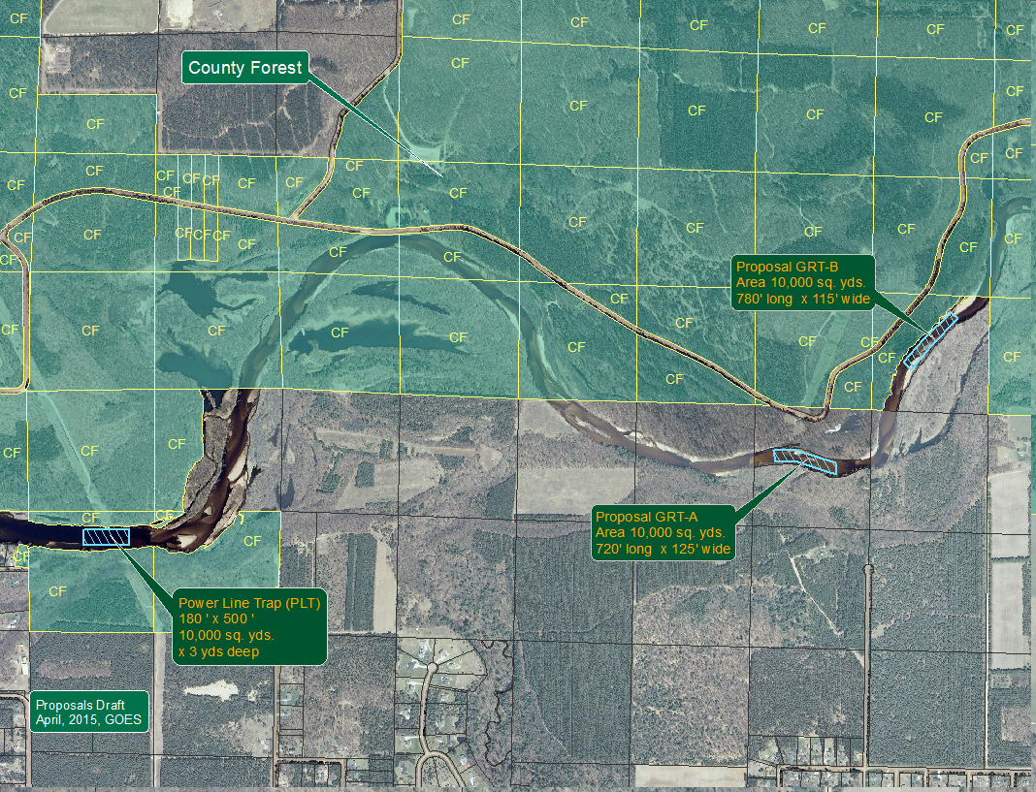

Figure 9: Proposed Multi-Trap Upstream Design Plan

GOES). These estimates are dependent on fuel costs and dredging company demand which is typically high during the spring through fall season. There are companies with winterized equipment that will dredge mechanically during the winter months and may offer better prices because job opportunities are fewer and dirt access haul roads are more stable when frozen.

4) STREAM FLOW REDUCTION STRATEGIES

As discussed above the use of multiple sediment traps along the course of the river causes the channel to deepen between them which increase the channel volume capacity which in turn reduces the velocity at the bed and hence bedload and some suspended load transport. As an example the proposed multi-sediment trap design shown in Figure 9 has numerous potential reconnection back waters that can be used to reduce main river channel energies (Figure 10). There are similar sites along the course of the river that could be used for this purpose and a comprehensive study would be required to identify the most likely possibilities and costs associated with reconnecting them.
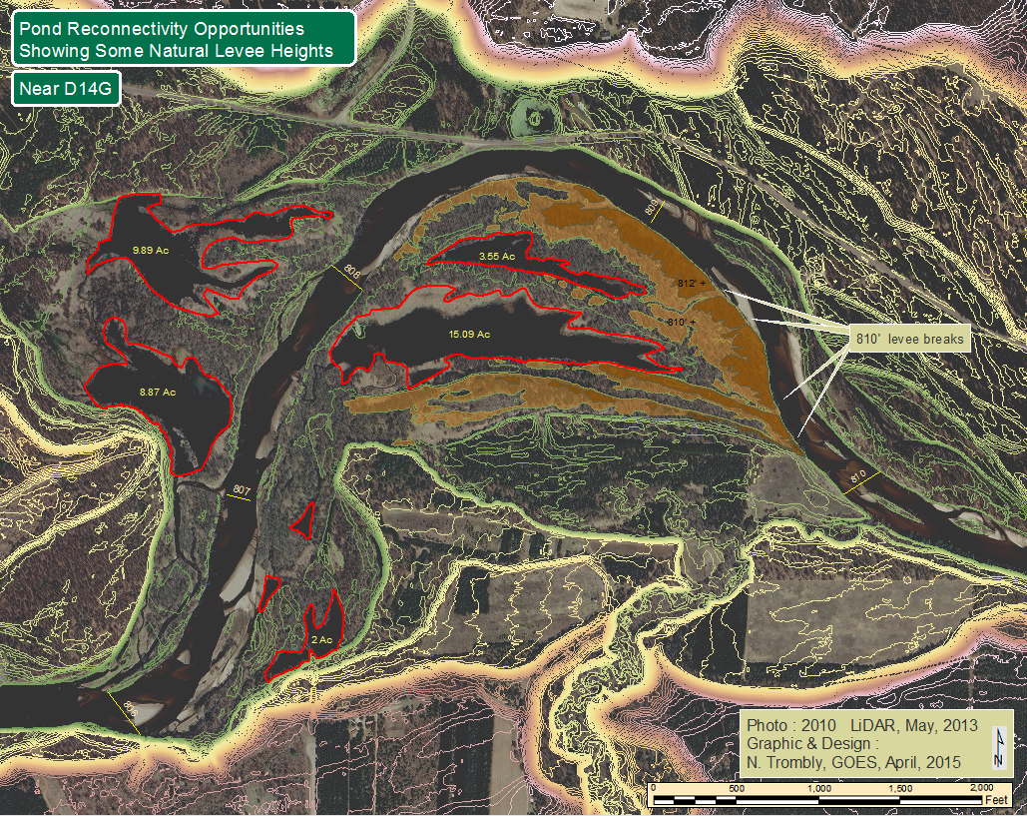

Figure 10: Identified Reconnection Backwaters along the Lower End of Section D

5) ENERGY REDUCTION IN SPECIFIC EXPANDED FLOOD PLAIN AREAS LIKE ZONE B

Another alternative to deal with fine suspended and wash load sediments is to design natural catchment basins at strategic points along the river channel. In viewing the LIDAR imagery the areas where there is the highest potential gain are near the B-C and C-D zonal boundaries as shown in Figure 11. There is a substantial acreage of low lying flood plain upstream of the these two zonal boundaries where flooding appears to occur during major flood events. Backing the river up at

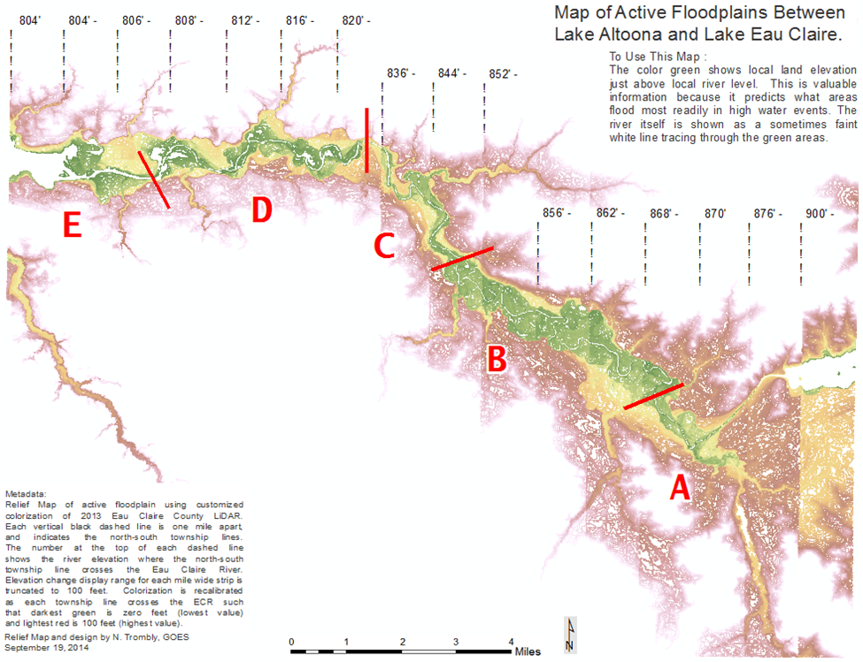

Figure 11: Defined Geological and Hydrological Zones between Lake Eau Claire and Lake Altoona

these points during flood events could help retain fine and wash load sediments through significant energy reduction and fine sediment interactions with vegetative and other non-mobile solid surfaces. In effect the depth and total water capacity of these flood zone prone areas would be increased. This could be accomplished by building partial dams across the flood plain at choke points in the river. The main river channel flow would be unrestricted except during high flood conditions.

Unfortunately there are many potential road blocks to accomplishing such a proposal. Land ownership is just one of those, but it may be worth developing a proposal to examine the prospect in more detail. Zone B is particularly attractive since it is a large area, much of which is public land. Also the various studies on erosion sites discussed previously all point to this zone as the largest sediment source area comprising as much as 85% of the sediment supply to Lake Altoona. So even though the project may require considerable effort to fulfill the long-term gains in sediment reduction for both the coarse and fine grain materials (wash load) could be more beneficial than any other single effort. The extend of the available acreage that could serve to accumulate sediment through aggradation are shown in Appendix

6) SEDIMENT DISPOSAL/STORAGE OPTIONS

Figure 7 shows that from recent bathymetry measurements the total sediment arriving in lake Altoona is 64,533 yd³/year. Of this total, erosion analysis of the river banks (Table III) indicates that roughly 20,700 yd³/year is due to river bank erosion. Most of the river bank source is sand and therefore likely collects in the delta or in functional sediment traps. To maintain functional sediment traps means that a minimum of 21,000 yd³/year of sediment must be removed and stored or disposed. This is an average value that in some years, depending largely on annual rain fall and major flood events, can be substantially larger.

Sand collected from dredging and sand trap operations is currently stored only at the hydraulic de-watering basin adjacent to the NW corner of the lake. Since dredging operations began the collected sand from the traps has been sold when possible. Current guidelines for such sales are the following:
- The contact person will be the Town of Seymour representative to the Lake Altoona District Board.
- Sand will be sold by the cubic yard.
- The Board will determine the price for sand based on the current market
  - Local sales for personal use or for bedding sand: $3.00/cubic yard
  - Large sales for commercial use or long-term sales will be negotiated
  - Prices will be “at the site” (loading and transportation not included)
  - The contact person will be responsible for arranging customer access to the storage site

One potential use for large amounts of dredged river sand is as frac sand. Although much of the bedload or dredged river sand from the Eau Claire River does have frac sand characteristics it is of low quality and expensive to process because of associated organic and inorganic contaminants (Zika et al., 2012). Therefore sales of sediment spoils as frac sand is an unlikely candidate for sand usage in today’s market.

RECOMMENDED FUTURE AND ONGOING PROJECTS AND STUDIES

A considerable amount of money has been spent over the past 50 years on various studies to identify sediment sources and magnitude of the problem facing the Lake Altoona District. Unfortunately questions still remain that require adequate answers or conformation of existing data from the previous studies. Without such results the outcome of mitigation measures suggested above may prove to unsuccessful or at least inadequate. Therefore the following are recommendations designed to fill in existing gaps of technical information and help confirm that applied mitigation measures working as designed.

- Use of LIDAR Data to Determine Erosion Hot-Spots and Historical Trends
- Regular Scheduling of Lake Bathymetric Maps
- Establish River Stage Continuous Monitoring Site and Calibrate for Discharge Rate (Flow)
- Determine River Transported Sediment Type and Size Distribution
- Establish Relationship for Stream Discharge Rate vs. Sediment Transport Rates to Predict Lake Sediment Loading
- Coring to Characterize Lake Sediment
- Sub-surface Profiling of River Channel
- Create Accurate Elevation Map of River Bed, Backwater, and Potential Aggregation Sites
- Identify Best Locations for Upstream Sediment Traps and Catchment Basins
- Identify and Design Re-connectivity and Improved Habitat Projects

1) LIDAR DATA TO DETERMINE EROSION HOT-SPOTS AND HISTORICAL TRENDS

In Table III (also Appendix B) river bank erosion and aggradation sites are identified. Only 1999-2013 values have been processed to this point. To determine historical trends in erosion it would useful to complete the table results for the periods 1938-1972 and 1972-1999 by applying current LIDAR imagery. This information would also help establish how mobile erosion hot-spots are over time. It may be bank stabilization measures are a waste of time for some stretches of the river.

2) REGULAR SCHEDULED BATHYMETRIC LAKE MAPPING

Lake lifetime projections are shown in Figure 7 and are based on the amount of infilling as determine by the various bathymetric maps that have been produced. Without going into great detail there are good reasons to question the validity of some of these studies and the accuracy of conclusions arrived at in this report. The change in lake volume resulting from infilling is probably the best way to determine annual sediment loading for the lake. Therefore it is recommended that regular bathymetry maps are produced and used to estimate sediment loading. The lake is the ultimate sediment trap and will accumulate all but the very finest suspended material which is transported over the dam and therefore not a threat to the lake.

A high quality bathymetric map should be generated in the next couple of years and should conform to agreed upon methodology, resolution, and contain all essential meta data for future applications . Once this first high resolution map is produced it can be used to test previous results and be used as the standard going forward. Subsequent maps of much lower results could then be used to estimate sediment loading in the future. The interval between these maps will be determined from the achievable precision of the method used and the determined rate of infilling.
3) ESTABLISH RIVER STAGE CONTINUOUS MONITORING SITE AND CALIBRATE FOR DISCHARGE RATE (FLOW)

It would be very useful to have accurate and timely river discharge rates for the lower Eau Claire River. Discharge rates are typically measured by measuring water height of the river with a stage gauge that is calibrated for flow in units of cubic feet/unit time. An automatic reporting stage gauge was operated by the USGS at County Highway K bridge in the past and some records prior to 1970 are available. More recently, until around 2011, the National Weather Service (NWS) used the stage gauge as a flood stage monitor, but they do not save continuous discharge rate information. Since USGS stopped maintaining the site it is no longer functional.

Since discharge rate is one of the primary determinants of sediment transport it is strongly recommended that the stage gauge be re-established, calibrated and maintained into the future. The estimate from USGS to perform this service was over $10,000 to put the service back up and roughly $20,000/year to maintain. The same can be accomplished for a lot less by purchasing and installing a compact integrated pressure sensor system with telemetry. For about $2000 an In Situ Incorporated LevelTroll data logger with telemetry capability would be a good choice. There is a cost associated with the telemetry of $35/month. The systems are rugged and provide long battery life. The system also measures temperature and compensate for atmospheric pressure differential. They are also upgradable and sensors like a turbidity meter can be added. Turbidity would be a way of assessing the magnitude of suspended sediment carried by the stream at different stage heights. Stage height could be converted to river discharge by calibrating the stage level at different stage heights with a conventional current meter (Zika and Trombly, 2015) or an ADCP (Acoustic Doppler Current Profiler).

4) DETERMINE RIVER TRANSPORTED SEDIMENT TYPE AND SIZE DISTRIBUTION

Figure 2 shows the distribution of sediment size along the course of the river. The samples used in producing this data came for the surface sediment bed and therefore represent what is deposited under different settlement regimes. The results show that higher current velocity regions have a higher composite of the larger size fraction while the downstream side of the delta (low velocity and long settling times) has a higher composite of the smaller size fractions. This is exactly what is expected, but this information would be more useful if the total composite size distribution were know from turbulent well mixed areas upstream of the lake delta. This information would provide useful picture of what the total suspended sediment load is approaching the lake. Various methods exist for making such measurements and some of these are summarized in Ongley, 1996 and Peters, 2005.

Previous studies for Lake Altoona relied on indirect means of determining the suspended sediment size load distribution and not on direct evaluations that characterized it. As discussed previously in this report, it is difficult to appraise the accuracy of the suspended load material distribution and yet as shown in Figure 7 the fine suspended load estimates have significant impacts on the lifetime projections for the lake. It is therefore recommended that suspended sediment samples be collected and characterized for different discharge rates. This will help to better the lifetime infilling projections and also be useful in defined the best mitigation measures.

5) ESTABLISH RELATIONSHIP FOR STREAM DISCHARGE RATE VS. SEDIMENT TRANSPORT RATES TO PREDICT LAKE SEDIMENT LOADING

The transport of sediment towards lake Altoona is directly linked to stream discharge rates and hence to precipitation in the watershed. The sediment load reaching Lake Altoona is the sum of uplands sheet flow plus river bank erosion. This total suspended load and bedload can be measured in the river for different flow rates and provide an estimating tool for determining sediment trap lifetimes and budgeting costs. It is difficult to do this from past results since they don’t exist or were marginal. Also if climate change models are correct the past relationship between precipitation and sediment transport may have a whole new meaning in the future. It is difficult to compare past river annual river discharge levels with current values because records have not been kept (Appendix F1). Although recent continuous stream gauge data for County Highway K does not exist the NWS has recorded high river crests since 1950 and they are shown in Appendix F-2. It is interested to note that there have been more high river crests recorded since the year 2000 than in the preceding 50 years for the Lower Eau Claire River. River crests are of course single events, but as shown in Appendix F-3 the climate change record since 1950 also indicates that annual precipitation amounts for the Eau Claire River watershed have increased by 6.5 inches/year during the period. These results indicate that there is a trend towards higher levels of precipitation and therefore most likely more sediment transport. The relationship between stream discharge and sediment transport rates will be useful in providing guidance on mitigation measures and budget projections for the future.

6) CORING TO CHARACTERIZE LAKE SEDIMENT

What was to become the Lake Altoona basin was prior to 1938 a board river plain with marsh vegetated areas. Sediment cores could be used to determine the actual thickness of deposited sediment since 1938 and establish size and nature of the material and trends over the years. On the order of 10 cores from different points around the lake could provide valuable information on trends and help quantify the actual fine sediment loading of the lake.

7) SUB-SURFACE PROFILING OF RIVER CHANNEL

Without knowing the sub-surface river channel characteristics the location of sediment traps, their design characteristics and the projected outcomes is a guessing game. There do not appear to be any data records or references to sub-surface profiling. As stated earlier the river bed prior to man’s intervention 200 years ago probably had a bottom strata composed of erosion resistant gravel, cobble and boulders. There is substantial evidence along the course of the river that there may solid granite or sandstone strata.

To confirm this it is recommended that sub-surface profiling using ground penetrating radar or a seismic chirp sounder be used to characterize the stratigraphy of channel (Sanhaji, et al., 2012). The latter instrument could also use multiple transducer frequency to simultaneously record water, river bottom elevation and sub-surface profile. Using a multi-beam instrument the entire width of the river could be characterized quickly since these instruments can profile at speeds of several knots.

8) CREATE ACCURATE ELEVATION MAP OF RIVER BED, BACKWATER AND POTENTIAL AGGREDATION SITES

To evaluate changes resulting from upstream mitigation measures it is important to measure the elevation of the river bottom. This should be done before any mitigation measures are taken to establish the base line while the sediment transport is in steady state. For instance when a sediment trap is completed in the river sediment starvation will ensue downstream of the trap and assuming the river bed is erodible below the trap the river bed elevation will decrease as a function of flow rate and high water duration. Measuring the change in river bed elevation is the only good means of determining progress in channel deepening.

Therefore it is recommended that river bed elevations are measured over the entire length of Eau Claire River or at specific point cross-sections along the stream corridor. This can be accomplished by setting elevation bench marks in stable river bank locations and then using standard surveyor transit and pole to determine changes in river elevations over time. A better approach is to use GPS RTK positioning system rover attached to the top of a sounding pole or a narrow beam high accuracy depth transducer with a GPS RTK antennae attached for recording horizontal and vertical coordinates. The latter system is usually fixed on the side of a small boat for stability, but also provides mobility so that large stretches of river can be evaluated quickly and easily.

9) IDENTIFY BEST LOCATIONS FOR UPSTREAM SEDIMENT TRAPS AND CATCHMENT BASINS

Examples of sediment trap locations and catchment basin areas are identified and discussed in previous sections of this report. It should be recognized that these have been evaluated at arm’s length and further more detailed evaluations need to be conducted. There are other potential sites that could be chosen and might prove to be better alternatives. Whatever sites are identified things such as sub-bottom profiling and river bed elevations should be conducted before proceeding. Also local property ownership and access routes need to be identified. Also it would be a good idea to ask experienced dredging contractors for their perspective on possible sites.

10) IDENTIFY AND DESIGN RE-CONNECTIVITY AND IMPROVED HABITAT PROJECTS

Depending on the circumstances of sediment reduction strategies it might be best not to open backwater channels or reconnect areas until sediment load reduction is achieved for those areas. If done prematurely more water and sediment transport than desired may be redirected and reduce some of benefit of the main channel traps or degrade the reconnected areas. It is therefore important to do preliminary surveys of these reconnection areas and to keep track of the progress of chance as sediment load-reduction proceeds.

TABLE V: Action Items for Sediment Mitigation Measures
Action | Implementation | Timeline | Finance
Use LiDAR data to determine erosion hot-spots | EC County provide data | 2015-2016 | EC County
Maintain useable lake surface of Lake Altoona
Develop Community Partnership | LA District | 2015-2018 | LA District
Let delta grow while focusing on upstream solutions (conflicts w/#2) | LA District, ECCLCD, WDNR, others?? | 2016-2018 | Watershed grants – results of 9 key project?
Reduce sediment transport into delta by 50% over 5 years Dependent on choices?
Reduce or eliminate the negative effects of dredging (noise, pollution, habitat, etc) | LA District, WDNR, ACOE,  And EC County | 2016 and on | EC County and LA District
Regular Bathymetric Mapping | WDNR, Consultants | 2016 and every 3 years there after | LA District
Coring and Characterizing Lake and River Sediment | WDNR and Consultants | 2016 - 2017 | LA District and Watershed Grant
Sub-Bottom Profiling River Channel | Consultants | 2015-2017 | LA District
River Stage/Discharge Rate Monitoring | WDNR, Consultants | 2015-2016 | LA District
Elevation Mapping of River Bed and Reconnection Sites | EC County, Consultants | Start before any new upstream dredging | EC County and LA District
Establish Relationship between Discharge Rate and Sediment Transport | Consultants | 2016-2020 | LA District

LITERATURE CITED
Finley Eng. Company (1975abc, 1976)
Hartnett, S., 2001. Bathymetric map of Lake Altoona. Available online at http://dnr.wi.gov/lakes/ maps/DNR/LakeAltoonaBathymetric2001-Small.pdf.
Implementation and post-implementation surveys 1983 to 2013
Lepsch, J. and N. Trombly (2013). DNR Point Intercept Aquatic Plant Survey for Lake Altoona. WI DNR West Central Region Office.
Mead & Hunt (1981)
National Land Cover Data (NLCD 2006), http://www.epa.gov/mrlc/nlcd-2006.html
Office of Inland Lake Renewal - DNR (1980)
Ongley, E. 1996 Water Quality Monitoring - A Practical Guide to the Design and Implementation of Freshwater. In Quality Studies and Monitoring Programmes, eds. J. Bartram and R. Balance. UNEP/WHO
Owen Ayres and Associates (1979)
Peters, J.J. 2005. Sediment Sampling in Sand-Bed Rivers: Methods and Instruments. AGORA: Hydraulic Instrumentation
River Country Resource Conservation & Dev. Council (1980, 1987)
Sanhaji, M., S. Porto and H. Guarin (2012) High-resolution seismic reflection coefficient
calculation using a Chirp Sub-bottom Profiler. ??
Simons, Li & Associates (1988)
West Central Wisconsin Regional Planning Commission (1988)
Zika, R.G., K. Jacobs, and P. Sorge (2012) Lake Eau Claire Management Plan.
Zika, R.G. and N. Trombly (2015), Lake Eau Claire District Management Plan, In Prep.

APPENDICES
APPENDIX A: LAKE ALTOONA BATHOMETRIC MAPS
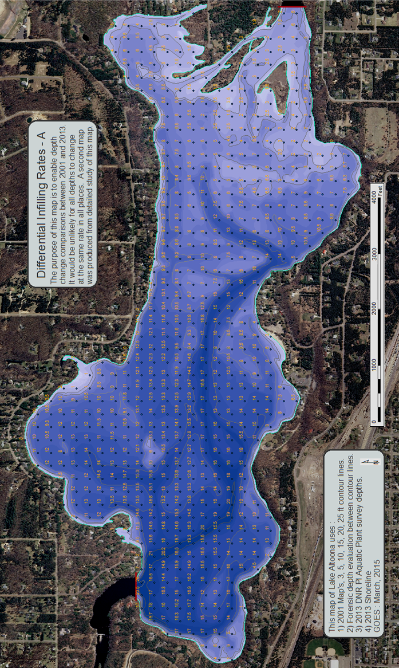
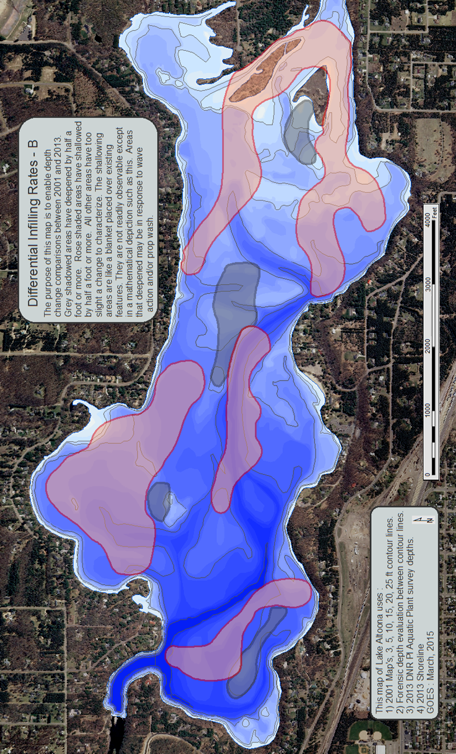
APPENDIX B: EROSION AND AGGRADATION DIRECTORY
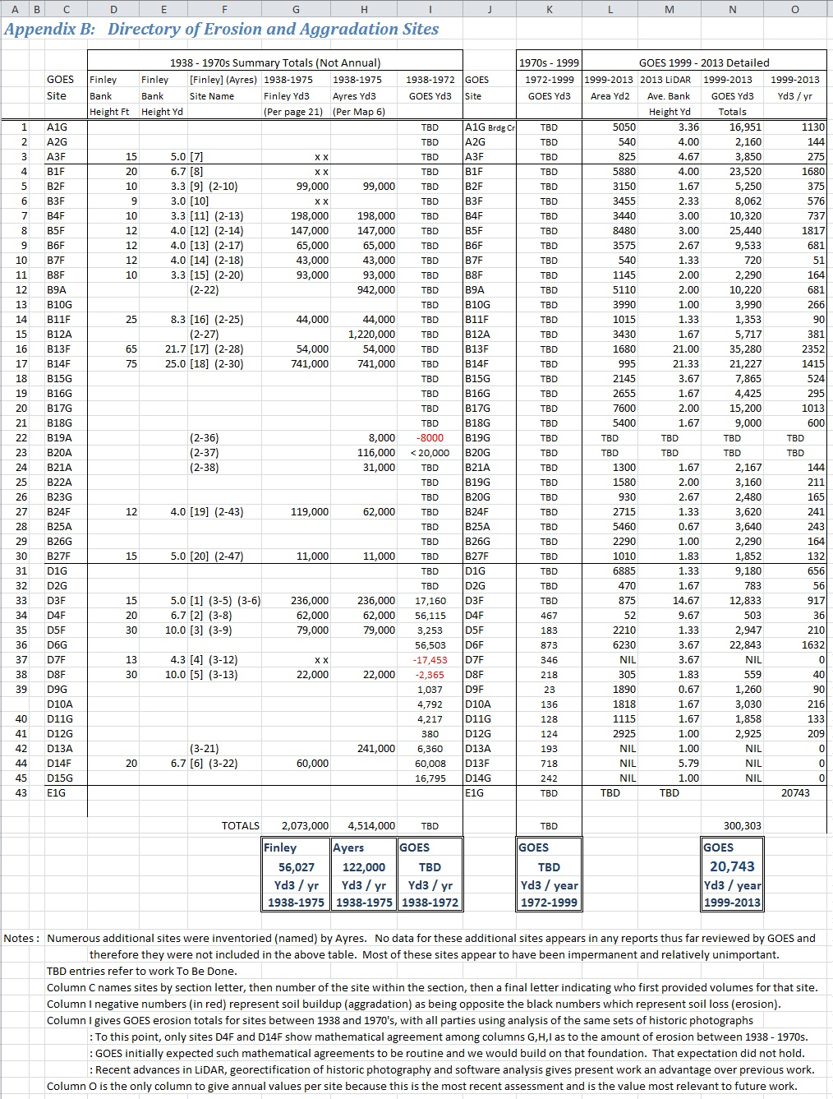
RIVER BANK EROSION VOLUME CALCULATION METHODOLGY

Purpose 1: To determine the gross volume of currently eroded sediments from riverine banks along the Eau Claire River between the Eau Claire Dam and the Upstream end of Lake Altoona.
Purpose 2 : To determine the gross volume of historically eroded sediments from riverine banks along the Eau Claire River between the Eau Claire Dam and the Upstream end of Lake Altoona. This is to ascertain trends and substantiate that the erosion-deposition figures of the past cannot be used in the present. Well started but incomplete.
Purpose 3 : To determine the gross volume of eroded sediments from all banks and shorelines between the Lake Eau Claire Dam and the Lake Altoona Dam. This would include volume of all erosion directly impacting Section E from direct erosion of the Lake Altoona shorelines and also include deposition from stream tributaries that empty directly into Lake Altoona. This Section E (Fig. 7) erosion study is highly incomplete.

What was examined: All river banks between the Lake Eau Claire Dam and the upstream end of Lake Altoona were examined. A subset of 45 erosion sites were selected for study in 2015. Inclusion in this subset was automatic if the site was previously listed in the Finley study [20 sites] or subsequently first studied by Ayers [6 sites]. These sites were included without regard to recent levels of erosion activity. An additional 19 sites identified as recently active were included by GOES. Point #1 of the GOES sites is actually a composite of 20 bank erosion sub-sites on Bridge Creek that are closest to the point where Bridge Creek empties into the Eau Claire River. Bridge Creek was the only tributary creek thus studied and appeared potentially significant.

Math components needed: To compute volume three metrics are needed V = L x W x D where V stand for Volume, L for length, W for width and D for depth. However, if area is computed automatically the formula simplifies to V = A x D where A stands for Area and replaces L x W. With modern technology, ArcMap provides highly accurate and automatic area (A) calculations of polygons such that the area returned is as accurate as the polygon drawn. The remaining component, D for depth of materials eroded, has long been difficult to ascertain over large areas but the recent arrival of LiDAR has greatly eased this difficulty and clarifies not only present but also previous erosion depths due to the surrounding continuity of floodplain surfaces as seen in old photographs.

Bank slope component considered not needed: Because this study is not fixated on single bank events it is considered not necessary to compute each bank’s event-response slope with exacting accuracy. The upshot of this is that variations over time in the angle of slope of the slip face of any given bank is ignored. The operative hypothesis is that the angle of repose of so many [45] separate erosion sites will stay close to a constant mean, whatever that is, over multi-year summaries. This hypothesis reduces the three dimensional slope issue to a two-dimensional line issue – it is only necessary to accurately determine, at two separate times, the drop off line where the bank is cutting into undisturbed soil. The area between these lines multiplied by the vertical height of the bank gives the erosion volume with sufficient accuracy when repeated over the 45 sites.

Units used : Because the historic and current unit used for describing cost and volume is cubic yards the units used in this study are yards for distance, square yards for area and cubic yards for volume. It was believed that to vary from this metric would be confusing to all those who must make bidding and management decisions based on this study.

Photographs used : To determine area values (A) historic photographs were used within the framework of ArcMap applications.
>The earliest photographs were 1938 -1939 and were obtained from an online archives in Madison, Wisconsin. These photographs are of exceptional quality, putting many more recent aerial photo surveys to shame. However, these photographs are not georectified. This meant that it was necessary to import these old photographs into ArcMap and then search exhaustively on already georectified modern photos for landmarks that survived intact from 1939. Further, all such airplane photographs are subject to ‘fish-eye’ distortions so each photo had to be ‘rubber sheeted’ to conform with satellite imagery. This was a time consuming but successful undertaking.
>The next set of photographs were hardcopy from 1972 and are internal to the Eau Claire, WI, DNR archives. These photographs were previously used by Finley and Ayers. Although the quality of these photographs was originally fine, they were marred by persons using the photos over the intervening half century. Also, the scale was unworkably small and not digital. This necessitated setting up a photo lab with sufficient magnification system to use a digital camera to capture two square inch portions of these 9” x 9” photos at a time. Once in digital format and at workable scale, these photos could be imported into ArcMap and georectified in the same way as the 1938-1939 photos.
>The third set of photos were from 1998 and 1999, digital and already georectified. These photographs exist in the DNR aerial photo library. The quality is not great but it turns out that Google Earth used some of these same photos in better condition, which proved useful to clarify some bank edge locations.
>The fourth set of photos were from 2013, DNR library, again of rather poor quality but able to be electronically manipulated towards clarity. These are already georectified, and happily of the same year as the May, 2013 LiDAR, yielding a very powerful analytical combination.

Calculations : With all four sets of photographs loaded and georectified in ArcMap, along with the relevant LiDAR, it was possible to sketch the top edge of the newly eroded bank at each of the four times listed above. Areas between each of these four lines represented areas eroded between [1939 – 1972], [1972 -1999], [1999 – 2013]. With use of LiDAR and other metrics it was possible to determine average vertical bank heights. With known area and height, eroded volumes could be calculated.

Results presentation : The results of these calculations are listed in table format in Appendix B. Following the table are site-by-site screen captures of each bank as it was being studied in ArcMap. The screen captures show 1999 photo imagery on 2013 Lidar lines so that the most recent erosion study is fully represented for critical review. Unlike previous studies, these most recent calculations are efficiently documented in detail. Thus far, only Section D displays values calculated for all three time periods.

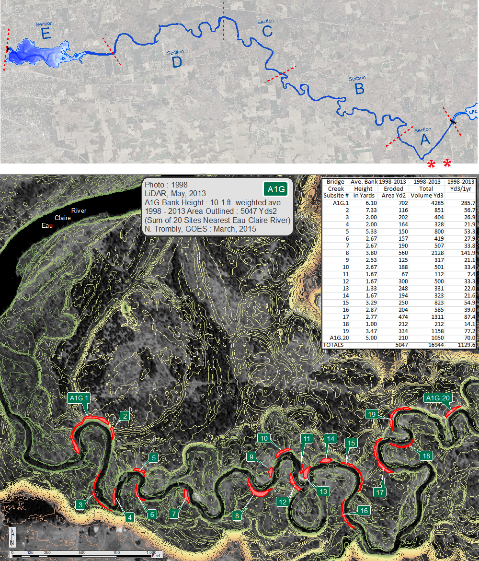

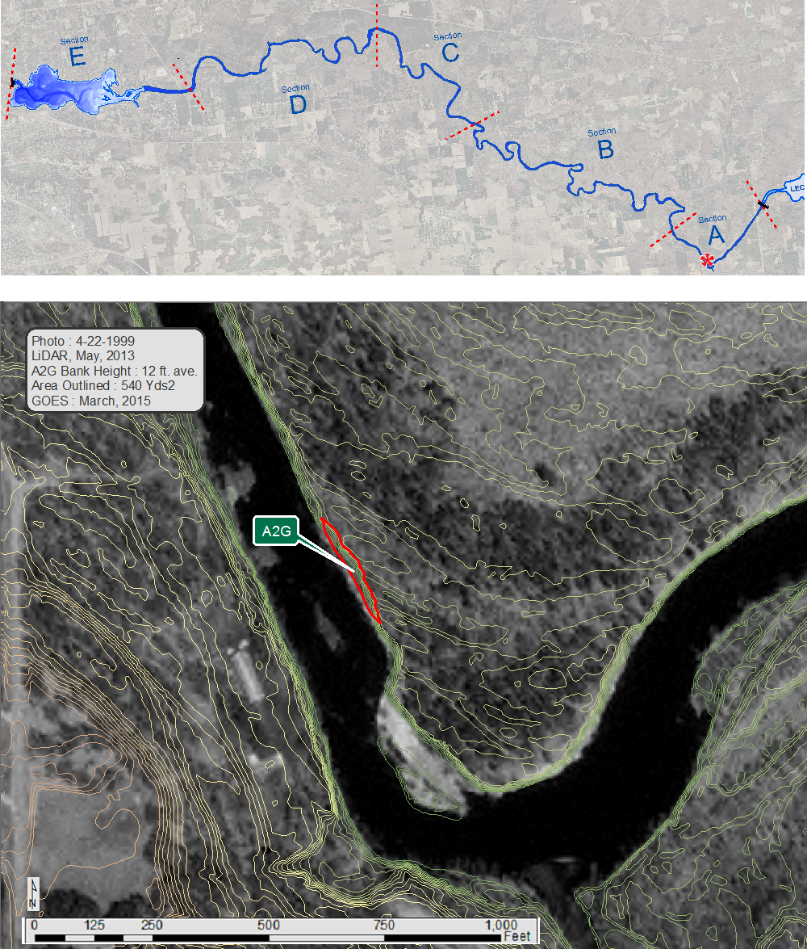

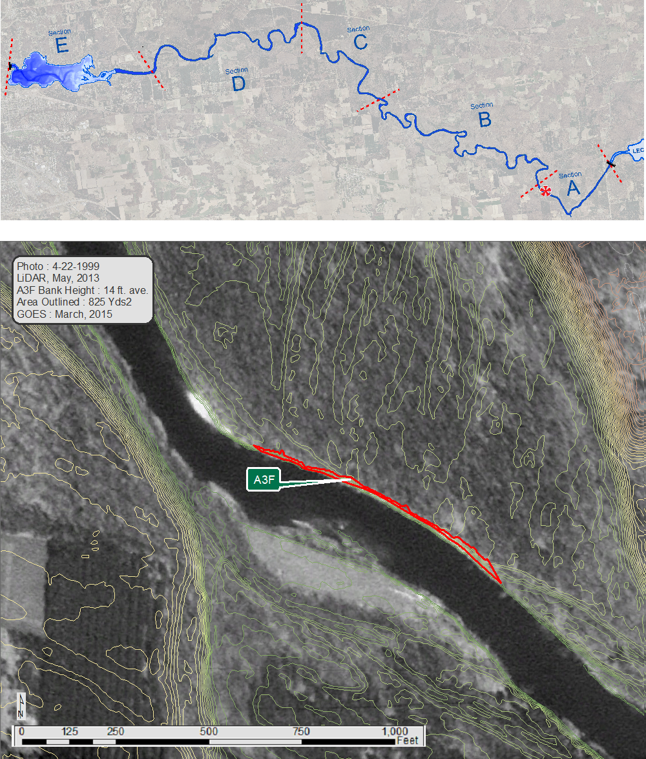

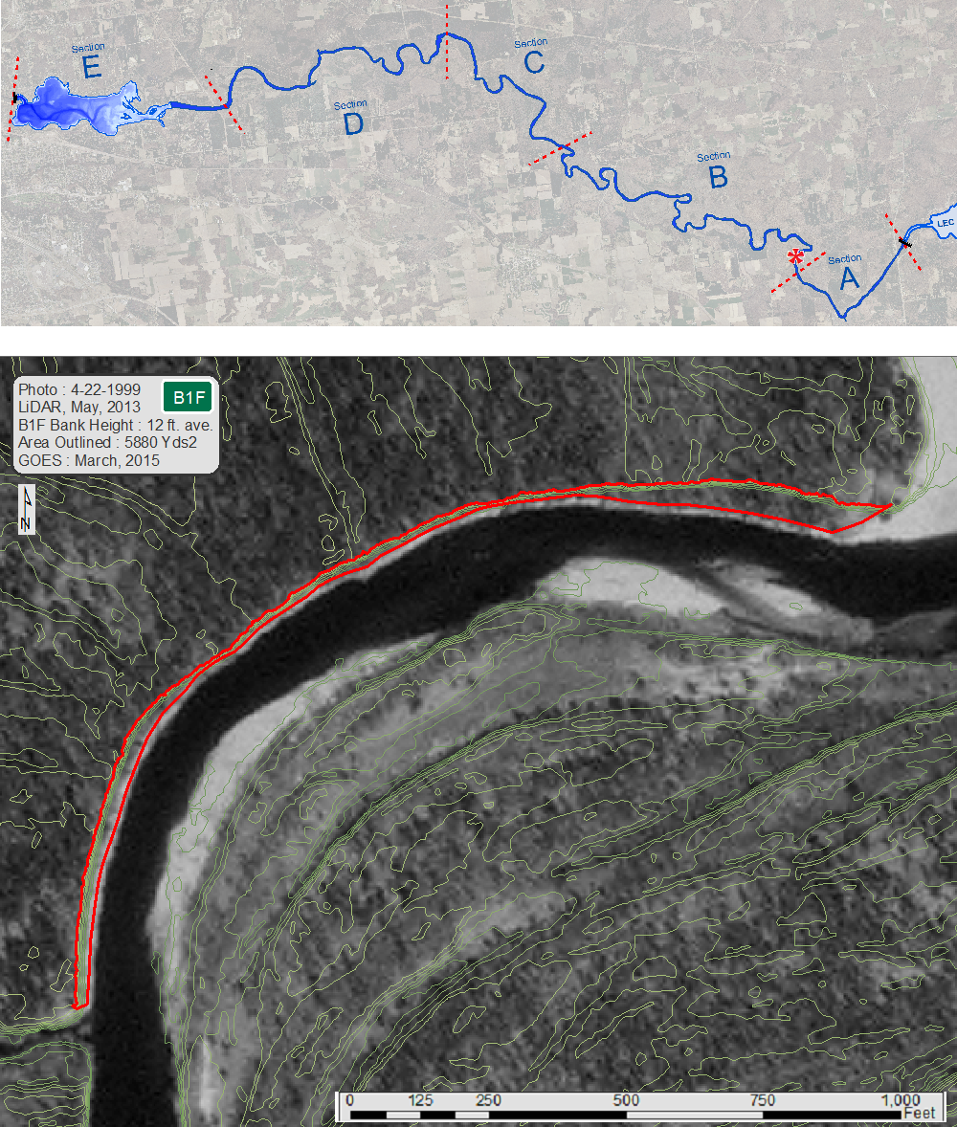
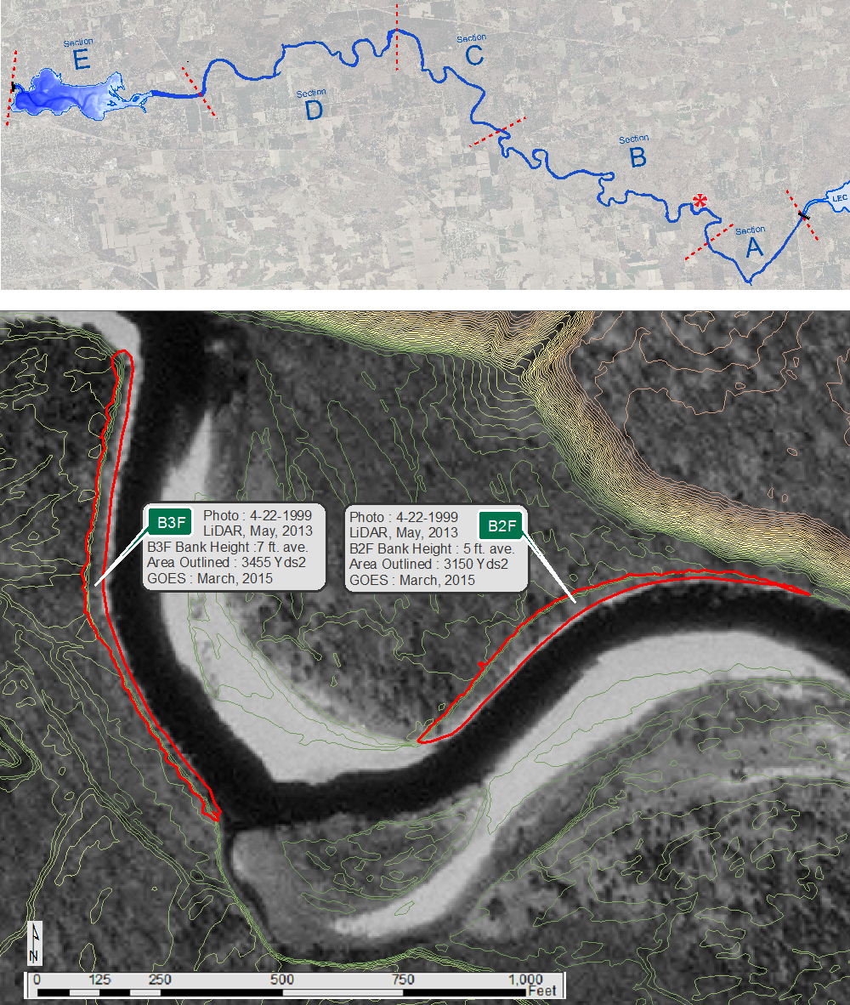

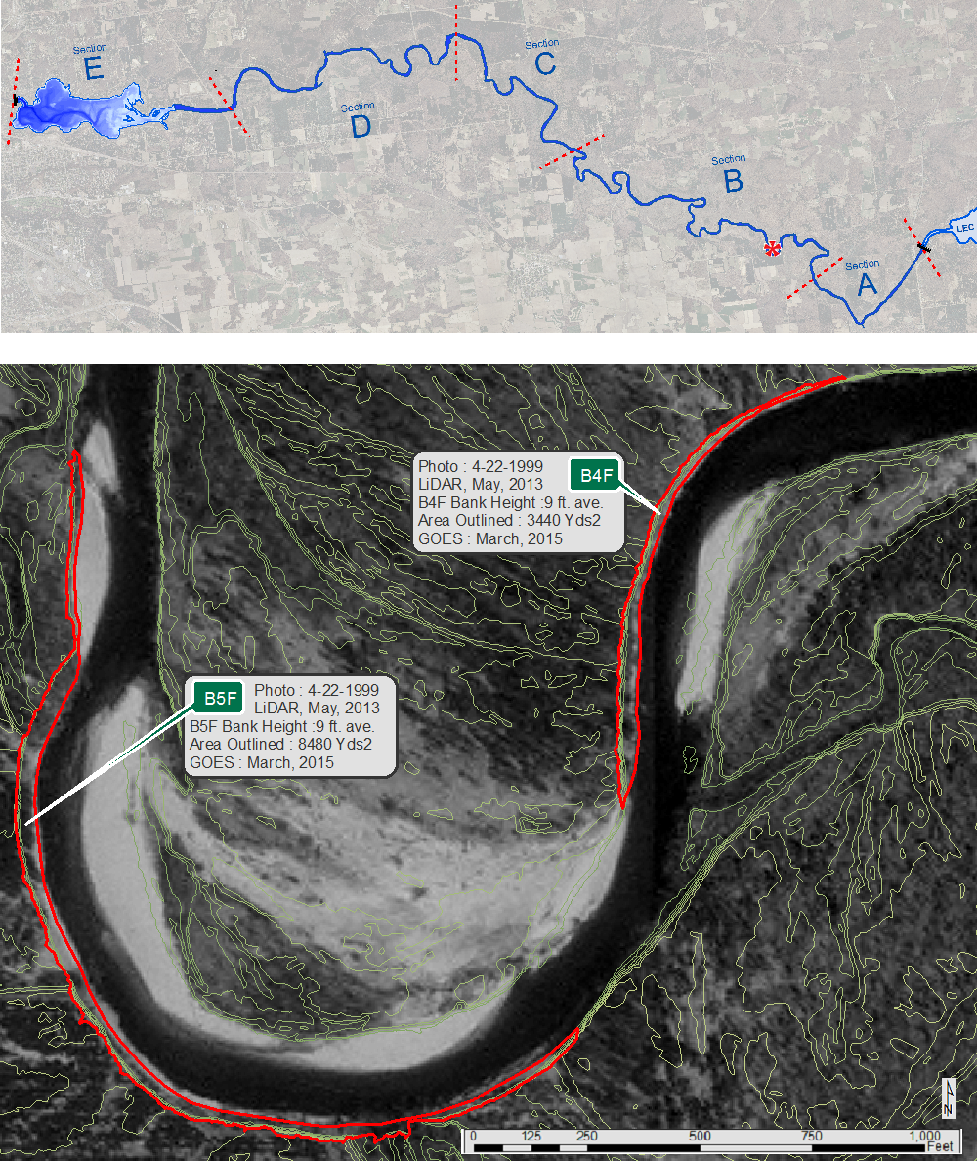

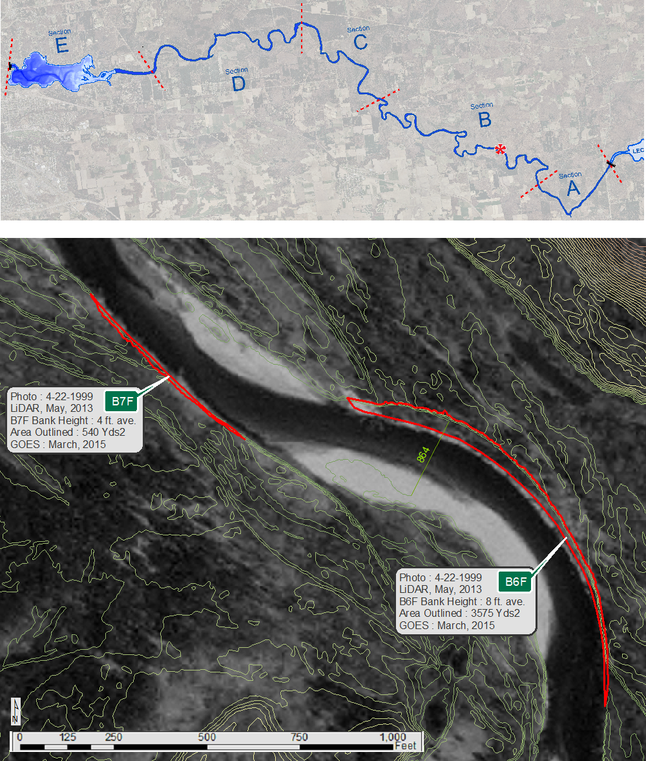
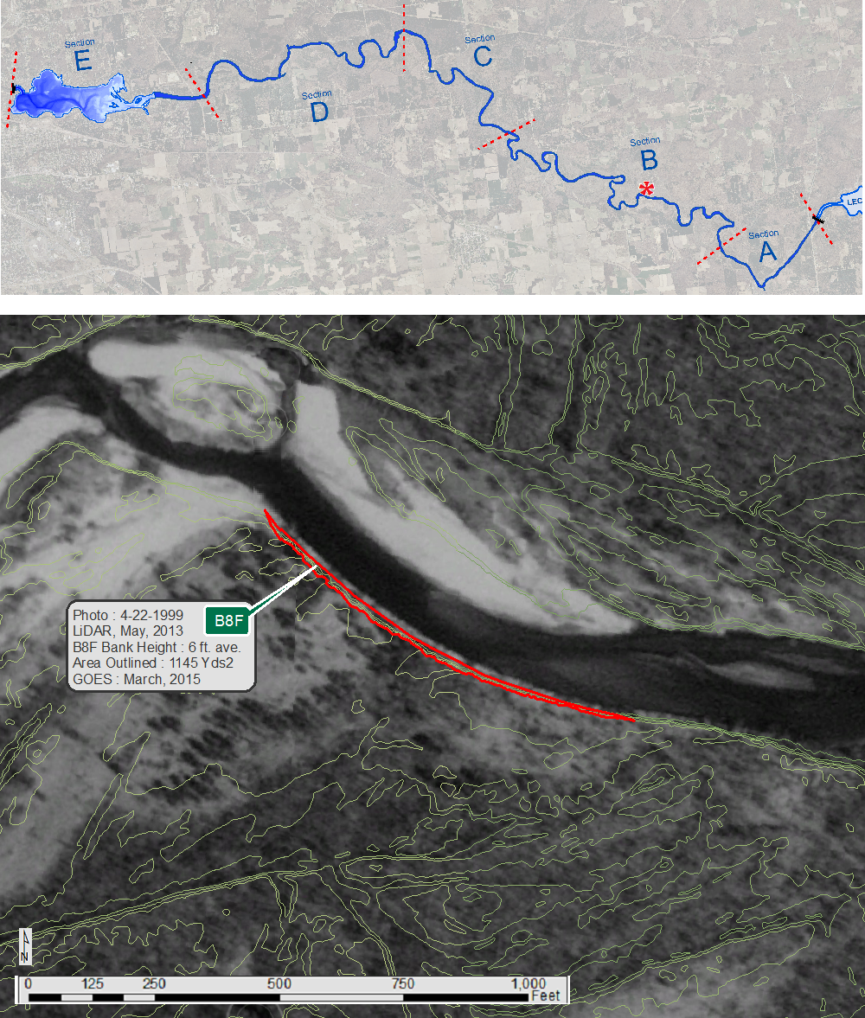
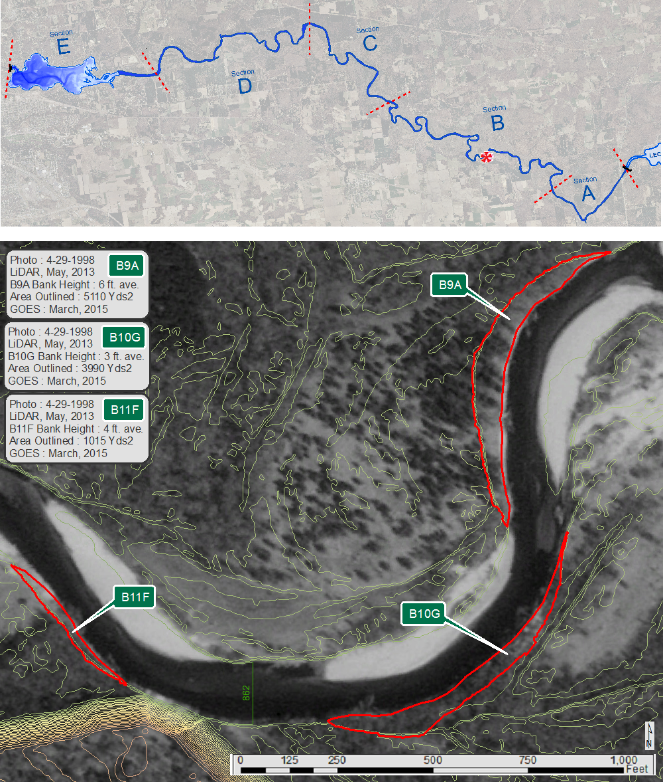
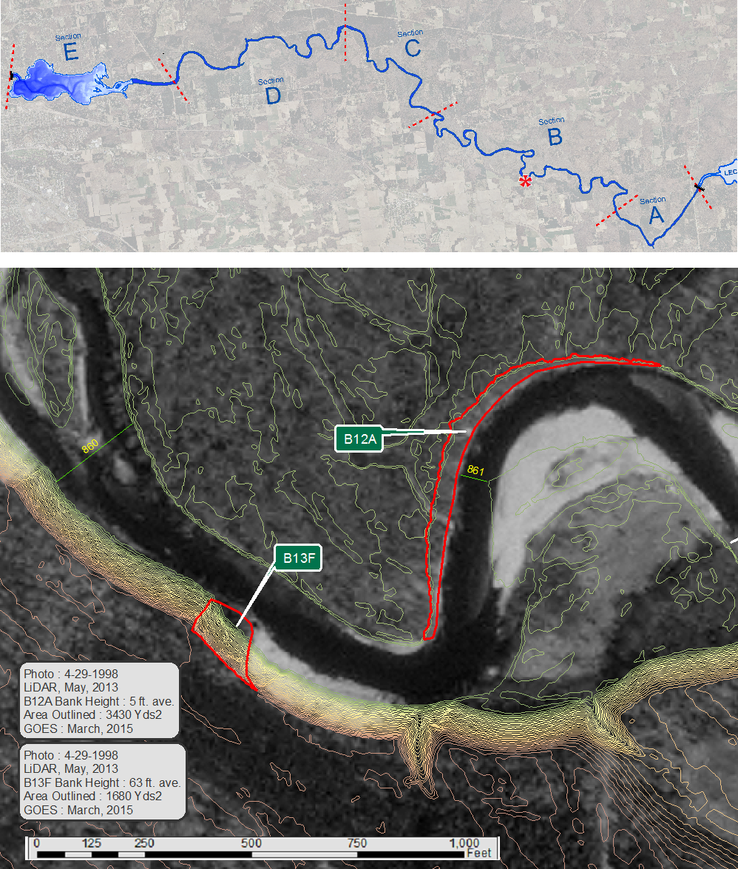

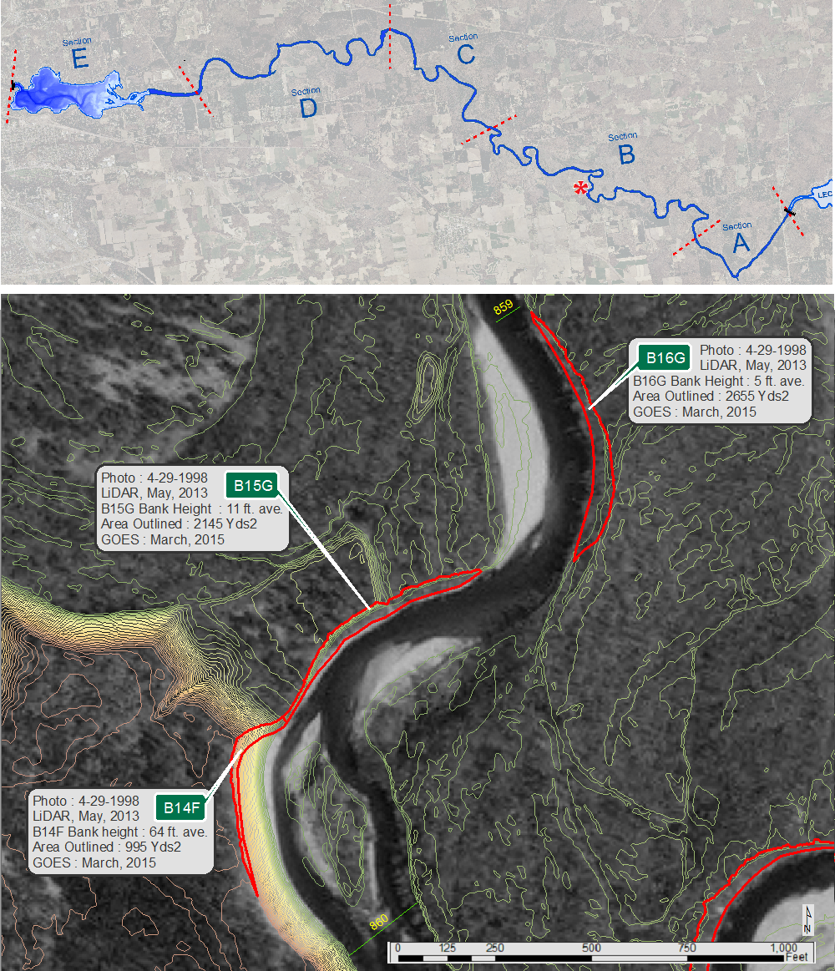

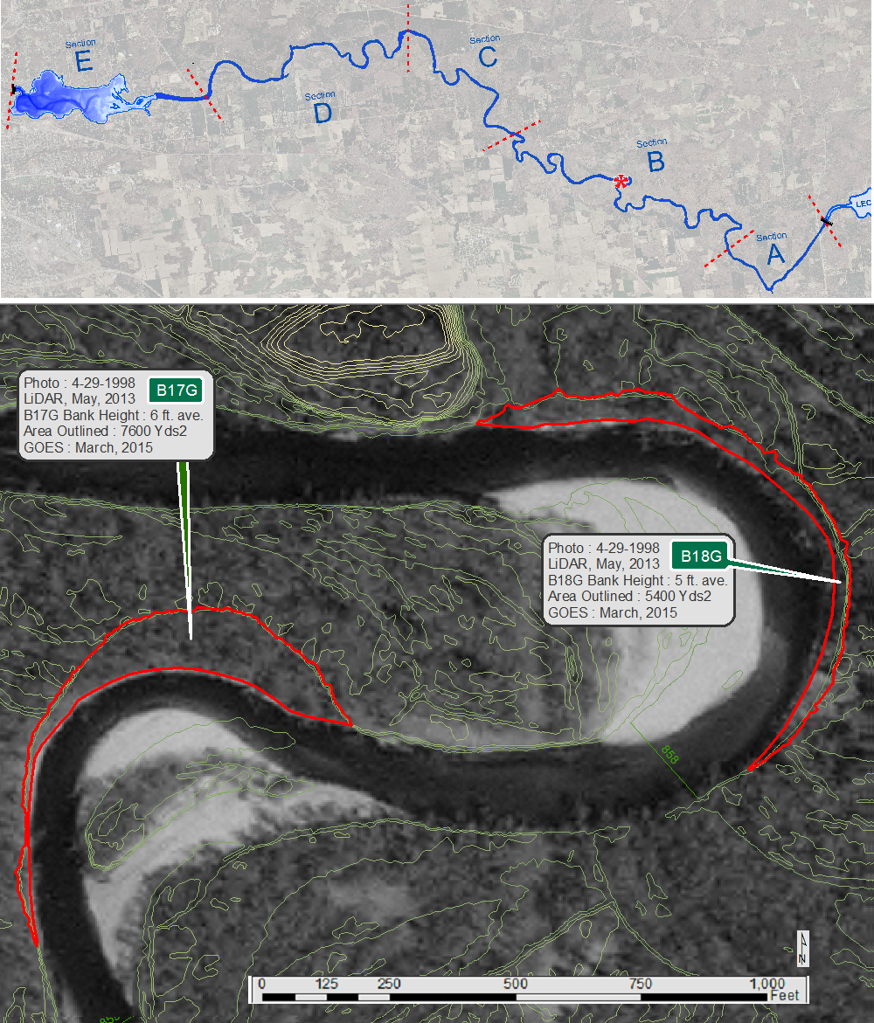
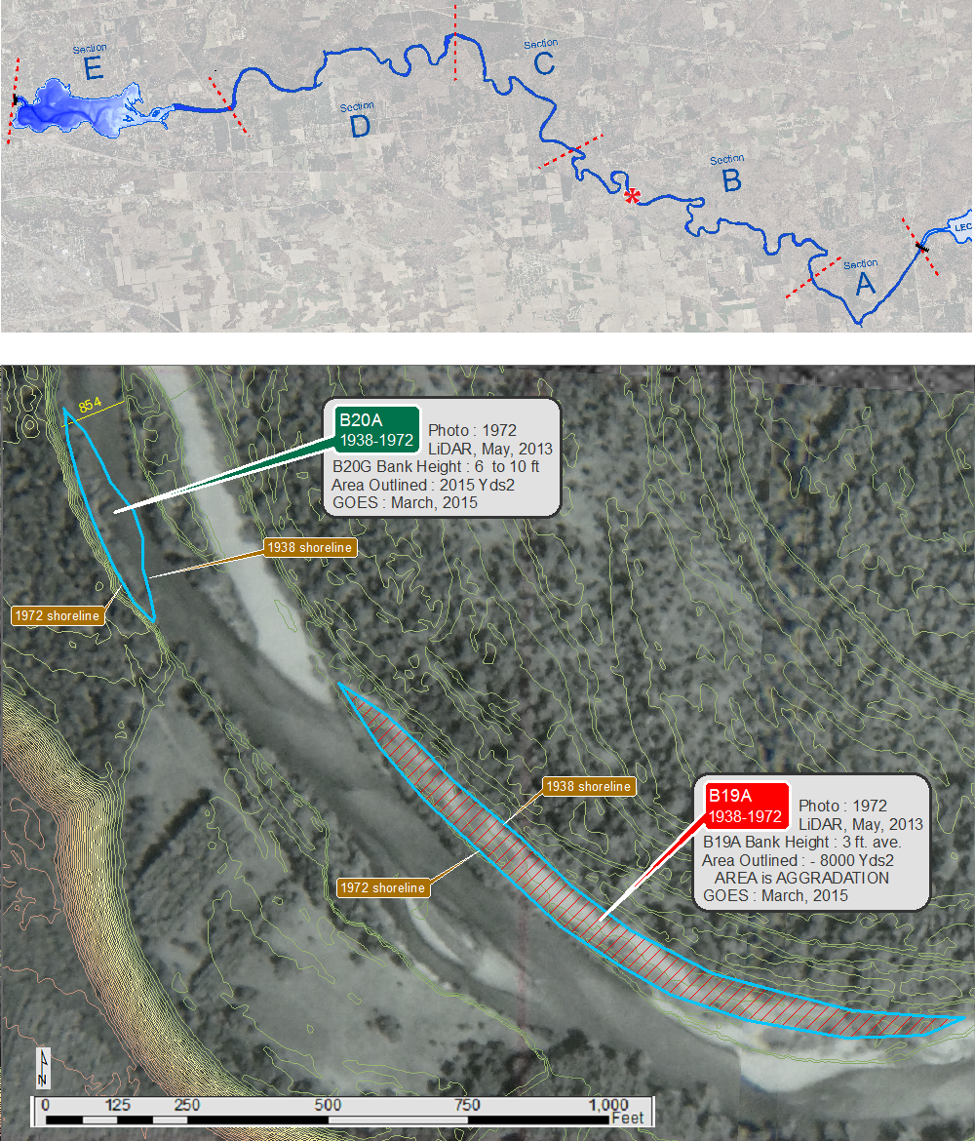
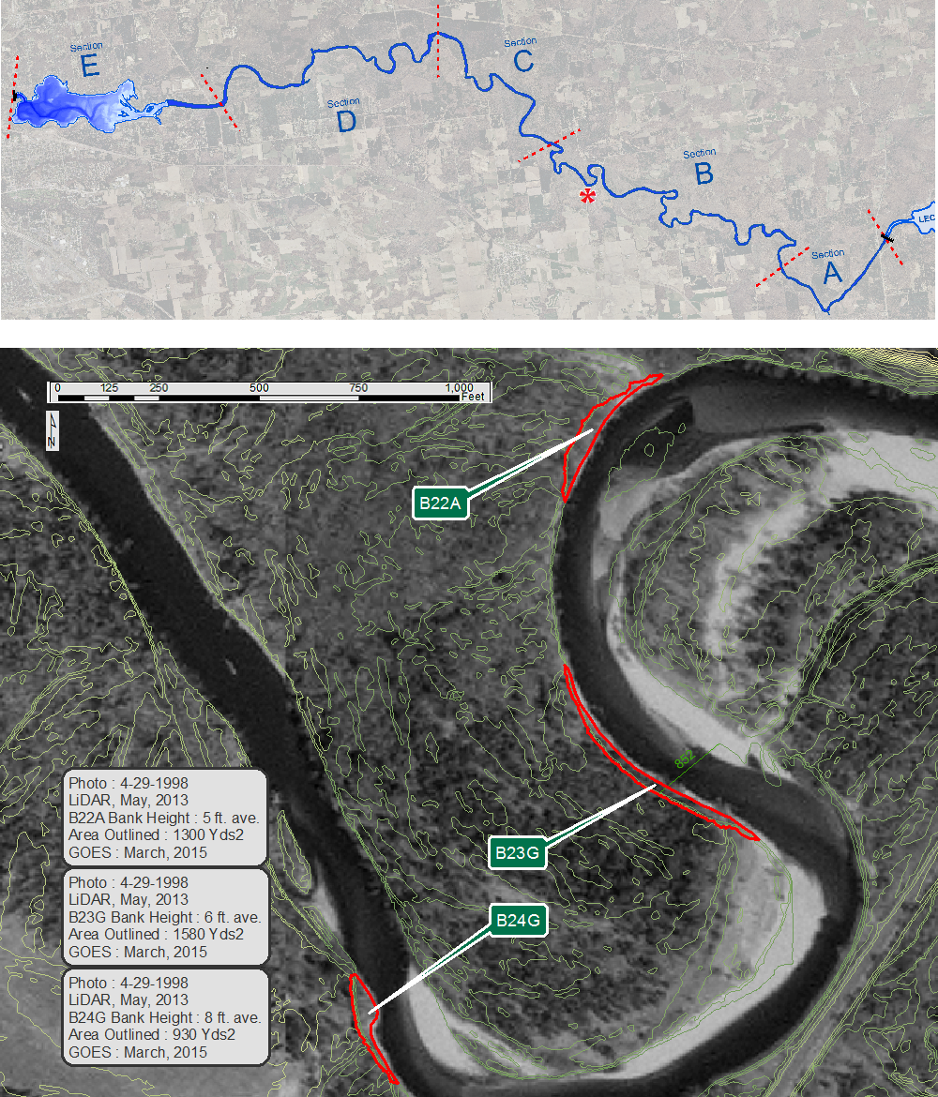

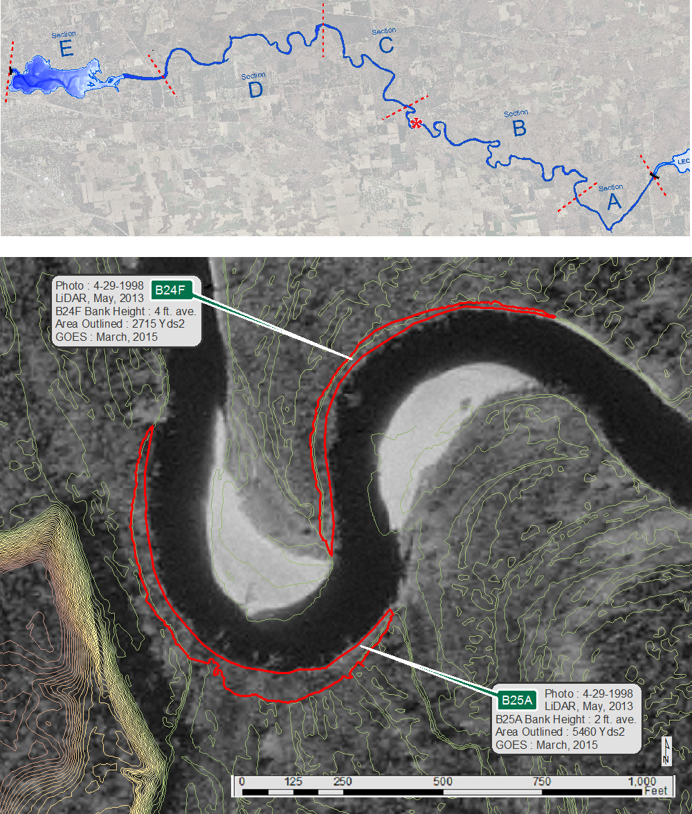

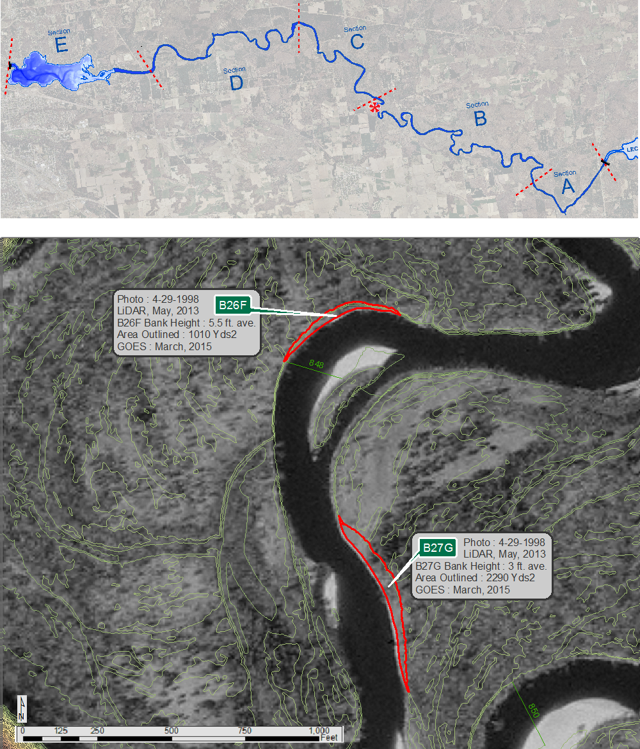
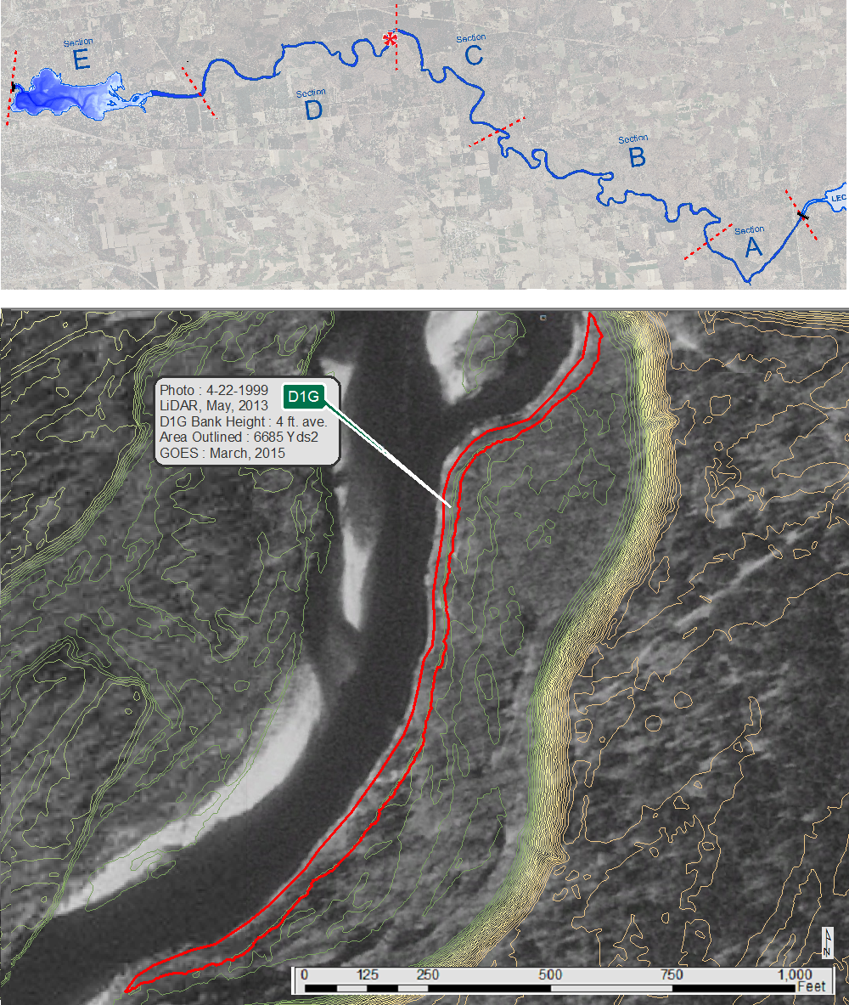
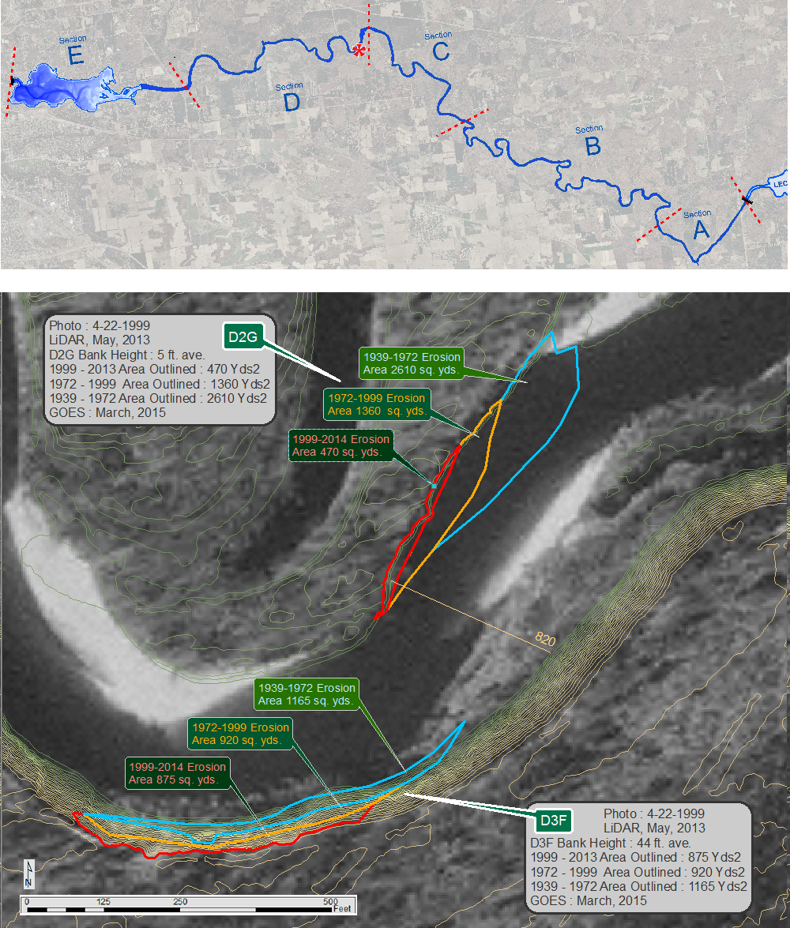
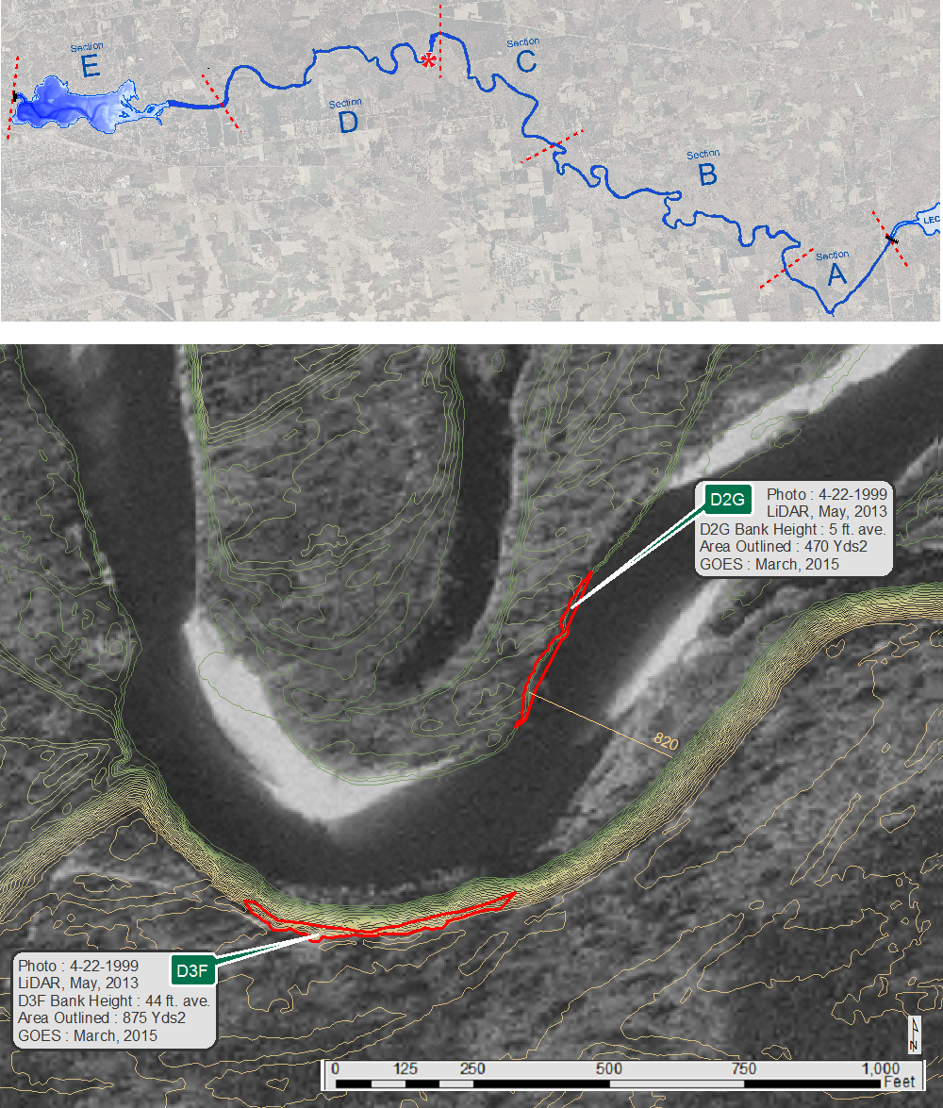

b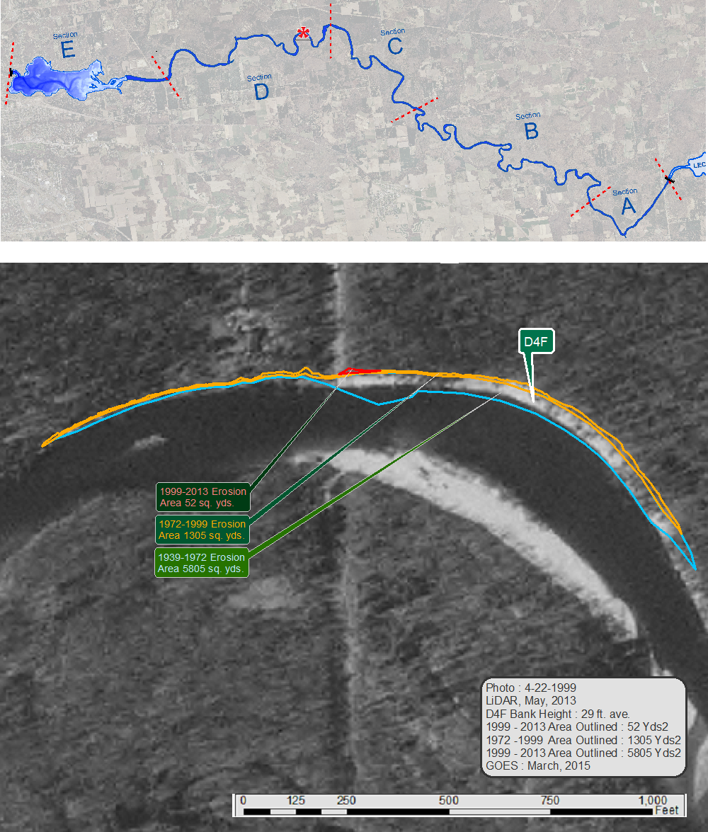
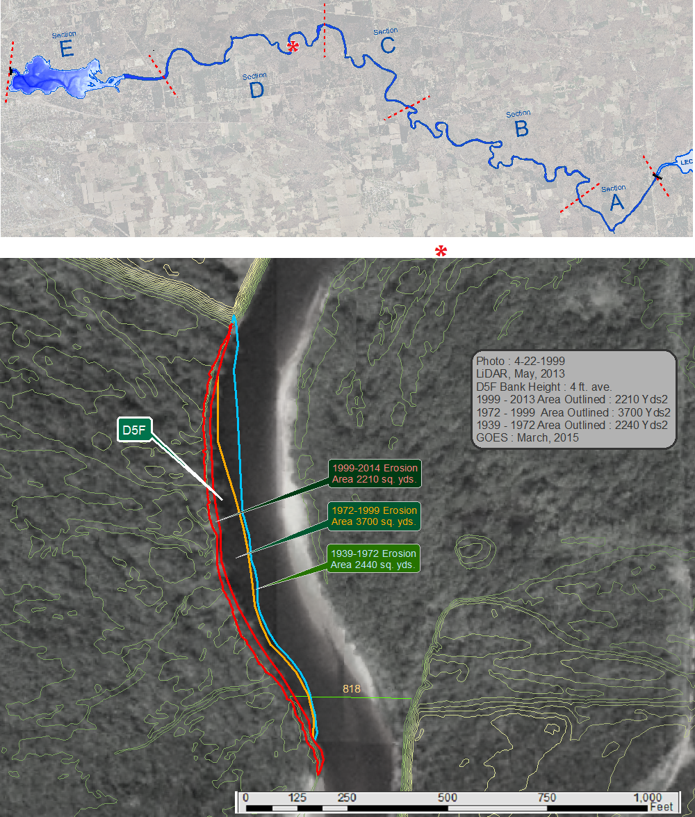
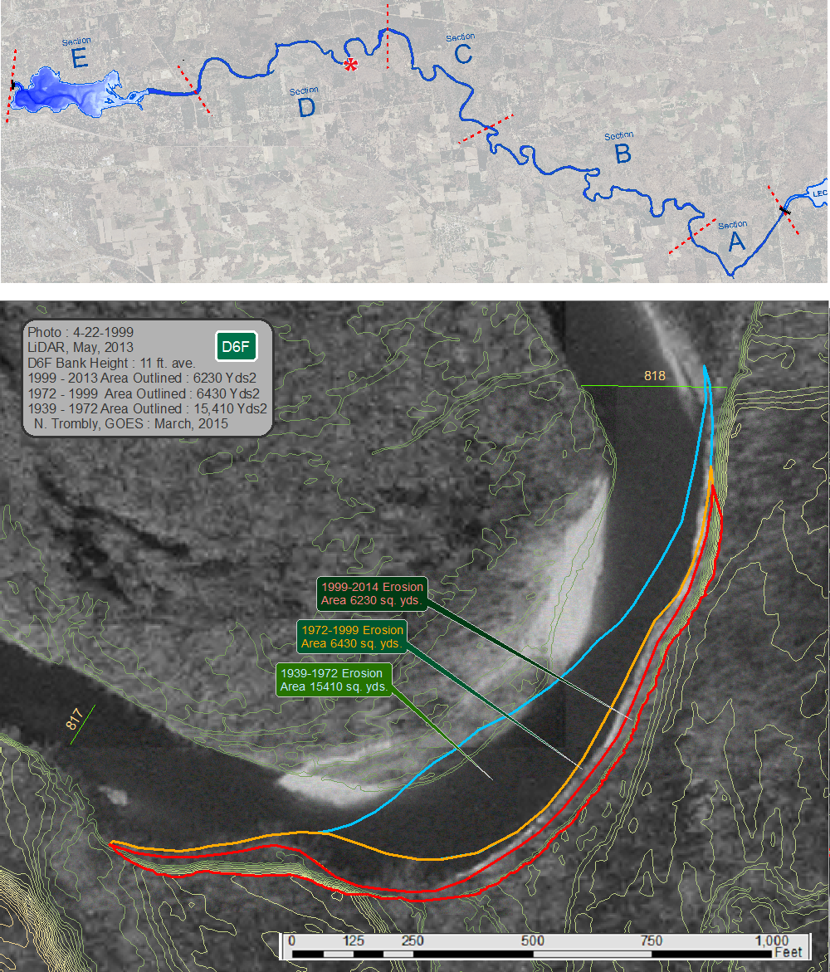

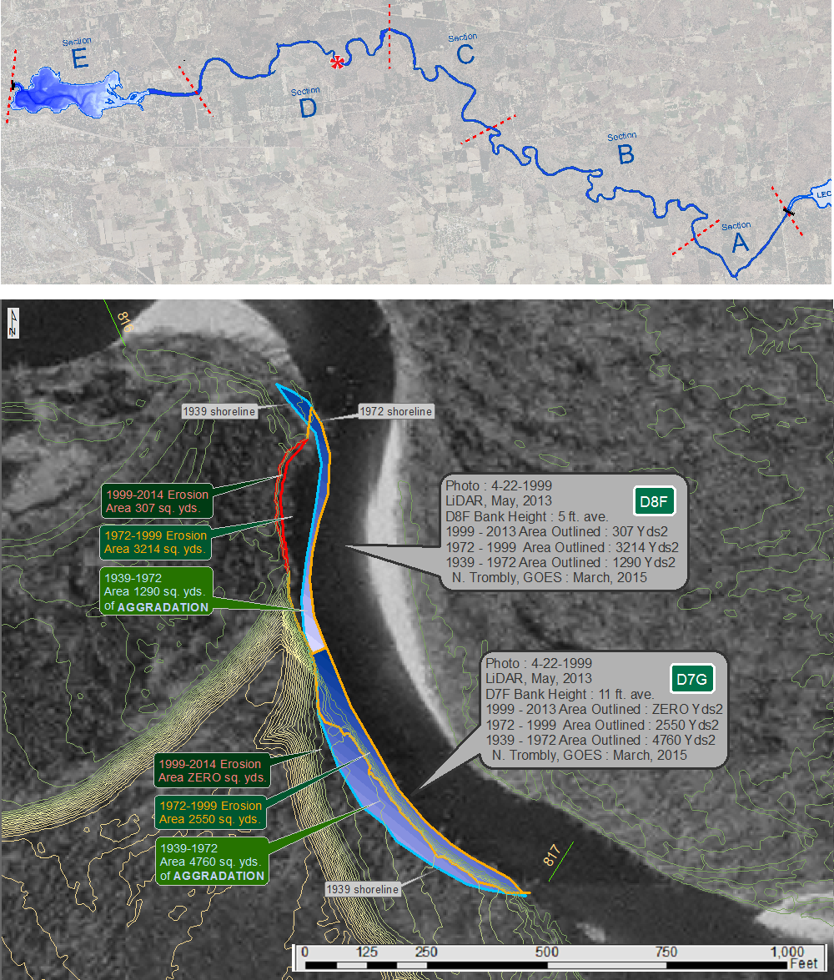

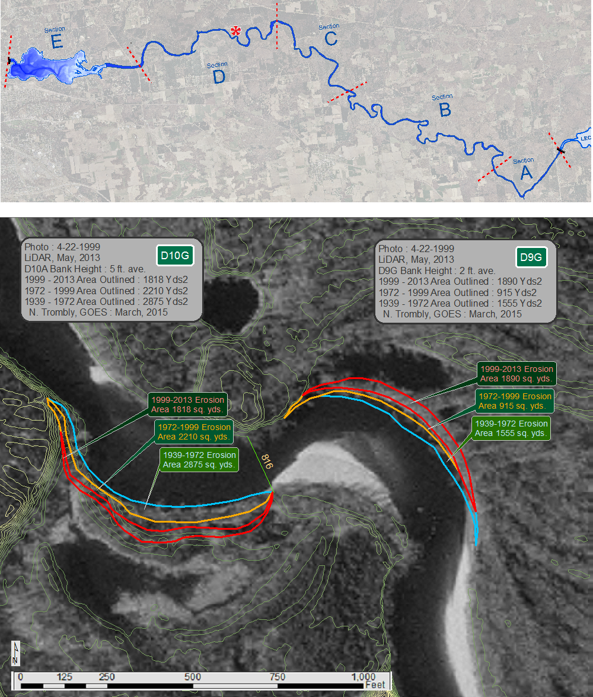

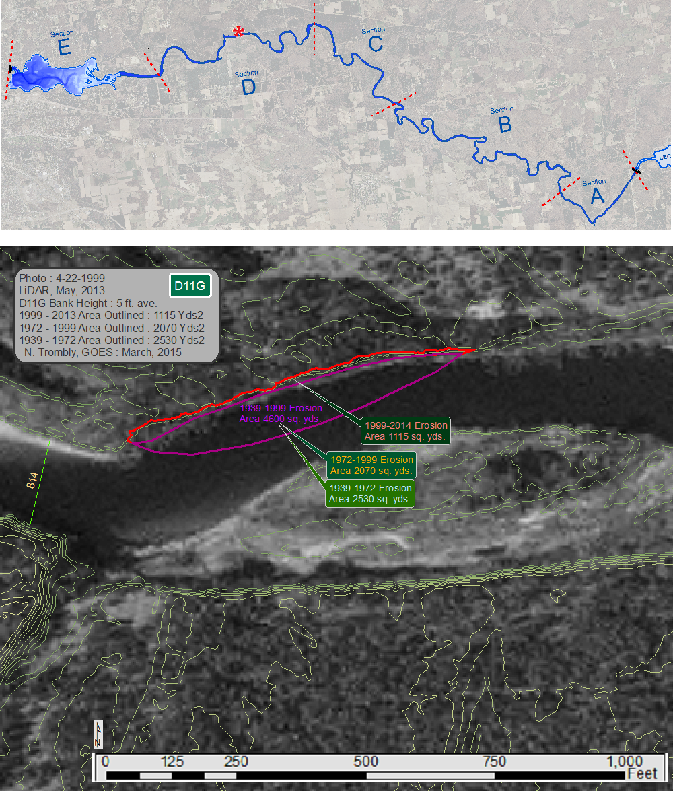
bb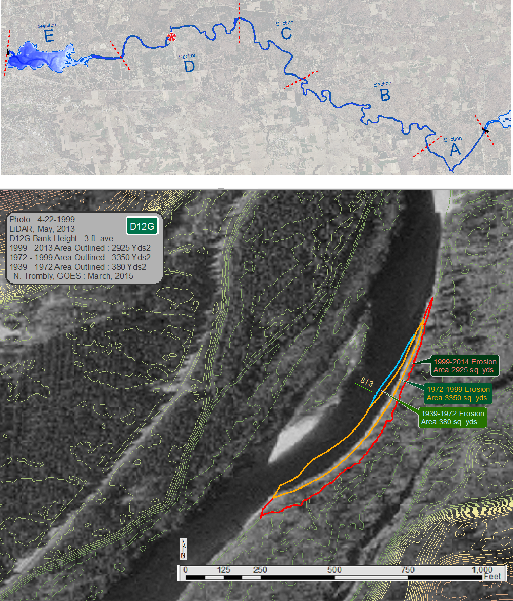

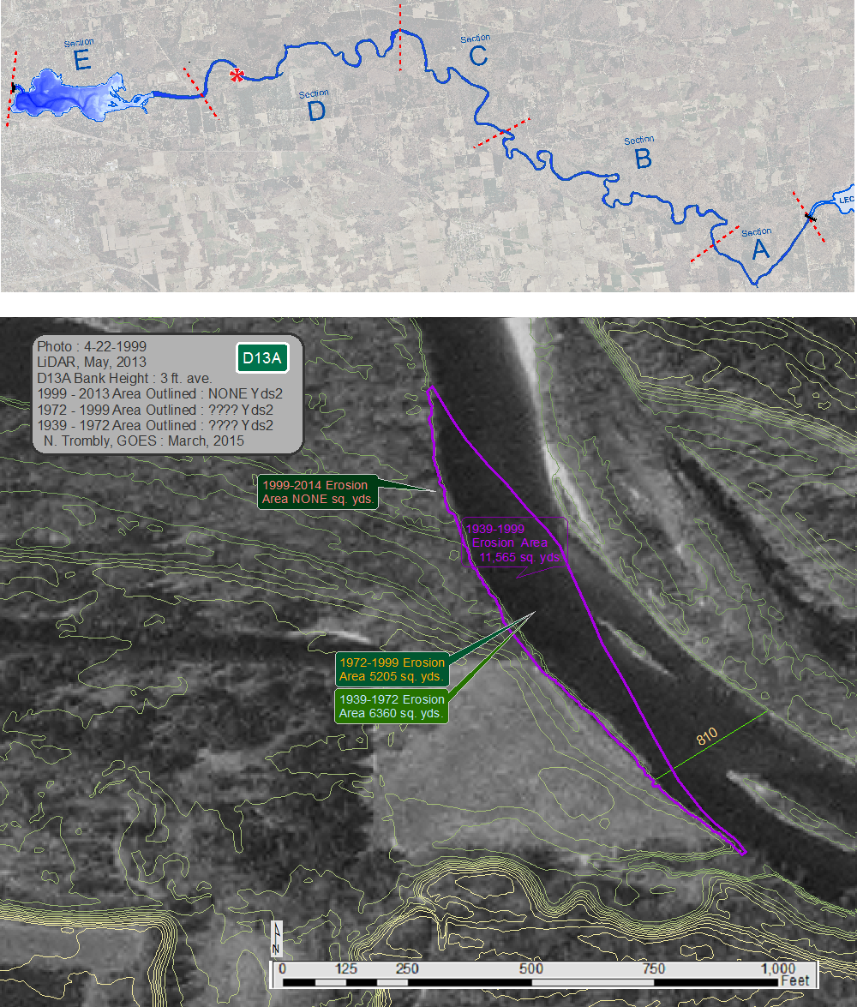

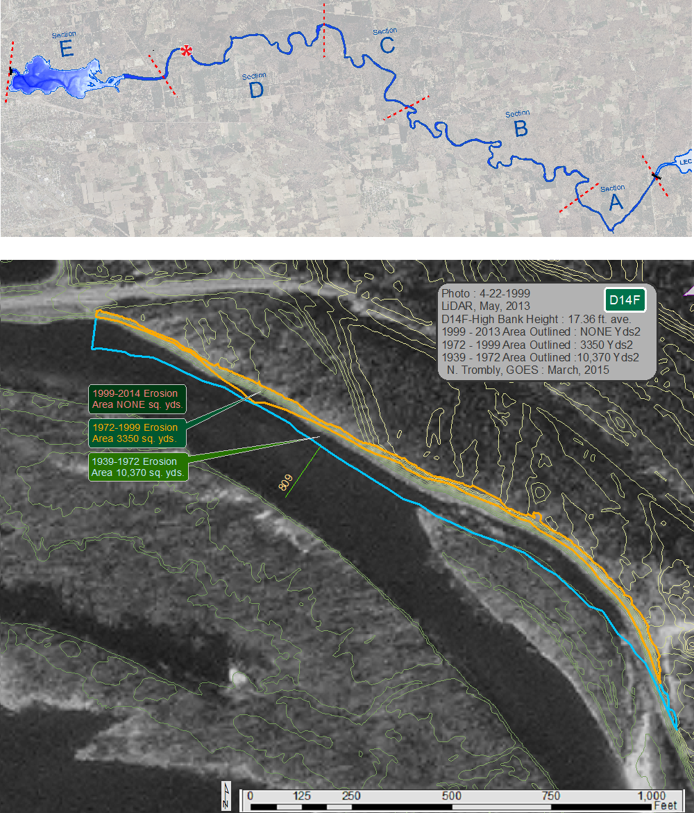
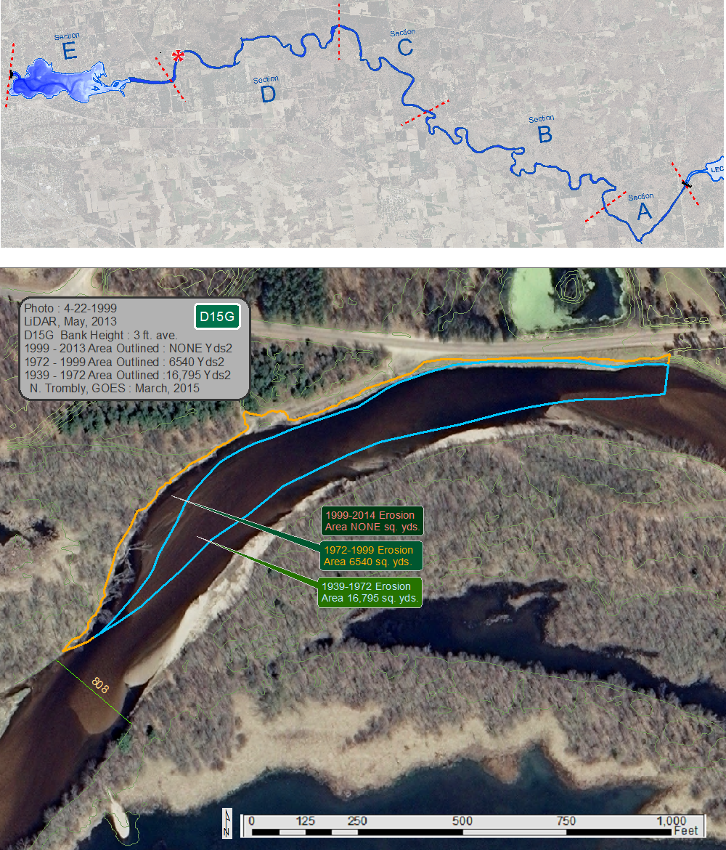

APPENDIX C: Hjulstrom Diagram Plots the Relationship between Particle Size and Energy for Deposition, Transportation and Erosion
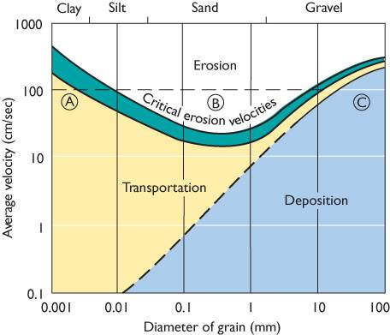

APPENDIX D: Sediment Trap and Dredged Boat Channel from the Trap to the Lake
TBD
APPENDIX E: Identified Potential Sediment Storage Areas Along a Stretch of the Lower Eau Claire River

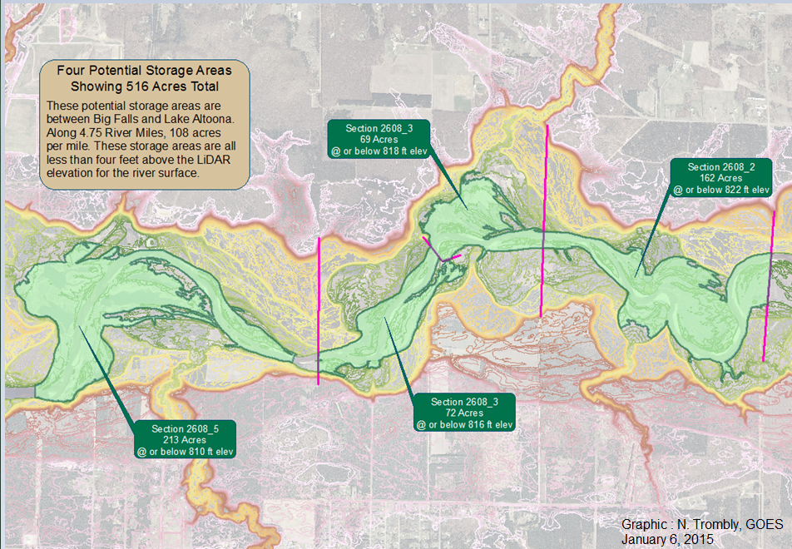
APPENDIX F: Precipitation Trends
F1: Existing Continuous Discharge Rates for Lower Eau Claire River
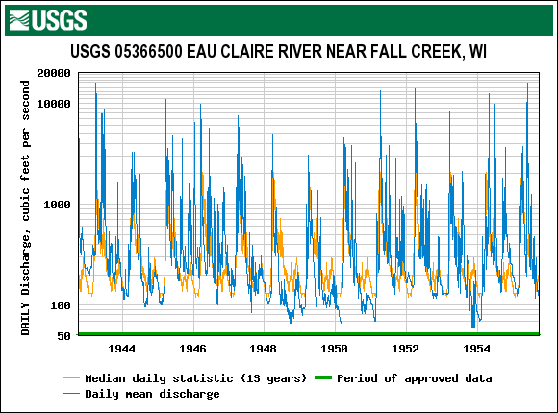

F2: Historical Major Eau Claire River Crests Recorded at Stage Gauge at County Highway K Bridge

F3: River Base flow Trends and Precipitation Change 1950 to 2006
