Habitat Restoration & Reconnectivity of the East Meander Floodplain of Lake Eau Claire

Wisconsin DNR
1300 West Clairemont Avenue
Eau Claire, Wisconsin, 54701
715-831-3272

05/10/2014
Neil R. Trombly
This Wisconsin DNR funded report is intended to become part of the Lake Eau Claire Lake District Management Plan for 2014-2015. This report identifies site-specific low-hanging fruit for habitat protection, restoration and aquatic reconnectivity opportunities within the East Meander Floodplain of Lake Eau Claire. At 524 acres, the East Meander Floodplain is the largest of the floodplains bordering Lake Eau Claire.

Habitat Restoration & Reconnectivity of the East Meander Floodplain of Lake Eau Claire

By Neil R Trombly, WDNR
May, 2014

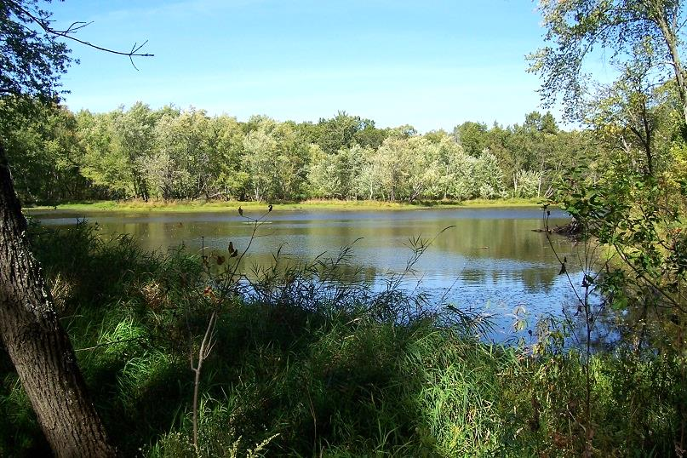
Strikingly beautiful Arrowhead Lake, in the East Meander Floodplain, bordered all around by natural grasses

Habitat Protection Restoration and Reconnectivity
Lake Eau Claire, Eau Claire County, Wisconsin
By Neil Trombly, WDNR, 2014
Introduction : This Wisconsin DNR funded report is intended to become part of the Lake Eau Claire Lake District Management Plan for 2014-2015. The abstract for this report will appear elsewhere in the larger report but this paragraph contains key elements of the abstract. The purpose of this report is to identify the riverine floodplain and channels that can most easily be reconnected to Lake Eau Claire and the Eau Claire River for habitat protection and restoration. The East Meander Floodplain is the largest of the floodplains bordering Lake Eau Claire; it covers 524 acres (Figure 1), which is more area than the other three combined. Log jam formation has caused infilling and sequential abandonment of previous low velocity main river channels in favor of a far shorter and higher velocity main river channel. Attendant consequences include loss of connectivity with spawning, fisheries, avian and terrestrial wildlife habitat. Also compromised are nutrient

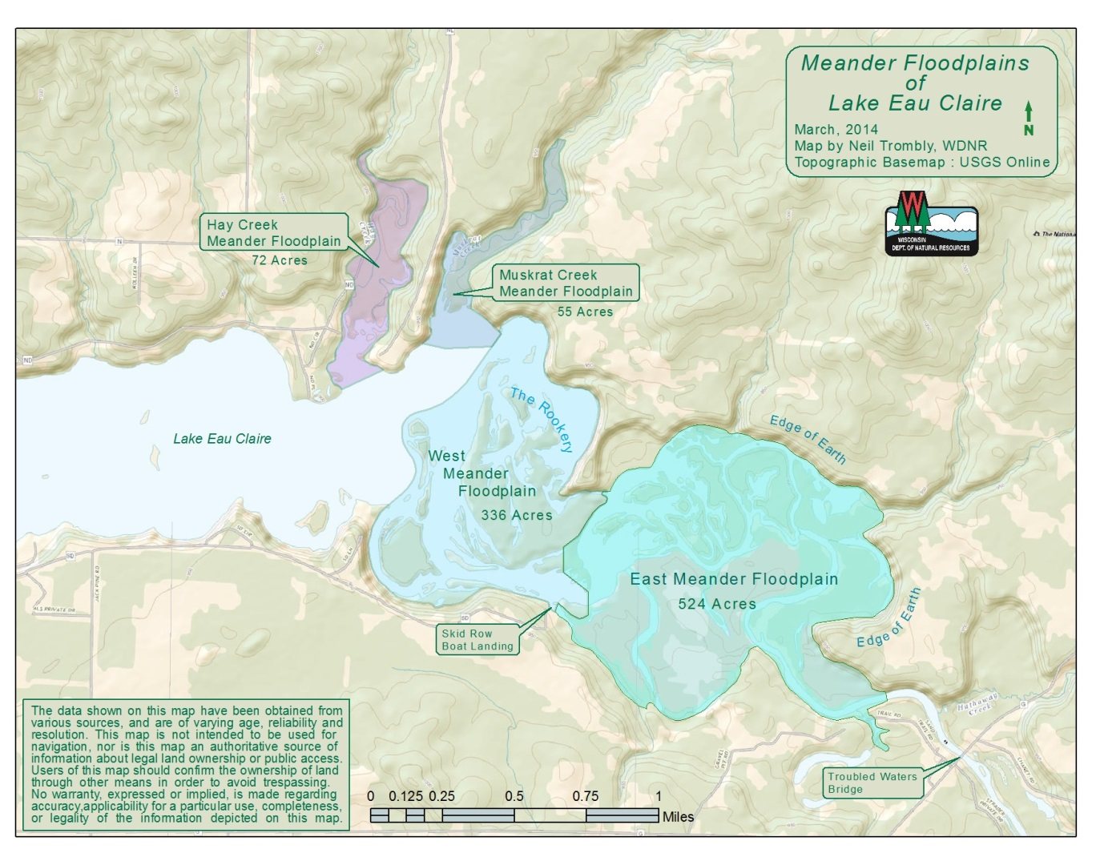
Figure 1 The Four Meander Floodplains of Lake Eau Claire. The East Meander Floodplain is the arena for this report.
sequestration capacity, water quality, nearshore and upriver navigability. Also unfolding is an imminent threat of rapidly infilling 200 acres of lake shallows and islands in the northeastern part of the West Meander Floodplain known as the Rookery (Figure 2). Although this report is specific in all instances, a floodplain is a moving target and the projects and logic described here are intended to be representative of plausible actions rather than static proposals. Stated acreages impacted by individual projects (Figure 52) are speculative because every project, sooner or later, impacts the entire 524 acre floodplain.

The East Meander Floodplain of Lake Eau Claire is located between the Skid Row boat landing and Troubled Waters Bridge on County Highway G. The floodplain consists of 524 acres of poorly consolidated river-transported sand deposition. It is surrounded on three sides by well-treed steep banks of long duration in their present location rising fifty or so feet to plateau highlands. On the fourth side, to the south, the transition to higher elevations is more gradual and less clearly defined. Nearly all of the floodplain consists of and is surrounded by county forest lands open to recreational use. A few privately owned properties border the floodplain on the south bank of the Eau Claire River near the Troubled Waters Bridge. 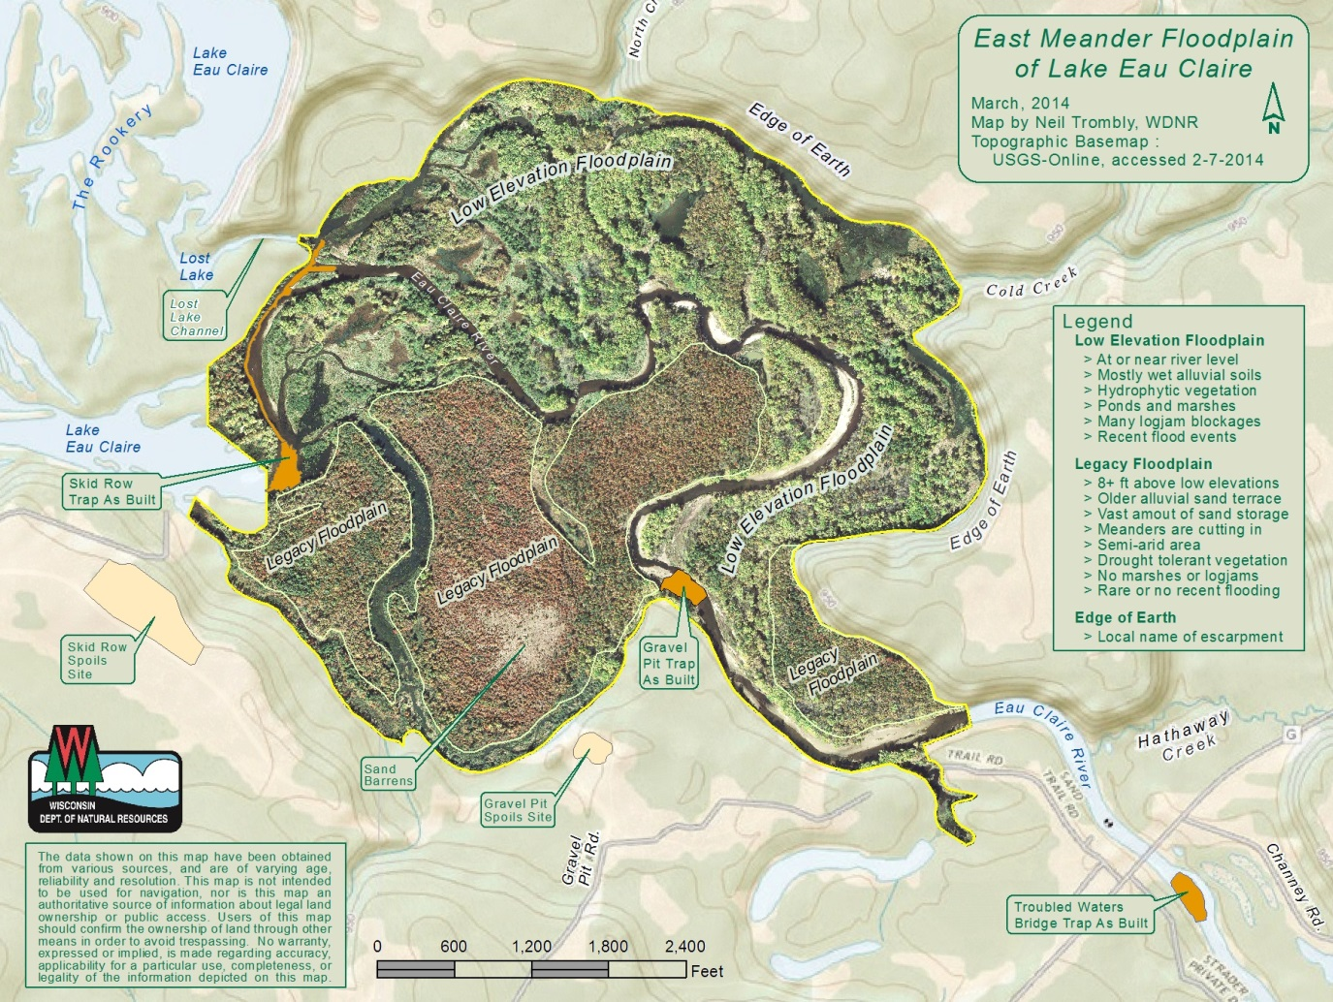
Figure 2 This map shows the topographic setting of Lake Eau Claire’s East Meander Floodplain. Note the steep slopes (Edge of Earth) rise fifty or more feet in an arc from northwest to southeast. Topo-lines are spaced by 10 foot changes in elevation. Lake level is a nominal 900 feet, depending on where the impoundment dam gates are set. (USGS shaded online topographic base layer, accessed 2-07-2014, has been heavily modified for clarity and use in this report.)
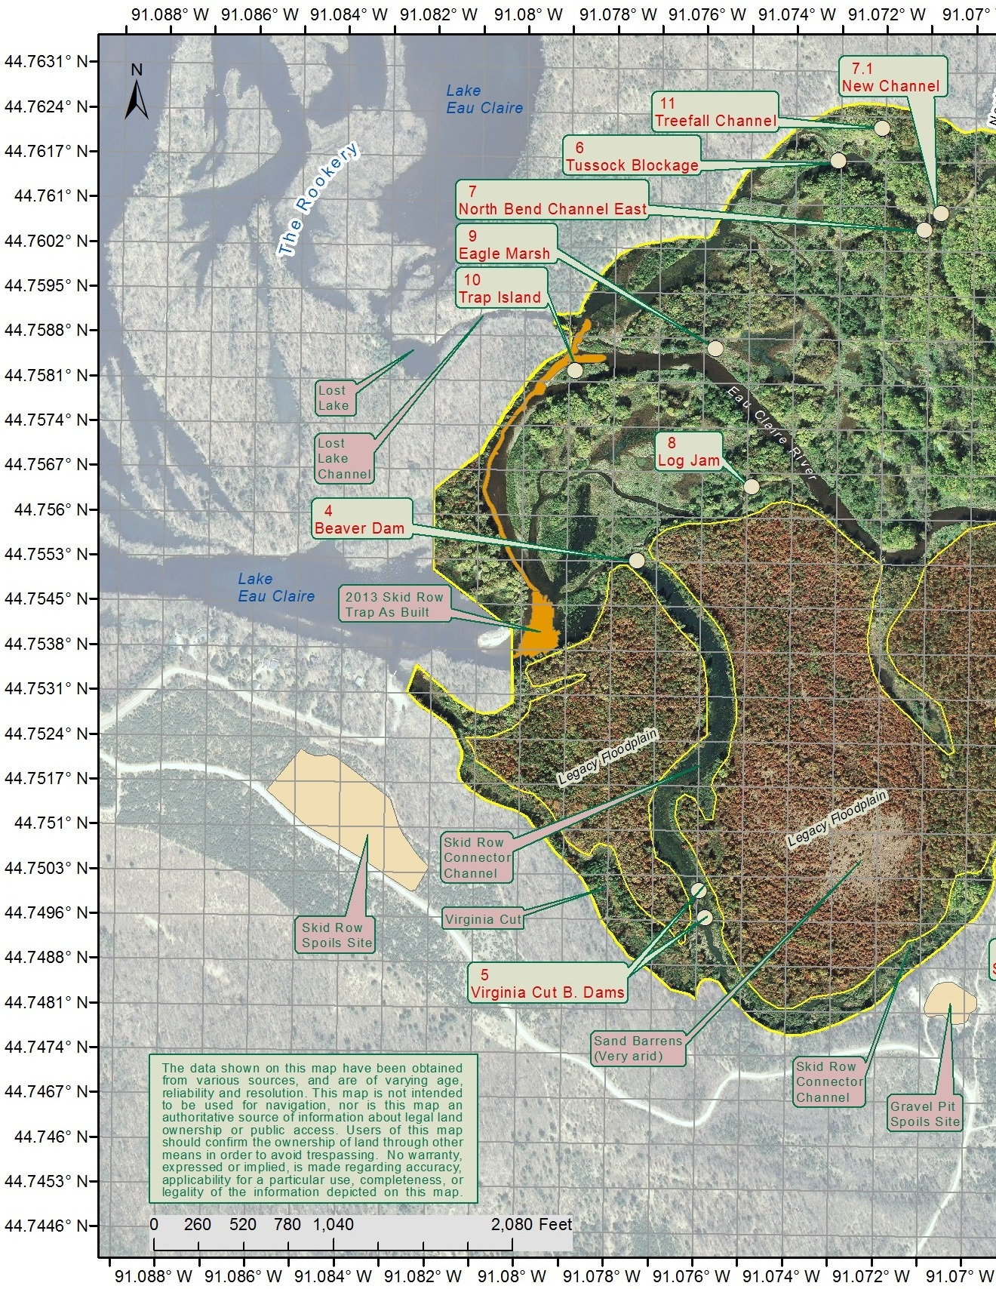
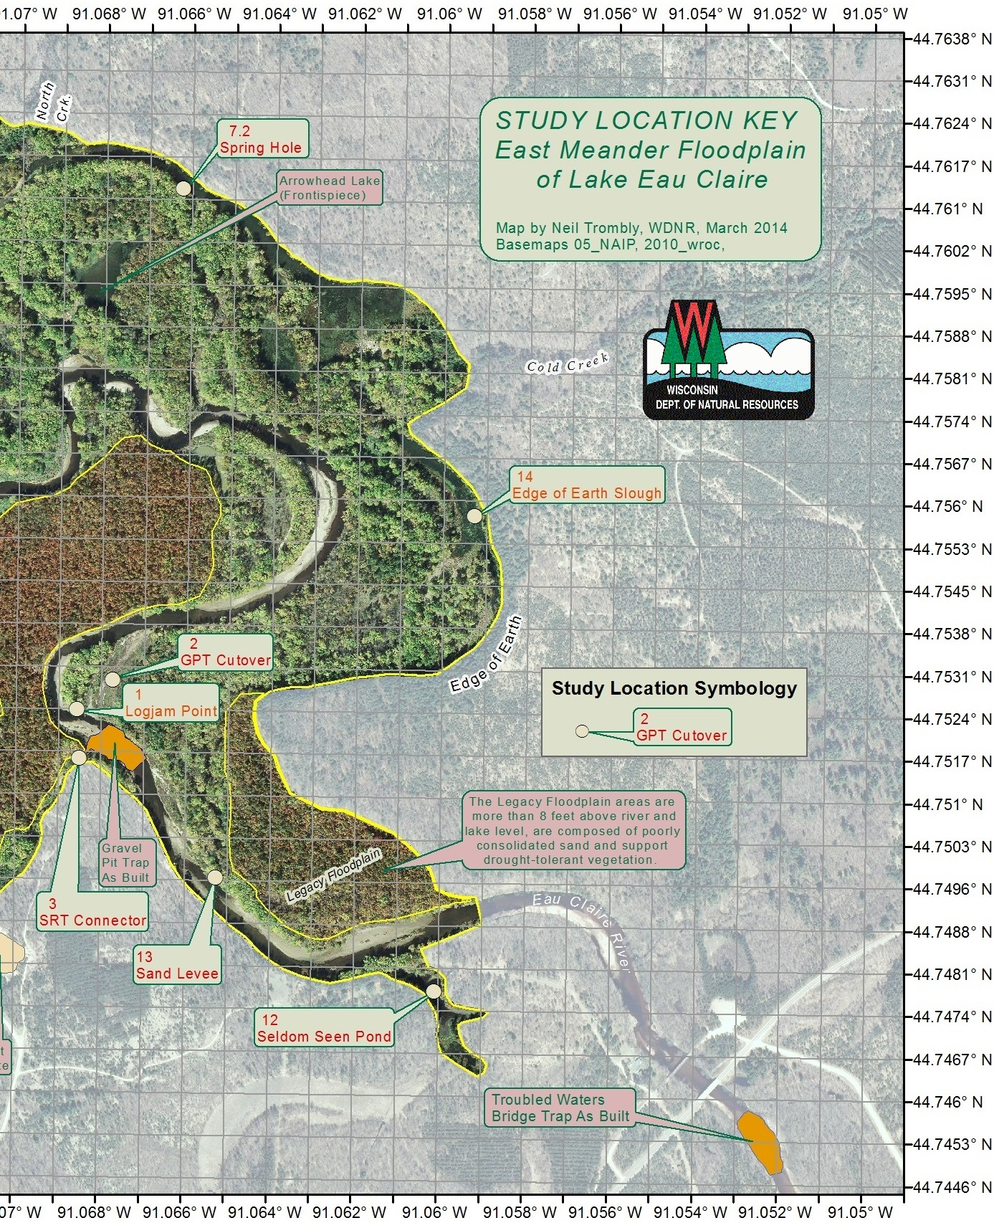Figure 3 BASEMAP. This map shows shows decimal degree locations of worksites within this report. Sites are both named and numbered for ease of reference. Numerous photos within the report also reference sites on this basemap. Although the Legacy Floodplain (showing a brownish tint) is droughty and several feet higher in elevation, it is still a quintessential part of the East Meander Floodplain because it is far closer to river level than the surrounding bluffs and presents real risks to the entire floodplain from possible erosion of large quantities of sand into the river which would then fill in lake and lowland areas and/or allow severe shortening of the main channel. These risks need study and management. Aerial digital ortho photograph base imagery is from 2010 WROC. Note: An additional graphic and table gives acreages of selected areas. See Figures 51 and 52 at the end of this report.

The East Meander Floodplain (the whole area within the outer yellow line in Figure 3) has two distinct elevations. The Low Elevation Floodplain (Figure 2, greener area on map) consists of 358 acres of nearly lake-level and river level marsh, cut off meanders and isolated ponds scattered among low lying lands spread out in a wide and almost U-shaped arc from Skid Row over to the high steep banks a mile to the north and east known locally as Edge of Earth. The more elevated areas, here called the Legacy Floodplain (Figure 2), are higher by 8 or more feet above mean river level and cover 166 acres (Figures 51 & 52) of droughty, older sand depositions. Legacy Floodplain areas are designated by the three outlines brownish areas on the Figure 3 map within the south portion of the floodplain. The brownish color of these areas is photographic and is due to the coloration of drought-tolerant vegetation. The Legacy Floodplain is of great interest and concern in that it holds an enormous amount of poorly consolidated sand which is best managed by assisting it to remain in place for as long as possible.
CONTEXT OF WORK UNDERWAY : Thirty years ago the entire Low Elevation Floodplain (shown as greener vegetation areas in both Figure 2 and Figure 3) had broad open water connections to Lake Eau Claire. Since then the Low Elevation Floodplain has been hit by chaotic and long-enduring logjams that recruit additional sand. Incoming bedload sand has filled extensive areas that were formerly open lake and open channels. The result is that numerous small lakes, ponds and marshes have come to exist that are aquatically and ecologically poorly connected or effectively disconnected from Lake Eau Claire except when inundated by flood events. Fish and other aquatic life trapped in or near these now isolated waters have no accessible place of refuge when water levels fluctuate too low or when ponds freeze solid in winter. Consequently, the Low Elevation Floodplain is no longer able to serve as the valuable fish, aquatic and wildlife habitat and nutrient buffer area it once was. Water quality, ecosystem and recreational use of the remaining contiguous area of Lake Eau Claire has been adversely impacted by loss of this large area of valuable habitat.

LAKE EAU CLAIRE MANAGEMENT PLANNING: Numerous management activities have been and are in progress for the improvement of Lake Eau Claire. Most relevant to this report is the installation in 2013 of three sediment traps to capture bedload in the Eau Claire River and thereby favorably alter river and floodplain dynamics. The most upstream is the Troubled Waters Bridge Trap (TWBT). The Gravel Pit Trap (GPT) is in the center of the floodplain north of a former Gravel Pit and the elongated Skid Row Trap (SRT) is north and east of Skid Row along the western edge of the East Meander Floodplain. These traps, if properly maintained, propose to halt further infilling of the lake and deepen the main river channel through the floodplain. Deepening the channel will fundamentally increase the channel’s capacity to handle flood events at lower, less erosive velocities and allow side channels, over time, to once again cut deeper and reopen connections to valuable habitat. Sequential removal of logjam and other blockages will assist the side channels to deepen and clear out accumulated sand.
VELOCITY REDUCTION – PRIORITY ONE : The most effective and overarching tool available to us for reducing river erosion and transport of sand into Lake Eau Claire is reduction of river water velocity and associated turbulence. There are various ways to do this. One way is by installation and maintenance of sediment traps which deepens the river channel over time. One reason this works is that a deepened river channel at any given discharge to the same lake level can and must deliver its water at a lower velocity. Another tool is to let rising but still channelized river flow make sooner use of currently log-jammed side channels. Another tool is to lower or breach natural levees which lowers the threshold at which flood stage waters begin to utilize the entire floodplain which, in turn, vastly slows adjoining water velocities, even in the main channel. Water velocity reduction is key because total river energy does not by itself dislodge and transport sand and gravel. It is the velocity component of a river’s total energy that dislodges sand and gravel. Once dislodged, total energy (work capacity) of the river comes into play, but even then, if velocity is lowered enough, the river’s energy will pass harmlessly by and transport very little previously dislodged sand or gravel. Likewise, if the channel is constricted (think of using your thumb to close off the end of a garden hose) velocity is greatly increased. We cannot control the river’s total energy here, but velocity will be lowered if the water volume of the channel (think size of the pipe) is increased.

DEFINING LOW-HANGING FRUIT: The term ‘low-hanging fruit’ has a dictionary definition:
1. the fruit that grows low on a tree and is therefore easy to reach 2. a course of action that can be undertaken quickly and easily as part of a wider range of changes or solutions to a problem. As defined here, the term ‘low-hanging fruit’ is useful in describing some aspects of current management activities but is inadequate. In this endeavor, the low-hanging fruit should also be clearly identified by a sequenced and circumspect plan and be firmly managed but also highly amendable with changing circumstances and resources at hand.

In general, downstream work should to be sequenced before upstream work because opening upstream obstructions before removing downstream obstructions may have unintended consequences – the course of the river might even change abruptly during a high water event unleashing a wave of sand and/or downed trees and logs. The abundance of potentially mobile logjam material and easily mobile sand makes this scenario plausible. Some upstream actions may appear to be low-hanging fruit when in reality there are many things to do first before pulling this or that particular plug.

LOGS ARE THE MAJOR PLAYER HERE: There are beaver dams and dense tussock grasses blocking off channels. However, these are minor players. The major players in disconnecting Lake Eau Claire from its best fisheries and habitat are big logs, and a lot of them. Why these logs appeared in recent pulses that drastically obstructed many channels in the East Meander Floodplain is speculative. Removing massive logjams composed of massive logs is under consideration at various levels but is not part of the 2014 – 2015 Lake Eau Claire Management Plan.

PERMITTING: All navigable waterways are under WDNR jurisdiction. The WDNR has indicated that the clearing of log jams from navigable channels of the Lake Eau Claire floodplain have the following issues:
  - Removal of recent logjams from navigable waterways, by hand, as they occur, does not require a permit.
  - Removal of existing logjams from navigable waterways, by hand, is acceptable without permit.
  - In either case above, approval of the riparian owners, in this case, Eau Claire County, is required. (Riparian owners are those with title to the adjacent riverine shoreline.)
  - Disposal of hand-removed logjam material on high ground in already forested land, with riparian approval, is acceptable.
  - If removal and transport machinery is used, then a dredging permit is needed.
  - If removal and transport machinery is used, then a narrative of disposal plans, in this case, disposal of log spoils within the county forest on already forested high land needs to be included in the permit application.

PHOTO DOCUMENTATION: Because permitting issues exist, all formal removal activities in the wetland should have a minimum of five GPS-referenced photos taken:
1) Before removal actions begin.
2) During removal work in progress (to document whether by hand or by machine).
3) After removal actions have ended (taken from about the same location as photo #1).
4) Disposal site before spoils are placed (or disposal truck with lettering visible).
5) Disposal site after spoils placed (or other documentation of where spoils were trucked).
REPORT STRUCTURE :
As a preliminary study, this report recognizes that there are multiple ‘first’ things that can and should be done in the complex restoration work that has been undertaken. Because there are multiple and relatively independent sectors of activity, this report will leave detailed prioritizing to future discussions. To avoid arbitrary ordering within the Suggested Management Actions section that follows, priority of presentation will be guided by the following factors:
- Timely defensive actions, depending on the threat level involved, should be given priority. Timely intervention, no matter where, to halt serious and/or worsening situations is most always less costly and easier than trying to correct them. An example would be the prompt removal of a new logjam before it so fills with sand and woody debris that it becomes resistant even during flood events.
- As mentioned previously, downstream projects should prioritize before upstream projects because opening upstream flows before removing downstream obstructions may result in unintended water diversion. It is assumed that removing obstructions that are already close to lake level and near open water of the lake are the most risk free actions that can be taken.
- The listing that follows will be designated by a leading number followed by a letter or letters among three categories:

  - R = Reconnectivity and/or Habitat Restoration
    - includes actions favoring fish and aquatic life habitat which then improves avian and wildlife feeding opportunities.
  - E = Erosion Control
    - includes actions that are intended to reduce river velocity
    - includes actions that are intended to reduce turbulence
  - S = Additional study may be needed before taking action

- Map Naming Convention: This report will use anecdotal names of features as they best fit in. For instance the anecdotal, Edge of Earth, describing the upland perimeter of the floodplain is too descriptive to not use. This report will also unabashedly invent and use place names as needed. To speak of ‘this channel’ and ‘that island’ has proven frustrating even between persons who know the floodplain from end to end. Most names invented for this report are highly descriptive rather than imaginative and can be used or discarded outside this document as people see fit.
  - Slough and hole are historic and popular terms around this wetland. They will be used as feature names that apply only to the ponded water extent of features that actually contain water most of the time.
  - Stream cuts with minor or intermittent residual streams will be called connection or cut.

Suggested Management Actions 2014:
Project 1-E Remove the channel-blocking extent of the Logjam at GPT (Spring, 2014)
-91.068567 44.752274 Decimal Degrees

Erosion Control : Two hundred feet downstream of the centrally-located Gravel Pit Trap a logjam at Logjam Point constricts and thereby increases the velocity of the river against the river’s left bank making the river a more effective tool of erosion. In addition, the blockage directs swirling vortices toward the cut bank which also increases the erosional focus of the river. (A cut bank is the outer bank of a bend in a river and is usually opposite a feature called a sand point bar.) This logjam has recently redirected the river’s energy to cutting directly westward. As the bend sharpens, erosion will quicken. The cut bank erosion recently removed the land whereon a logging road once ran Figure 6.
Removing the stream-blocking aspect of this logjam is an important step toward shutting down a plausibly existential threat to the East Meander Floodplain. The threat is this: There is an old cut, Legacy Cut, which starts just 275 feet to the west of the current cut bank face. Legacy Cut is deep, evidenced by its pond despite the sand environment. If current erosion rates go unchecked the river will soon breach to Legacy Cut and attain a far steeper transit gradient by a factor of 4x.

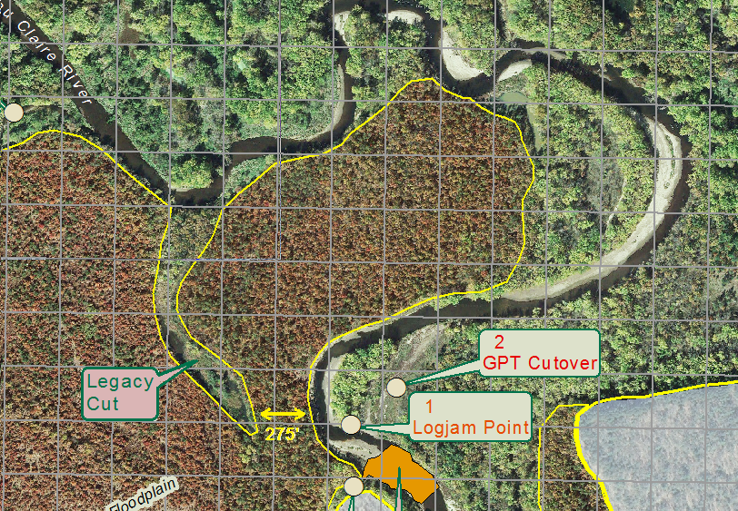
Figure 4 Only 275 feet of elevated land remains to prevent a drastic shortening of the river at a point of high erosion. See the Figure 3 basemap for the location of this map snippet.

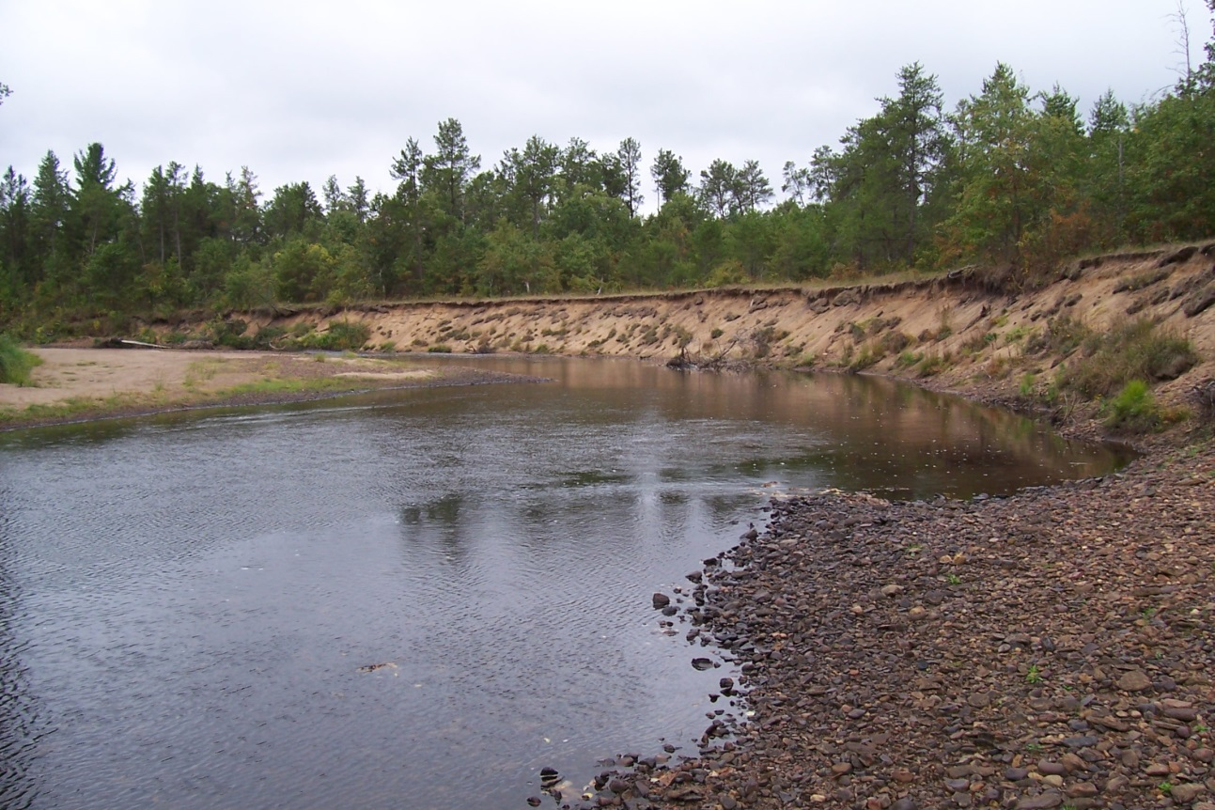
Figure 5 View facing the GPT. Erosion here is now most rapid in the distance where the largest chunks of sod have fallen toward the river. There is unsupported sod ready to fall along the entire cut bank drop off.
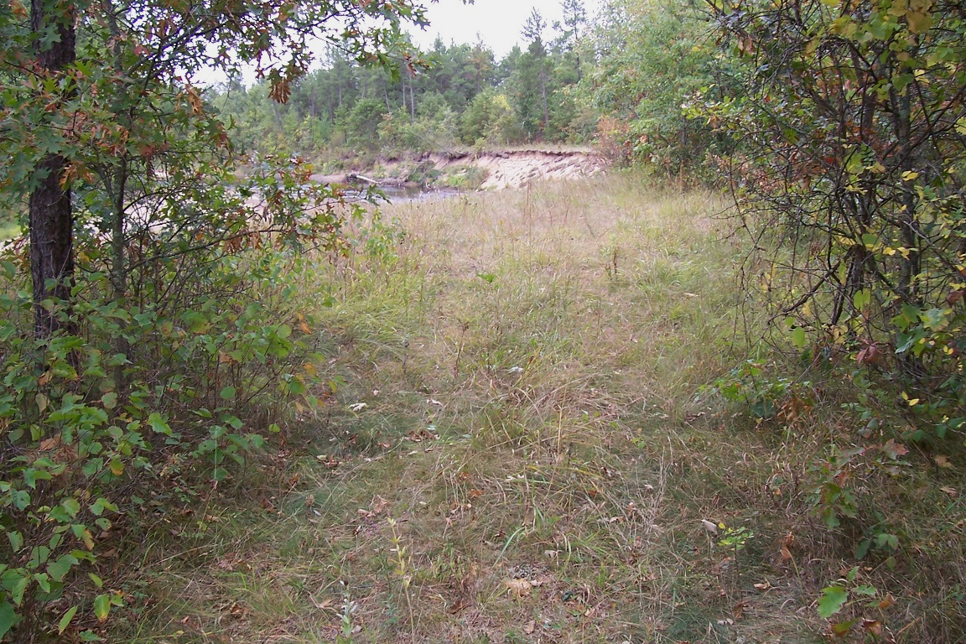
Figure 6: The old logging road which used to extend to the far grassy area now comes to a definitive end. Both photos above are looking south near 91.069W 44.7531N on basemap Figure 3.
Project 2-E Reopen the GPT Cutover on the east side of Logjam Island. (Summer, 2014)
-91.067840 44.752972 Decimal Degrees, see Figure 3.

Erosion Control: Reopening the GPT Cutover channel will alleviate pressure on the severely cut bank (top of photo) and buy time. Recently, there is heavy cobble at the mouth of the channel in front of the logjam. If the channel is reopened, the sand component may clear by river action.
Concern : If the river has more flow through the GPT Cutover, Logjam Island will need protection from increased exposure to severe erosion due to an even sharper bend in the river. In this regard, the non-offending and loosely consolidated logjam along the island’s cut bank shore should be left in place and perhaps supplemented by a deliberate mix of additional logs and excavation cobble, one anchoring the other. Otherwise the island could easily disappear altogether in a single major storm. Persistent logjams may be the only reason this island still exists, look what happened beyond it, giving some sense to calling it Logjam Island.

WEST
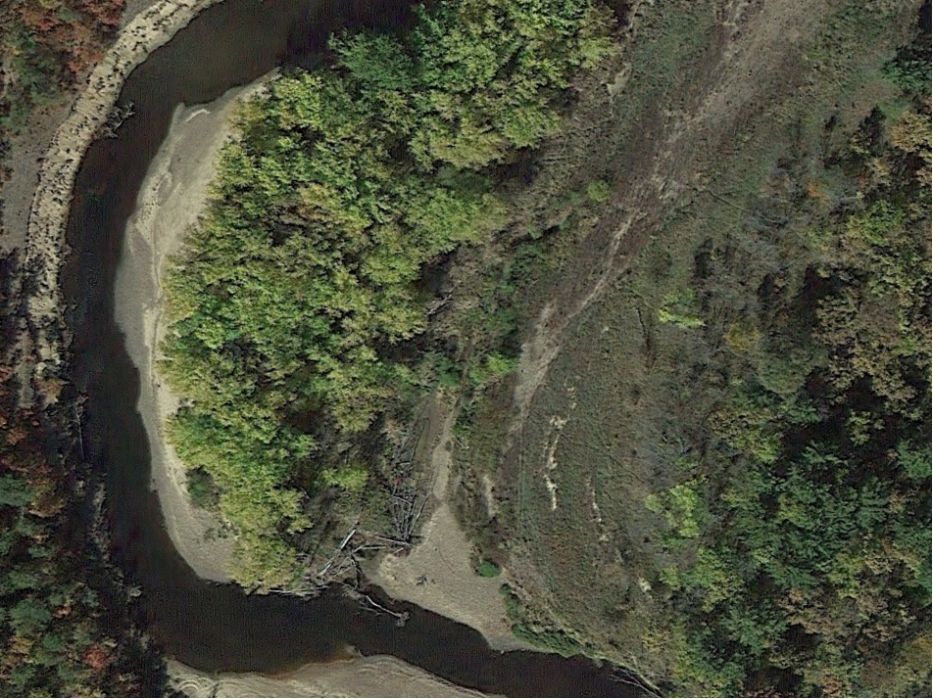
Figure 7: Photo is facing west. The GPT Cutover is almost clear of trees in the center of the photo. The GPT Cutover needs to be excavated to alleviate erosion on the cut bank. Note how the logjam at Logjam Point is protecting Logjam Island and directing the river squarely west into the well-established stand of trees, far upper left, taking them out.
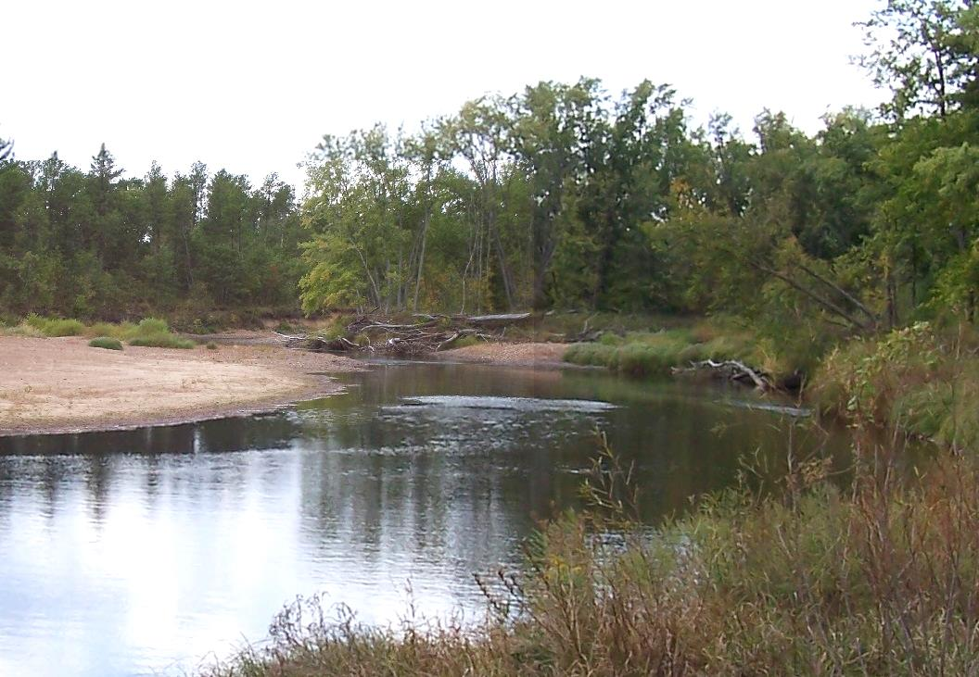
Figures 8 & 9 Above: The logjam at Logjam Point is shown in center. The cutoff east of Logjam Island begins at the right of the logjam. Below: the GPT Cutoff east of Logjam Island.
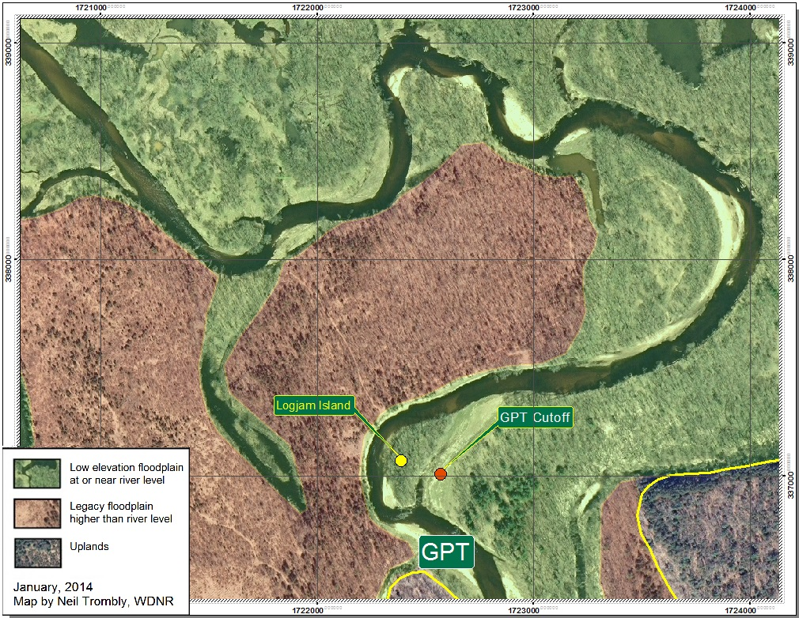
Project 3-RES Reopen the GPT / Skid Row Connector Channel.
-91.068514 44.751584 Decimal Degrees, see Figure 3

Also in the immediate area of the Gravel Pit Trap is the left bank side channel which connects the GPT area to Skid Row. This Skid Row Connector Channel has long diverted water from the main channel during high water events. This has occurred naturally. The threshold land at the upper end of this channel appears to be about 30 feet wide measuring perpendicular to the river. Lowering the GPT threshold at the head of this channel can increase flowage frequency. Widening the GPT threshold at the head of this channel can increase volume during high river stage events. Both options have their merits and they are not mutually exclusive. Although either of these actions may appear easy and inexpensive, there are issues needing further study, among them:

- The water route to Skid Row is a fraction of the distance to Skid Row by way of the main channel. This means that the stream gradient through this channel is much greater and erosive velocities can occur accordingly.
- There are areas of well-rooted plant growth in the mid-to-upper reaches of this channel to dampen heavy intermittent flows. Significantly heavier use could cause plant attrition.
- The earth threshold out of the GPT area may need to be reinforced/stabilized if the threshold is lowered or widened for heavier and/or more frequent use. Given the available gradient, there is a possibility of being overly successful.
- There may be substantial downstream benefits to increased flow in this connector channel. This issue is covered in 4-R
- There may be substantial downstream risks to increased flow in this connector channel due to diversion. This interesting issue is covered in 5-S.

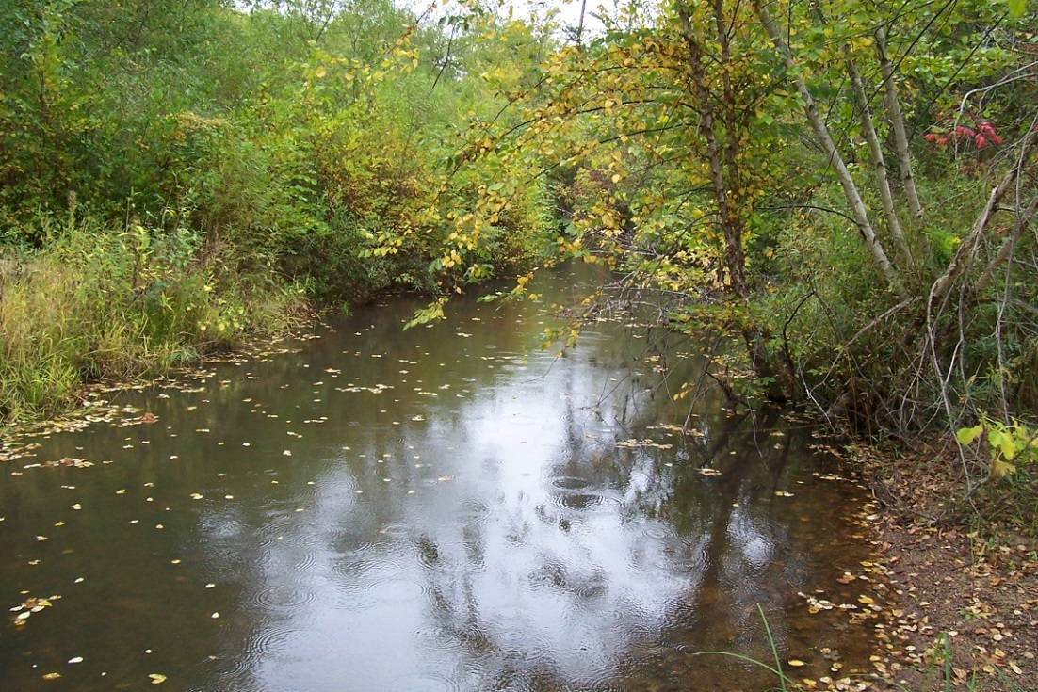
Figure 10-A: Looking north from the middle of the old logging road that crosses the GPT / Skid Row Connector Channel in September of 2012 at low river stage. A very peaceful and hidden place – but not always …
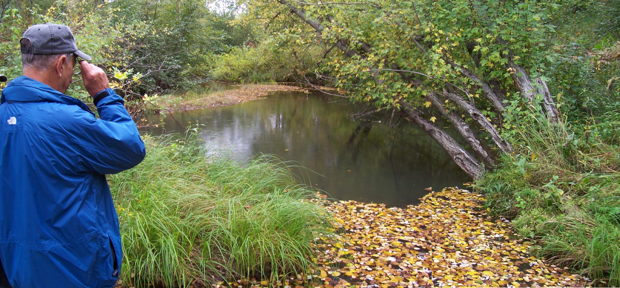
Figure 10-B: Rod Zika at the same site looking south while standing in the middle of the old logging road that crosses the GPT / Skid Row Connector Channel.

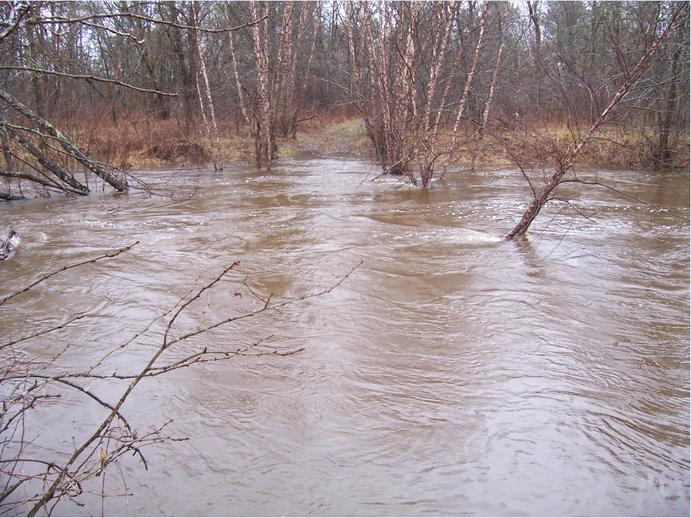
Figure 10-C: This is the exact same location as previous photos. In September, 2012, Rod was standing near the trees that are seen above as leaning to the left while he was looking in the direction they were leaning. This Figure 11-C photo from April 30, 2014, was taken while the Eau Claire river was 8 feet higher. This flowage was so deep the connector channel was boatable which is how the author covered most of the distance upstream to get this photograph.

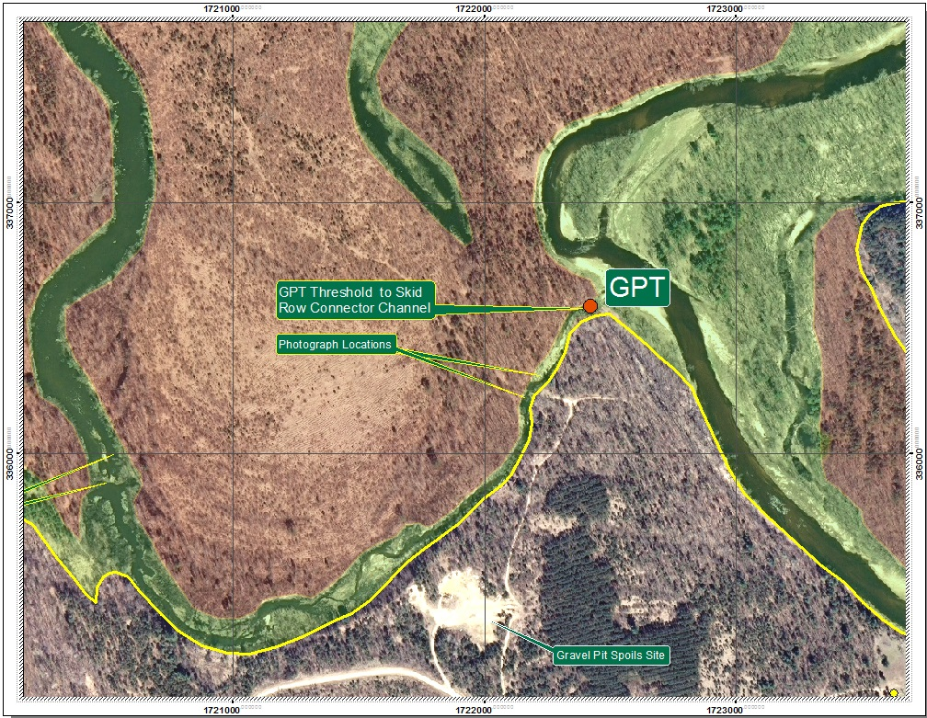
Figure 11: Location of the ‘threshold’ of the GPT / Skid Row Connector Channel

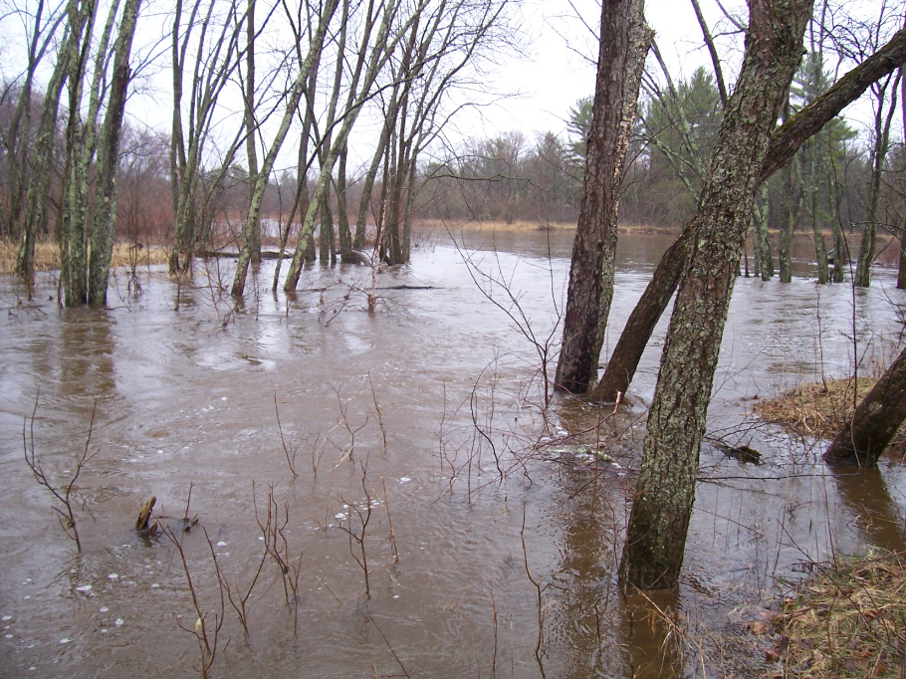
Figure 12, The ‘threshold’ at the upper end of the GPT / Skid Row Connector Channel, April 30, 2014, in high flood.

Project 4-R Remove Skid Row Beaver Dam at end of GPT / Skid Row Connector Channel.
-91.077439 44.755250 Decimal Degrees, see Figure 3

Reconnectivity : There is a beaver dam blockage at the end of Finger Slough which is at the Skid Row end of the GPT/Skid Row Connector Channel. The rise in water level is only about 6 inches across this dam but the dam is impermeable, even to small fish. It is a well-established dam and is reinforced by rooted grasses and small hydrophytic shrubs. Removing this dam will immediately reconnect eight acres of open water for fisheries, wildlife and recreation. Because this action is minor and so near the open lake, there is little risk here other than to the local beaver population which may or may not need to be addressed.

Habitat Restoration : Zika has stated that twenty years ago Finger Slough would fill with ducks in the fall. When we dragged our canoe over the dam and canoed its length in September, 2012, we found it dead to any apparent wildlife and hypereutrophic. By fostering an increased flow stemming from adjustments to the GPT threshold, considerable habitat restoration could be accomplished.

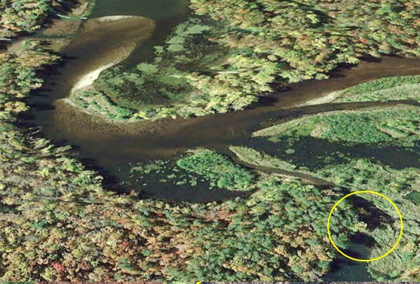
Figure 13: The Skid Row Beaver Dam is seen within the yellow circle. It is reinforced by rooted grasses and small hydrophytic shrubs. Location is -91.077439 44.755250 Decimal Degrees

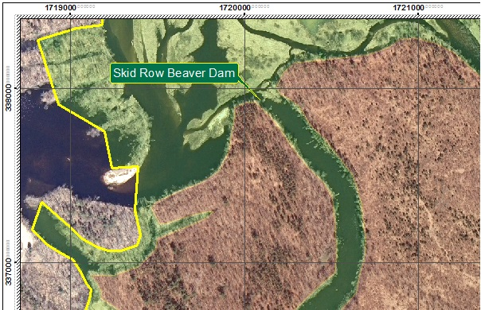

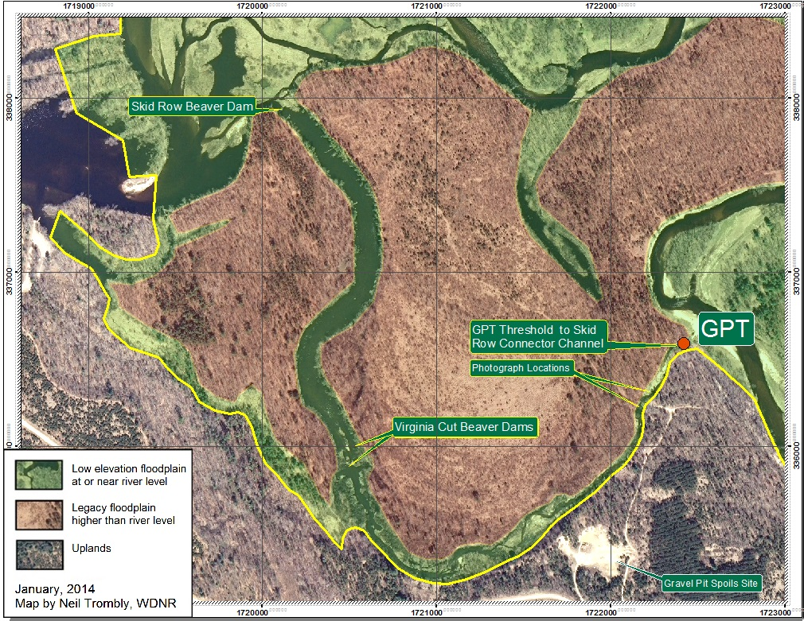
Figure 7: Aerial view of blockage in center left portion of channel.
Figure 14: The Skid Row Beaver Dam is at the top of the map.

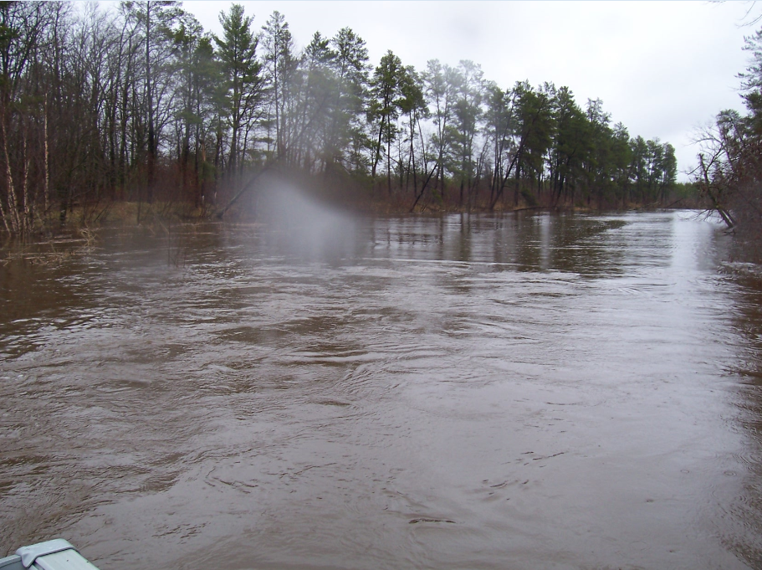
Figure 15: Looking back across the Skid Row Beaver Dam during flood, April 30, 2014. Lake was so high we had just moments earlier boated over it. The calm water area beyond the dam is the long straight section of Finger Slough.
Project 5-S Study elevations and natural function of the Virginia Cut Beaver Dams.
-91.075815 44.749911 Decimal Degrees, Upper Virginia Cut Dam, see Figure 3
-91.075844 44.749585 Decimal Degrees, Lower Virginia Cut Dam

Study : Midway down the GPT / Skid Row Connector Channel are two beaver dams less than 200 feet apart. Both these dams are clearly visible in the Google Earth image below. It appears certain that something is altering the vegetation in Virginia Cut. The small streamlet in the cut veers towards the highway to the left but the vegetation suppression does not follow it. The most likely cause is episodic flood event spillovers from just upstream of the beaver dams. Nutrient-depleted, recently deposited sand could also be the limiting factor. Although these two beaver dams are located in the GPT/Skid Row Connector Channel, what makes them interesting is their unclear relationship with Virginia Cut. Therefore, I named them for what makes them interesting, the Upper and Lower Virginia Cut Beaver Dams.

Regarding episodic and massive spillovers into Virginia Cut, we do not know if this is a good or a bad thing to have happen. Such a spillover during a 50 year storm may take a lot of velocity out of the main river channel and suppress wild erosion. We do not know the rise of the somewhat treed threshold holding back water from entering Virginia Cut. We do not know the role the beaver dams are playing. Perhaps the Virginia Cut Beaver Dams are not needed to encourage flowage down Virginia Cut. There is a potentially complex river stage / spillover relationship to be explored here before any action is taken. 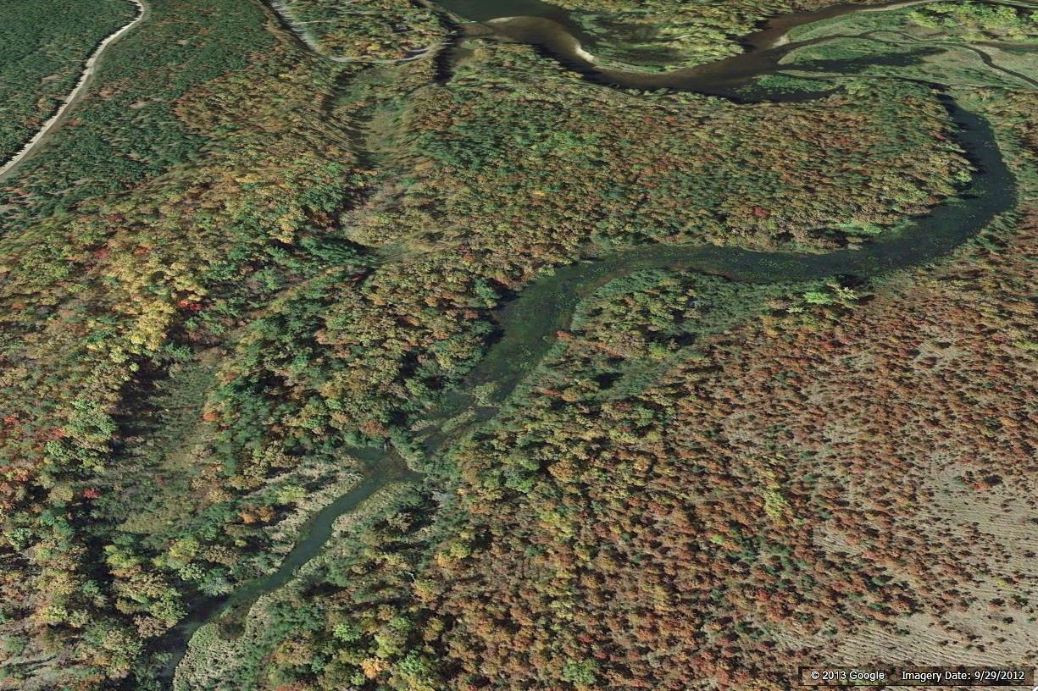
Figure 16: The upper beaver dam is very well established. It is the heavy line of vegetation at the top of the pond that is shaped very much like a claw hammer. The second beaver dam is the thin line just down river. Both were present when Zika and Trombly visited the area in Sept., 2012, neither of us suspecting that the dams might be capable of diverting water which was previously diverted from the GPT area during high river stage flows.
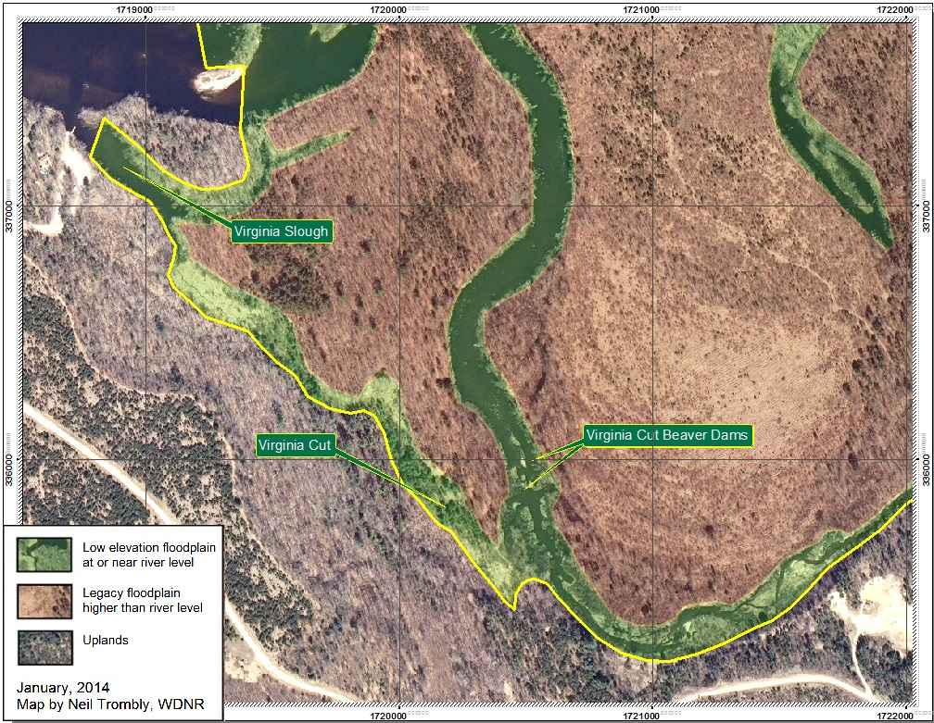
Figure 17: The image above shows the location of the two beaver dams that may, at times, encourage heavy flow into Virginia Cut.

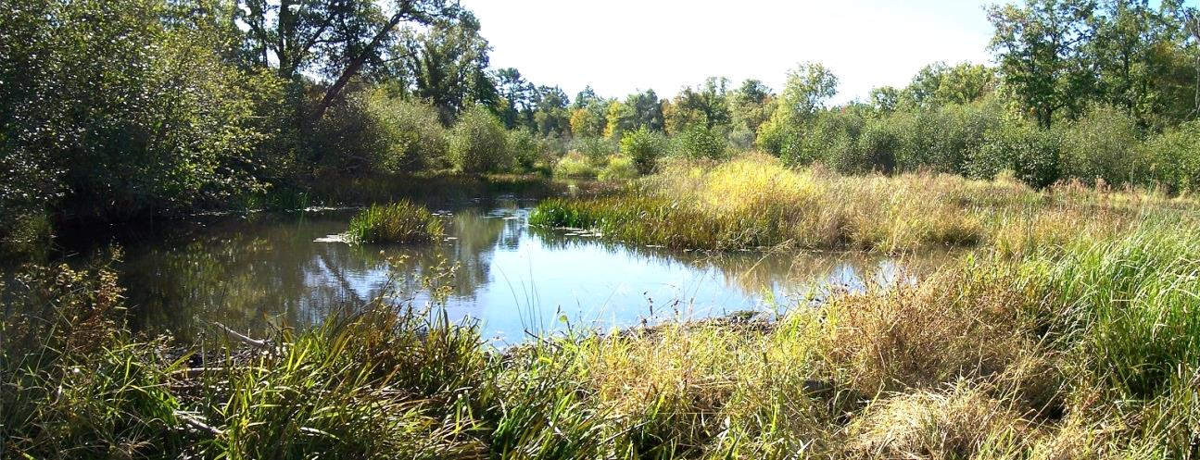
Figure 18-A: The photo above shows the impoundment behind (lower) Virginia Cut Beaver Dam 2, the lighter duty dam, which we visited on Sept., 25, 2012. Note the leaning tree trunk at top, center left.

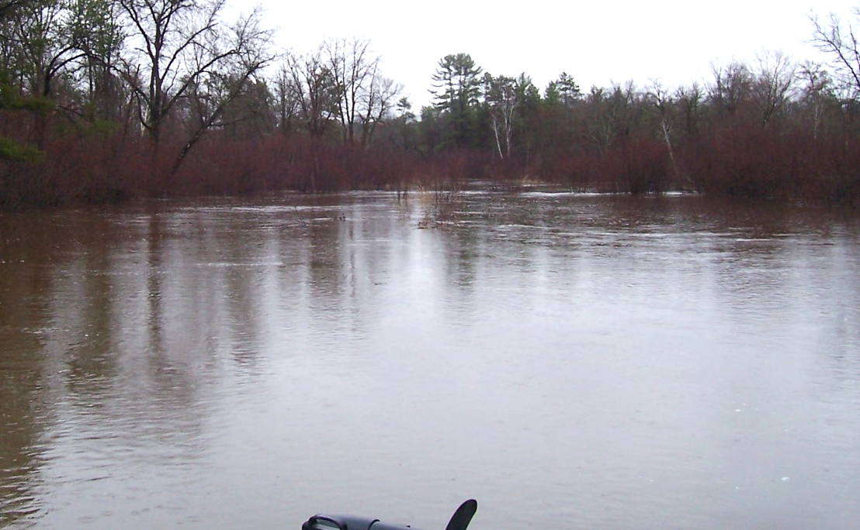
Figure 18-B: The same leaning tree trunk is seen in both photos. Photo 18-B (above) was taken April 30, 2014 and shows the (upper) Virginia Cut Beaver Dam 1 as causing a line of white across the entire waterway. Water levels are so high that (lower) Virginia Cut Beaver Dam 2, the lighter duty dam, barely causes a ripple. We would soon boat over both dams.
Project 6-R Remove Tussock Blockage in North Bend Channel.
-91.073022 44.761668 Decimal Degrees, see Figure 3
Dense tussock growth has closed off North Bend Channel creating an isolated pond. It is possible to traverse the blockage by dragging a boat to the ponded stream section and people do that. The blockage is at lake level and appears free of logs. This blockage is a particularly low-hanging fruit to restore connectivity without negative consequence. The blockage is estimated 75 feet across. This blockage works in concert with other blockages to cut off water access to the 50 acres of the North Bend - Leeches Slough area, see Figures 51 & 52.
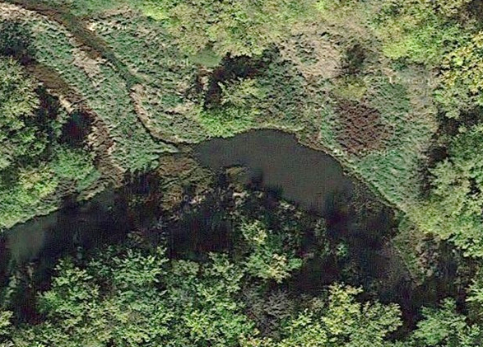
Figure 18: Aerial view of Tussock Blockage in center left portion of channel.
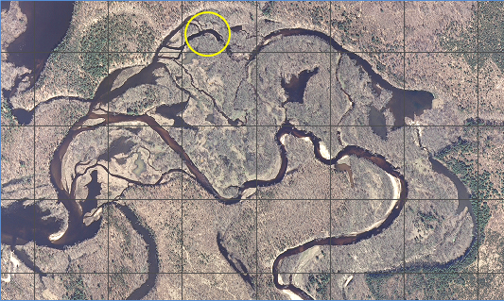
Figure 20: Location of Tussock Blockage is -91.072898 44.761729 Decimal Degrees
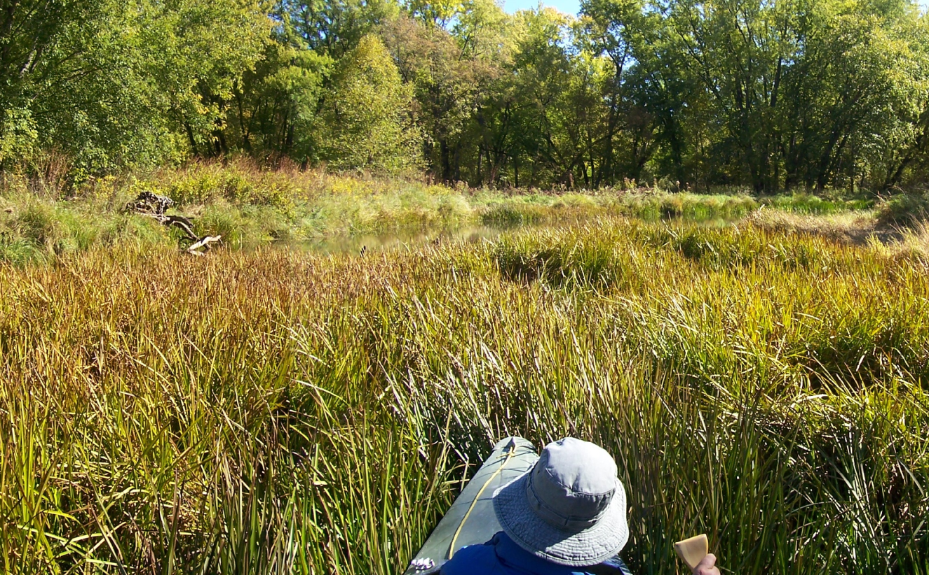
Figure 29: Looking across the tussock blockage. Because of the height of the grasses and reeds, only a narrow slice of a pond is visible above. Note the small amount of driftwood on left shoreline.
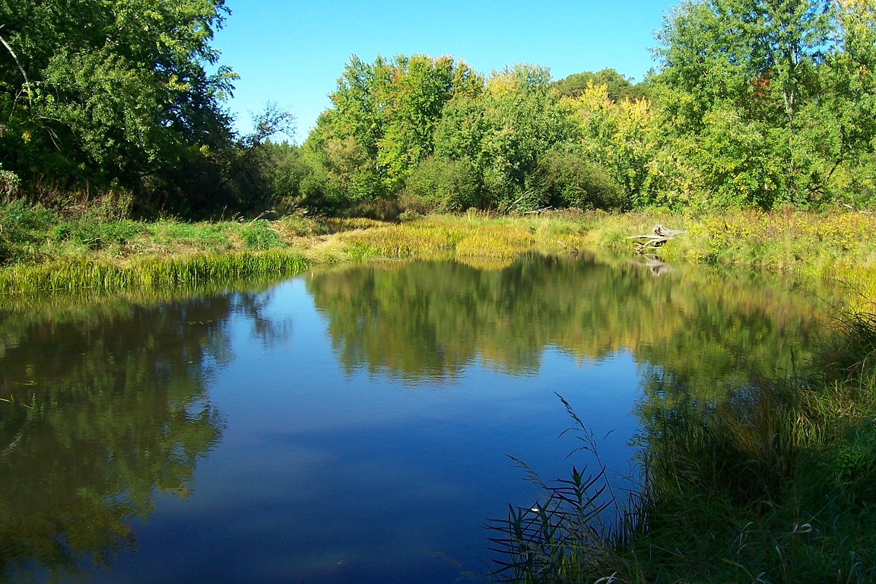
Figure 22: Now on foot, looking back across the pond at the tussock blockage from the other side. The same driftwood as in the previous photo is on the right shoreline.

Project 7-R Restore year round aquatic passage through North Bend Channel east.
-91.071173 44.760692 Decimal Degrees, see Figure 3

RESTORATION : 500 feet of the east section of North Bend Channel needs restoration. It is shallow and has hundreds of obstructions but most of them are not large in size. This is one place where a small army of weekend volunteers might be put to good use.
RECONNECTION : This is low-hanging fruit only in the sense of being the least difficult possibility for restoring connectivity of a substantial 70 acres of spawning, fisheries and rookery to Lake Eau Claire. Two other channels could accomplish the same thing but they have daunting logjams that require heavy machinery and/or long hours of chainsaw effort to be cleared. Further, clearing either of those channels might unleash a large pulse of sand which needs to be considered.

A dense log jam of uprooted tree trunks is washed up against the south bank at the east end of North Bend Channel. Most of the heavy logs are so positioned as to not completely block North Bend Channel at this time. However, the remaining channel to the west is crisscrossed by so many smaller driftwood trunks, tree falls and branches as to be non-negotiable for passage by boats or possibly even fish. Restoring the connectivity across North Bend Channel all the way to North Bend Pond is about 500 feet of difficult work but it is important to reestablish Lake Eau Claire’s connection to Spring Channel and wetlands beyond.

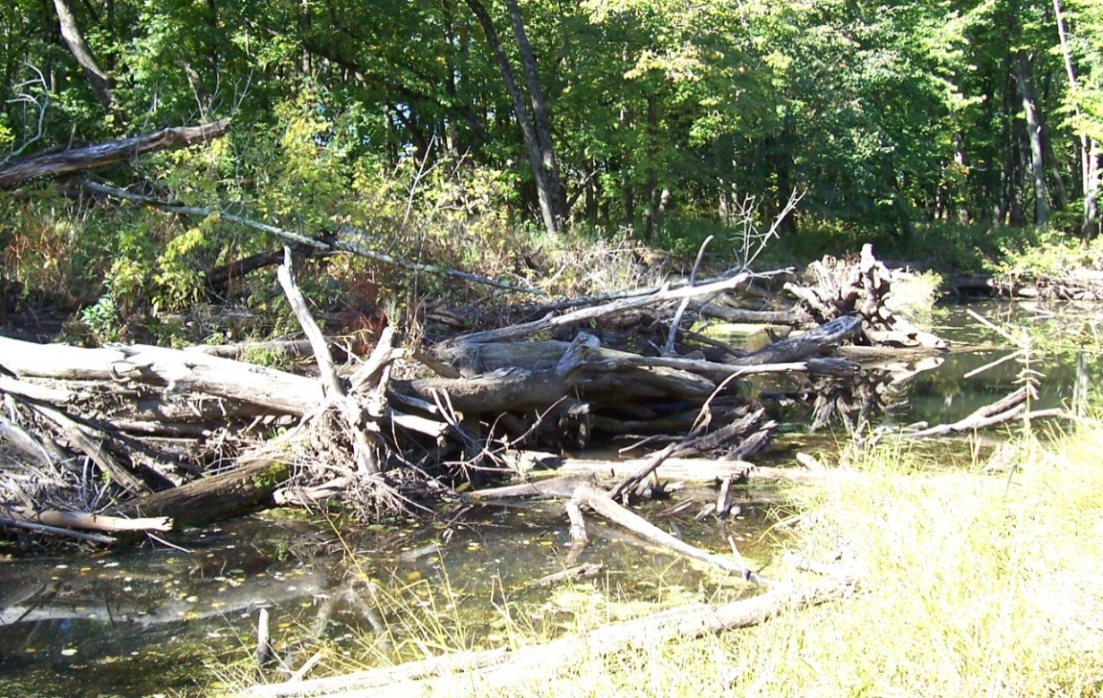
Figure 23: Looking southwest, the logs are to the south so the channel skirts it to the north.
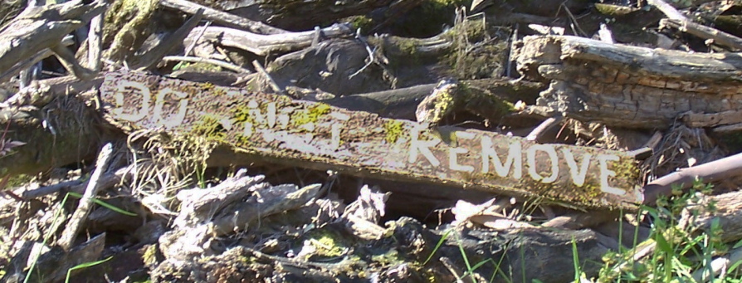
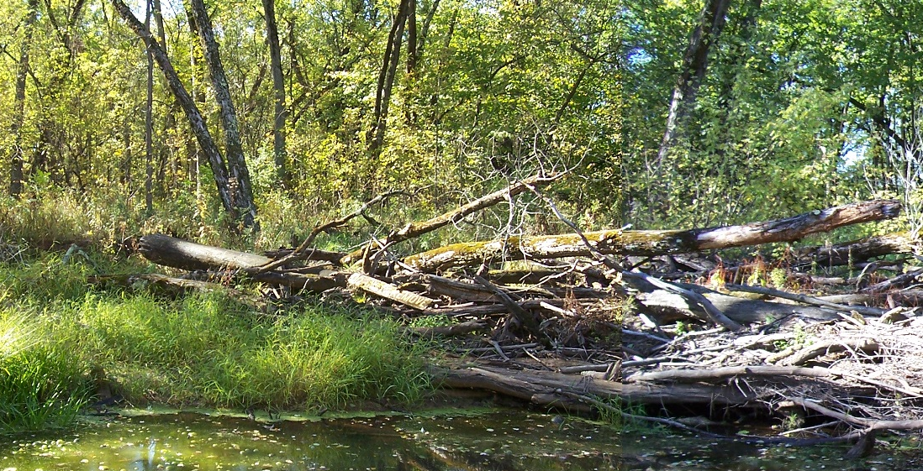
Figure 24: Above is the east end of the same logjam as in the previous picture. A driftwood sign is seen lodged in the logjam pile at left of center. The close-up shows it says DO NOT REMOVE.
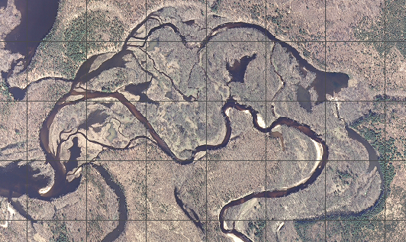
Figure 25: Location of North Bend Channel Blockage at-91.071173 44.760692 Decimal Degrees

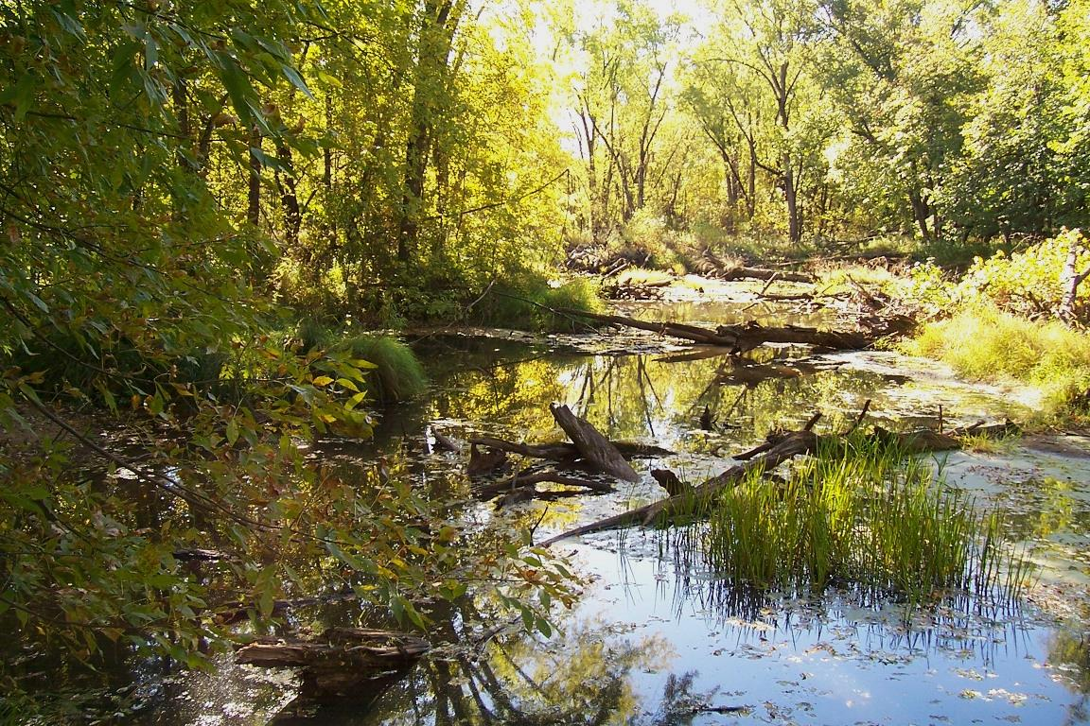
Figure 26: Above shows a section of the North Bend Channel. There is a lot of work here but a passage can be cleared.
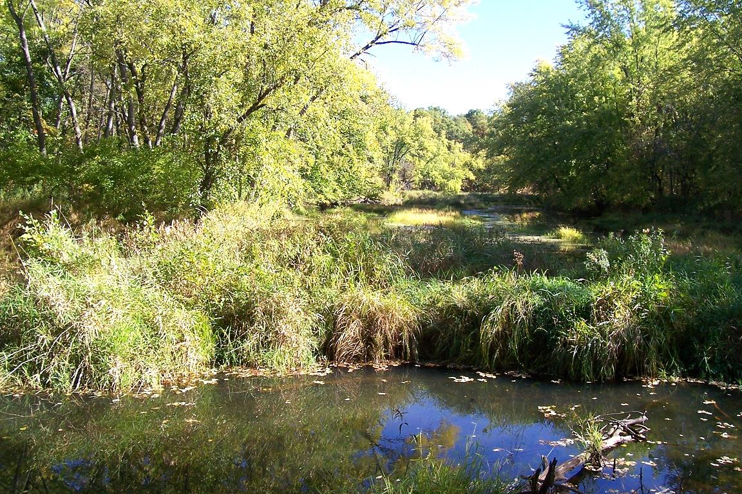
Figure 27-A: This is the connection from the end of North Bend Channel to Spring Channel, facing Northeast in September 2012. This broad connector channel has a lot of sand but few logs so large flows must keep it clear. If North Bend Channel and/or other channels are cleared, the river in flood might deepen this channel without direct excavation intervention.

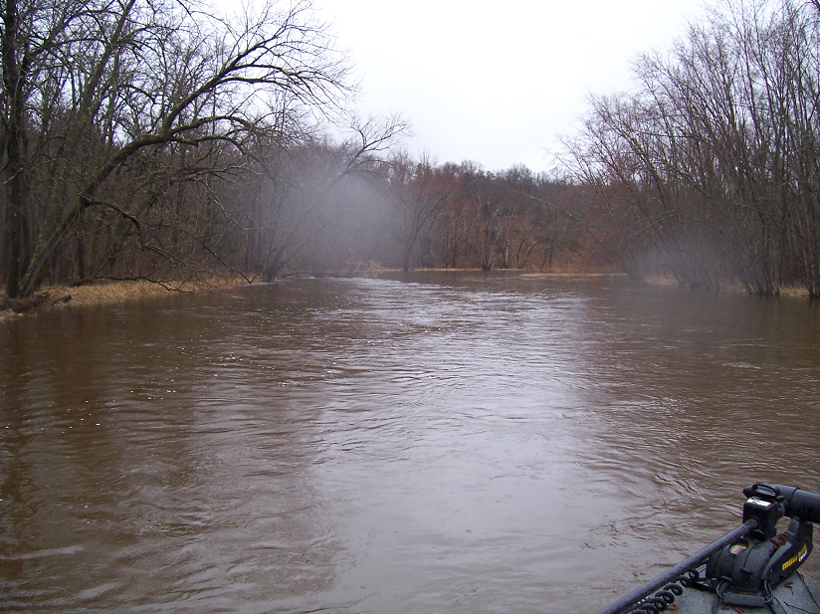
Figure 27-B: This is the same connection from the end of North Bend Channel to Spring Channel, facing Northeast during high flood. The Eau Claire river at the Troubled Waters Bridge was 8 feet above base flow on this day, April 30, 2014 and Lake Eau Claire was about 2 feet above normal, perhaps more. The author estimates this section of the intervening floodplain is 4 to 5 feet above normal. The flowage was extremely heavy like we were boating up a main river channel. This makes it clear why there is a lot of sand but few logs in this channel – they get hung up elsewhere. Large, occasional flows like this are capable of keeping it clear. If North Bend Channel and/or other channels are cleared sufficiently of logjams, rare but heavy flows such as this might deepen this channel without mechanical excavation.

7.1-S Supporting documentation for the work called for in North Bend Channel.
-91.071082 44.761094 Decimal Degrees, see Figure 3

Due to severe blockage on the east end of North Bend Channel a new channel has begun to be blown out just to the north. It is probably not low-hanging fruit but the two following images document its existence. Part of the reason for including at least one site such as this is to show that channel blowouts can and do occur.

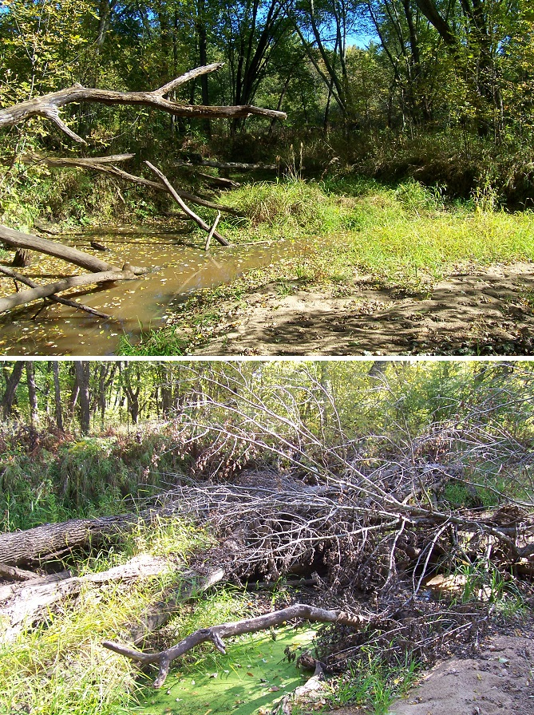
Figures 28 & 29 A short new channel has served as a relief valve for clogged North Bend Channel.

7.2-S Supporting documentation for the work called for in North Bend Channel.
-91.065599 44.760874 Decimal Degrees, see Figure 3
-91.061923 44.758591 Decimal Degrees
Reconnecting the 50 or so acres in the North Bend – Leeches Slough Area is important. (See Figure 52 at the end of this report for areas.) Figure 30 is a snippet of the Spring Hole part of Spring Channel. It curves beautifully untouched both ways from here. At the east end of Spring Channel we came upon the scene in Figure 31. It was raining the day of the photograph but its unspoiled venue lifted my spirits. This is what it’s all about, reconnecting Lake Eau Claire’s fisheries and recreation to such places as these.

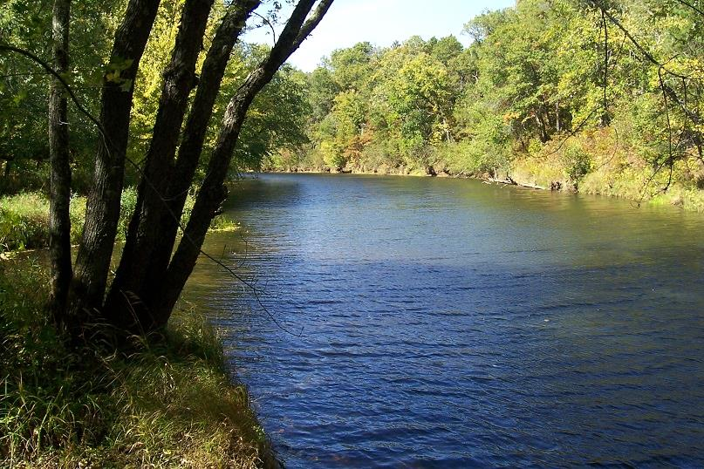
Figure 30 : The Spring Hole portion of Spring Channel
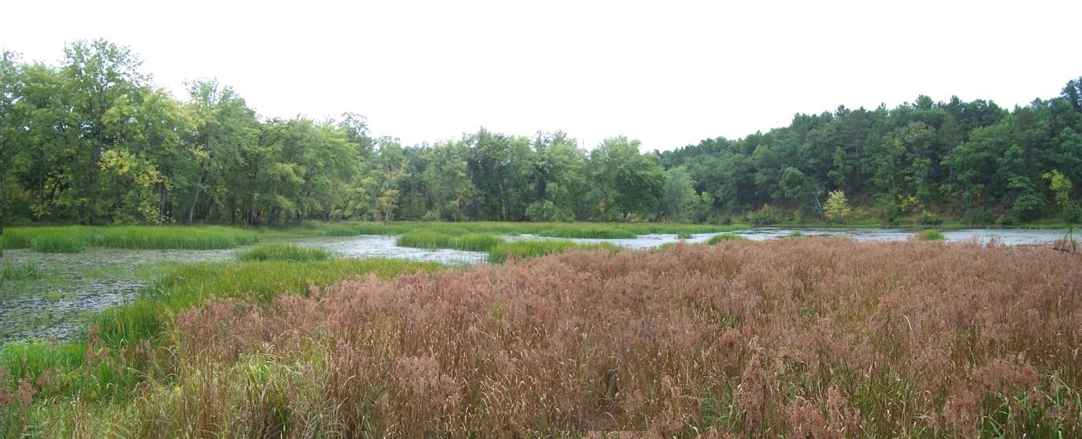
Figure 31 The watercourse of Leaches Slough curves around into Spring Channel by the farthest low trees.

Project 8-RE Remove logjam around the first bend of Left Fork Meander.
-91.075119 44.756289 Decimal Degrees, see Figure 3

This jogjam (Figure 32) is not large and could be removed by a few men with a chainsaw. There is also the high forested ground of the Legacy Floodplain very close by to properly dispose of spoils. This logjam has been breached, split in half, enough to allow boats of shallowest draft to get through but it does back up water producing a constricted flow. Removal of this logjam will improve connectivity to Cranberry Marsh’s 32.7 acres. Project 10-R Remove Trap Island also improves connectivity to Cranberry Marsh.

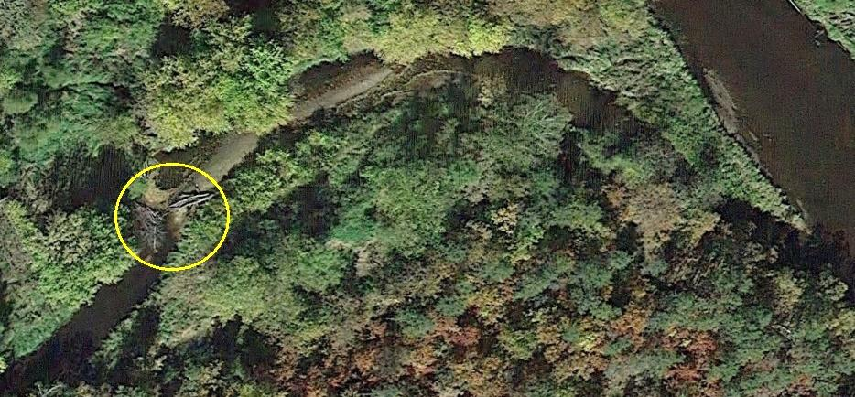
Figure 32: Above shows a split logjam on Left Fork Meander.

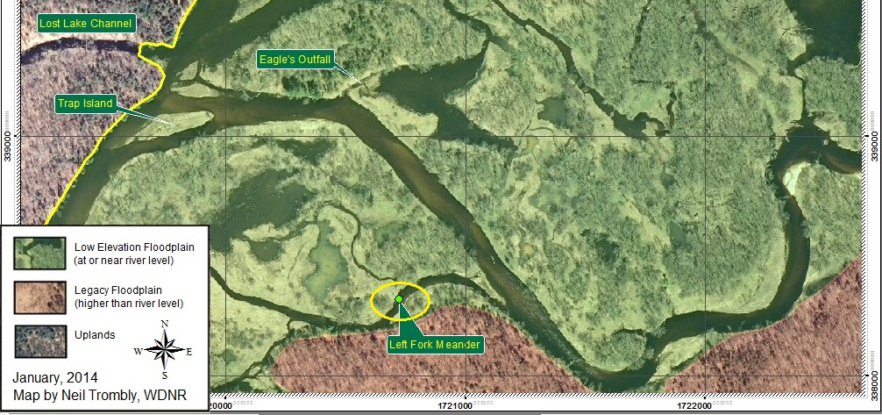
Figure 33: A partial map showing the location of Left Fork Meander logjam

Project 9-R Improve the aquatic connectivity through Eagle Marsh.
-91.075799 44.758762 Decimal Degrees, see Figure 3

There is a small sand delta where this project, Eagle’s Outfall, empties into the main channel. In the upper right the much larger intake channel to this marsh can be seen as well as in Figure 35-B. The outflow is not nearly as cleared as the inflow area which may indicate the marsh is filling in. Re-deepening the Eagle’s Outfall channel could make this area availabe for fisheries. This vicinity has long been named for eagle’s nests in the area and, interestingly, the marsh image is shaped a bit like an eagle about to launch. Maintaining this as water habitat could encorage resident eagles to stay.
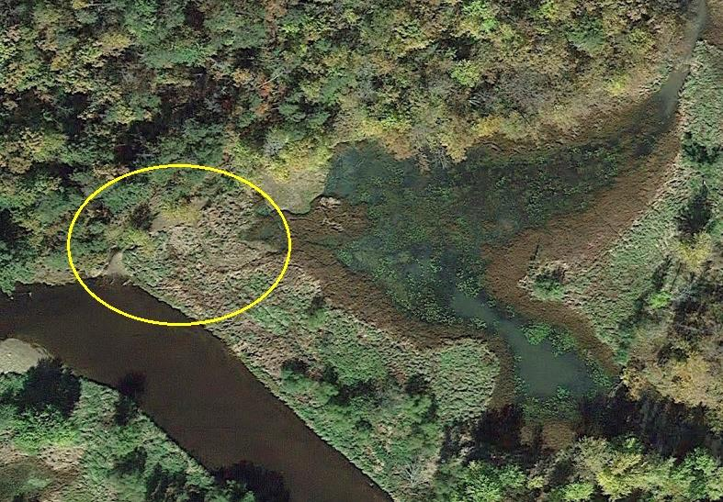
Figure 34-A : Location of Eagle Outfall. It appears to have filled in only recently.
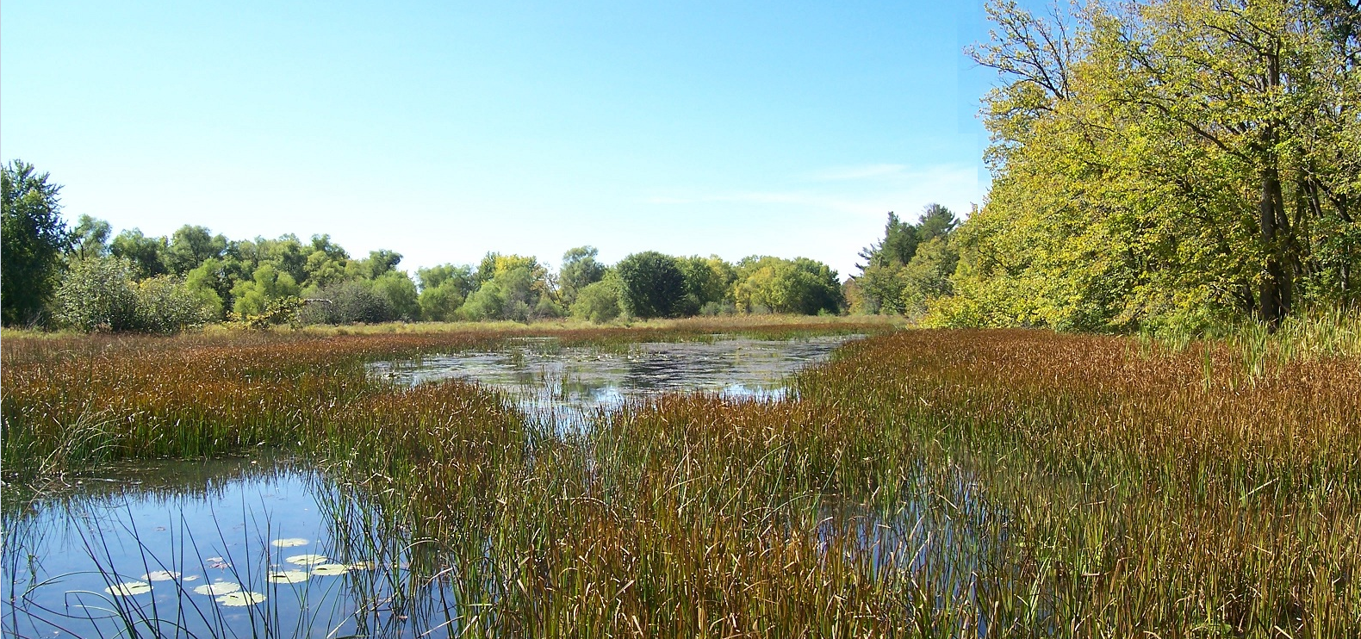
Figure 34-B : Looking across the upper reach of Eagle Marsh with the Eagle Outfall reconnectivity site in the distance on the right. We need to take steps to keep this 17.5 acre marsh from infilling, it is simply too valuable to lose.
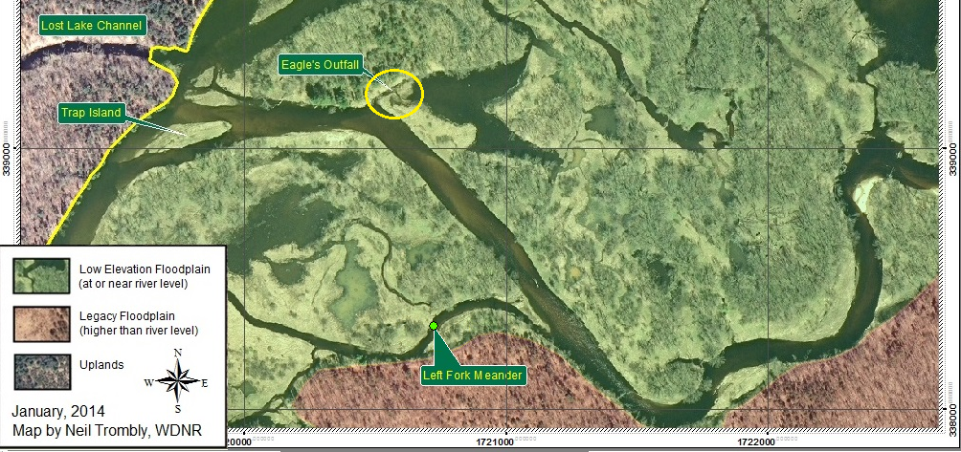
Figure 35-A : Partial map showing location of Eagle’s Outfall.

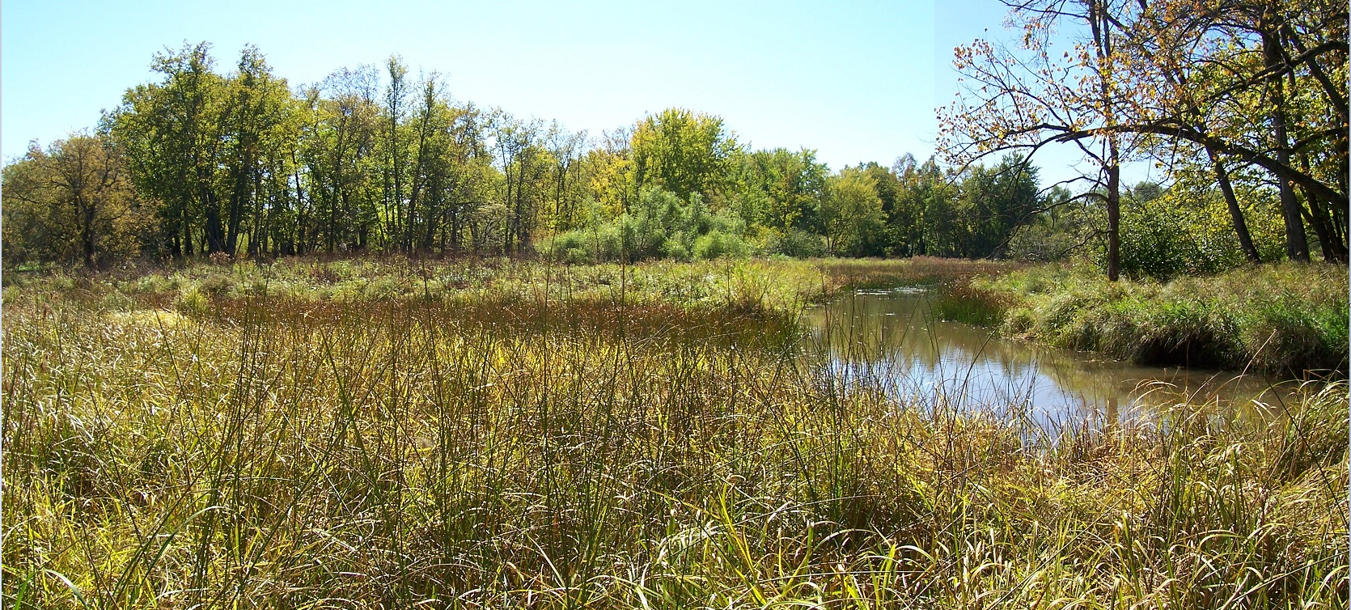
Figure 35-B : Northeast inlet channel to Eagle Marsh on September 25, 2012.
Project 10-R Remove Trap Island.
-91.078803 44.758231 Decimal Degrees, see Figure 3

The north end of Skid Row Trap (SRT) has a sandbar island that has begun to grass over. This sand bar island is entirely within the intended 2013 sediment trap footprint at Skid Row. Because calculations show that the excavation goal for the SRT was not achieved in 2013 it is probable that up to an additional 10,000 yards of sand will be contracted for removal in 2014 - 15. It would be ideal if in the process, this small island where removed. Where a river widens and forks like this, sand likes to accumulate anyway so the current footprint of Trap Island would be an ideal addition to the SRT.

The immediate impact of removal of this island is that by improving the function of the SRT the large adjacent marsh to its south called Cranberry Marsh, 32.7 acres, will have less tendency to receive flood water deposits. Its channels will be able to deepen over time. This would be a significant amount of restoration and reconnection.

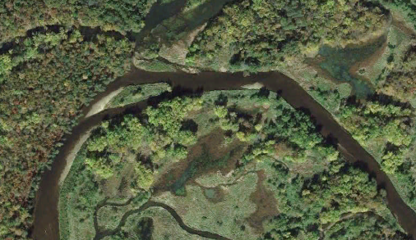
Figure 36 : Trap Island is the distinct island in the midstream of the channel. It consists of recently deposited sand but has begun to support some plants.

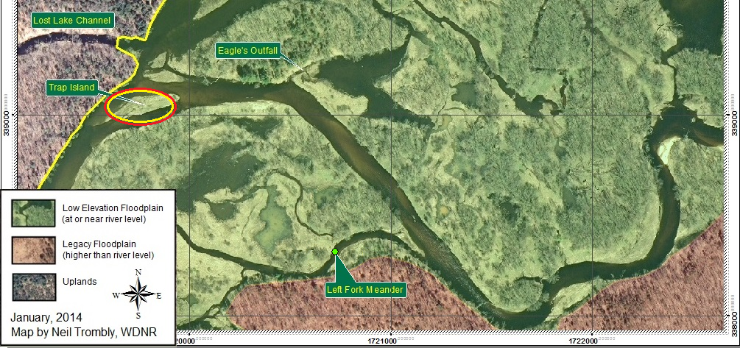
Figure 37 : Partial map showing location of Trap Island.

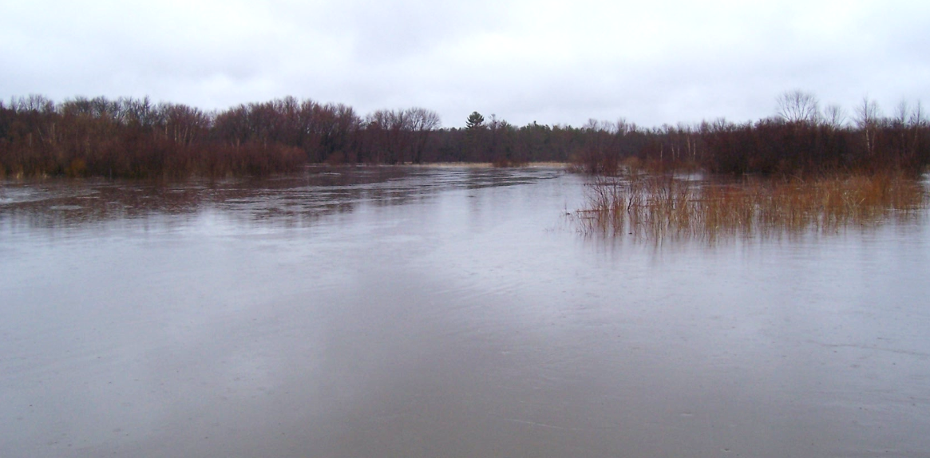
Figure 37-B : Cranberry Marsh, located south of Trap Island, during flood of April 30, 2014. In the remote distance is a giant white pine and the dead tree just to the right of it supports an eagle’s nest not far from the outfall of Eagle Marsh. This photo was taken while approaching the SRT Beaver Dam.

Project 11-R Clear Treefall Channel
-91.078803 44.758231 Decimal Degrees, see Figure 3

This is a beautiful and afflicted place. A picture is worth a thousand words. Low-hanging fruit as far as easy and cheap -- but remote. This will come down to priorities.

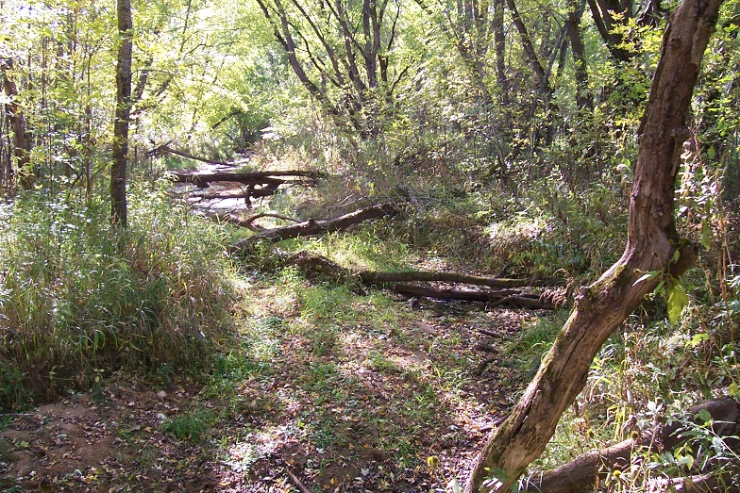
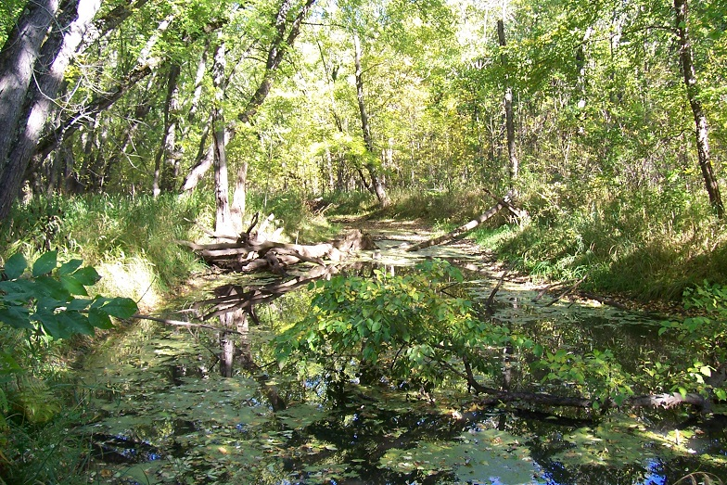
Figures 38, 39: Treefall Channel is a thin channel in the far north of the floodplain.

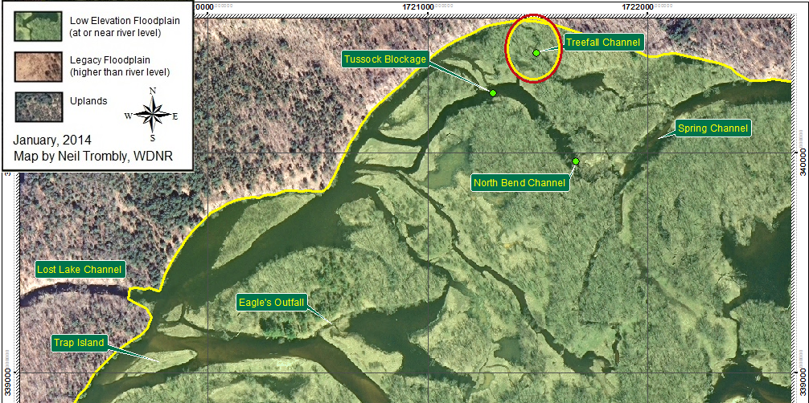
Figure 40: Treefall Channel is a thin channel that serves a pond and is an alternate high water shortcut alleviating heavy flows through North Bend Channel.

Project 12-S Restore Connectivity to Seldom Seen Pond.
-91.060305 44.747928 Decimal Degrees, see Figure 3

A thousand feet downstream from the Troubled waters Bridge, on the south side of the river, is a remnant meander pond that few people are likely to have ever seen. It is a gem hidden behind the levee. It would be good to take a look at how this pond can best be utilized and determine if its connection to the river can or should be enhanced. Perhaps it should be left as it is. It has a north woods feel.
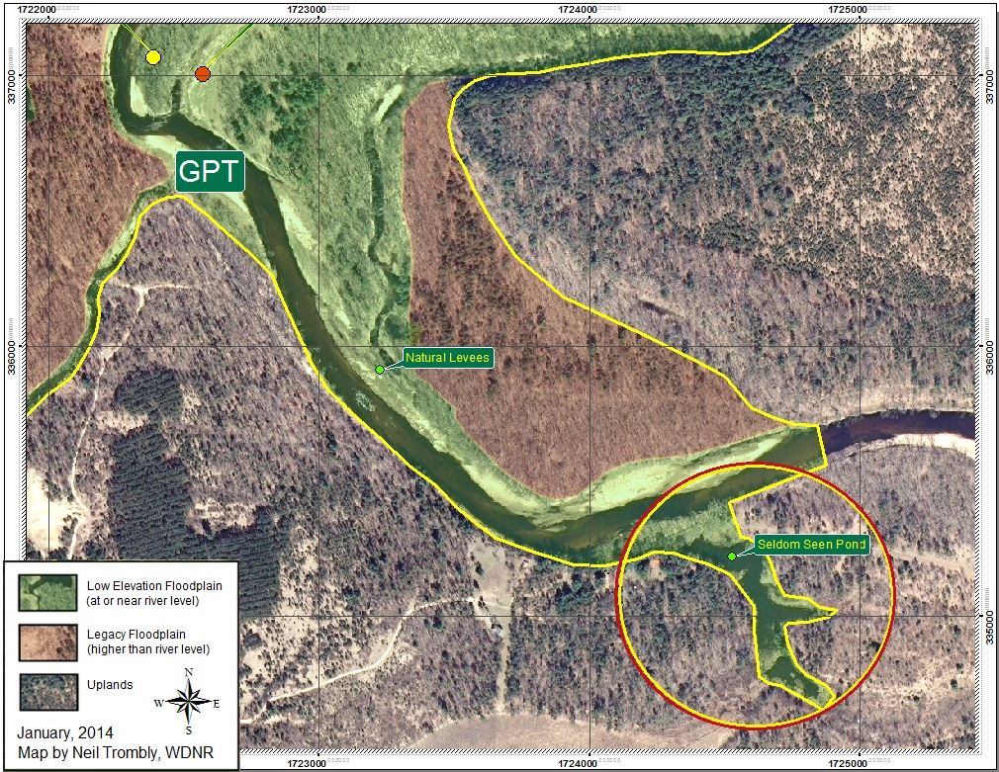

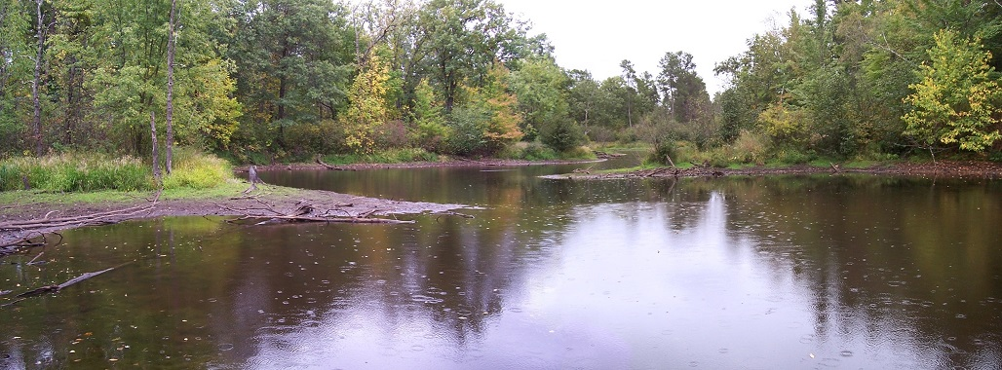
Figures 41 & 42, Seldom Seen Pond
Project 13-RES Breach the Natural Levee above GPT
-91.065338 44.749778 Decimal Degrees, see Figure 3

This project is quite easy to accomplish, the cleared channel is already there. Only the steep sided levees keep the water channelized enough to delay the river from going into overbank flooding. The dark line above the Natural levees is the beginning of Edge of Earth Channel. When, where and if to lower these natural levees are important decisions.
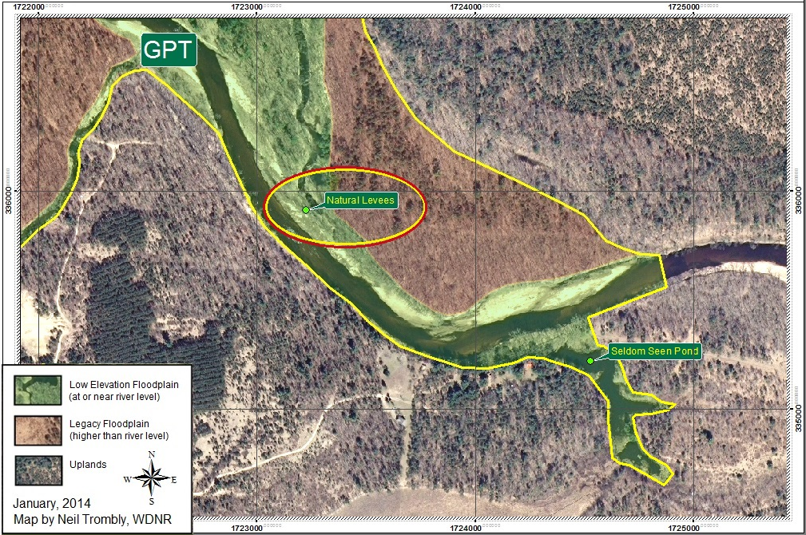

Figures 43 & 44. Below, standing on a levee that could be easily breached or lowered.
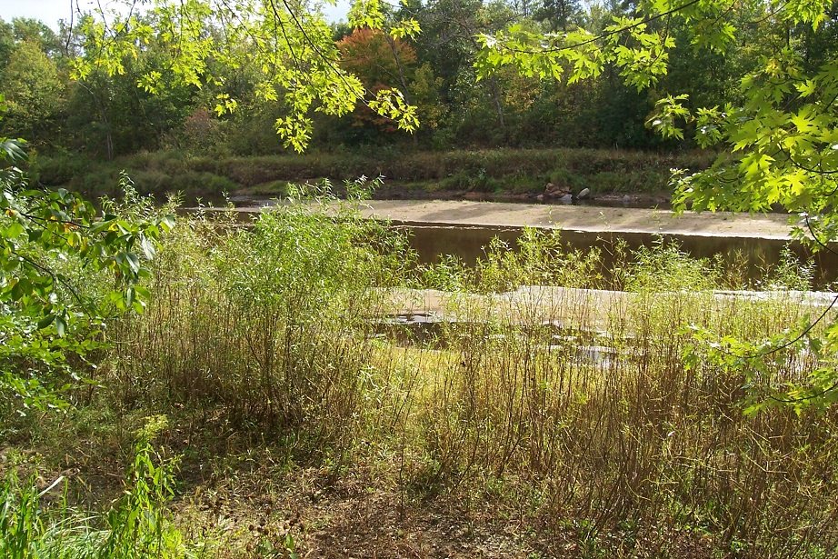
Project 14-RS Improve Connectivity to Edge of Earth Slough
-91.061654 44.757720 Decimal Degrees, see Figure 3
-91.061920 44.756875 Decimal Degrees

Edge of Earth Slough needs to be reconnected to Lake Eau Claire so I will mention it. The easiest connectors appear to be the two channels at its north end. But I have questions about how low-hanging this one is. The following photographs taken in the waterway of Edge of Earth Channel offer some visual admonishments that there are brutal flood events that happen here. They come up from the south and may get more powerful if project 13-RES is undertaken.

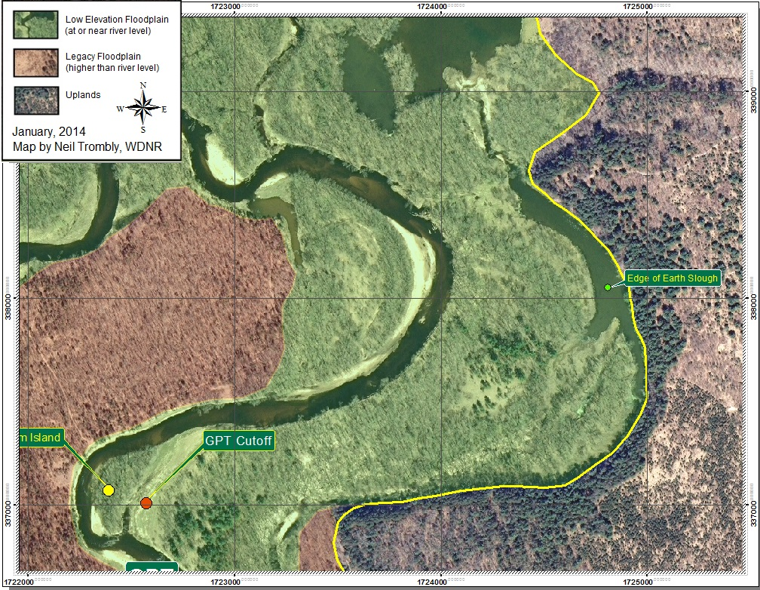
Figure 45, Locating Edge of Earth Slough.

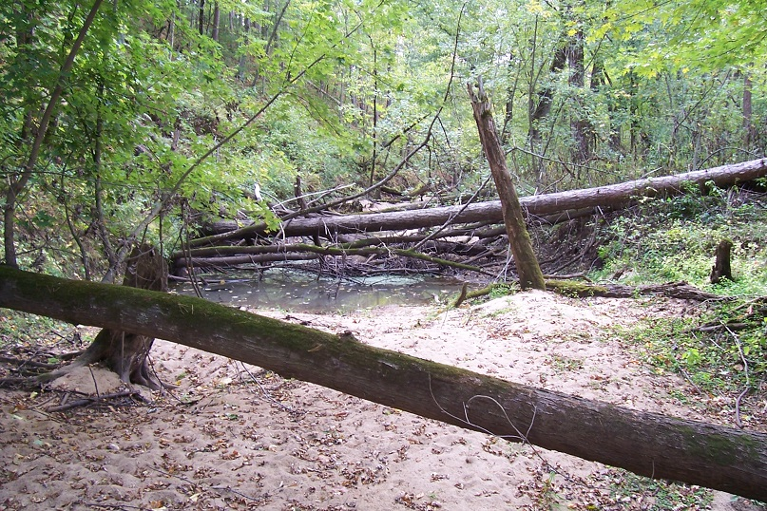

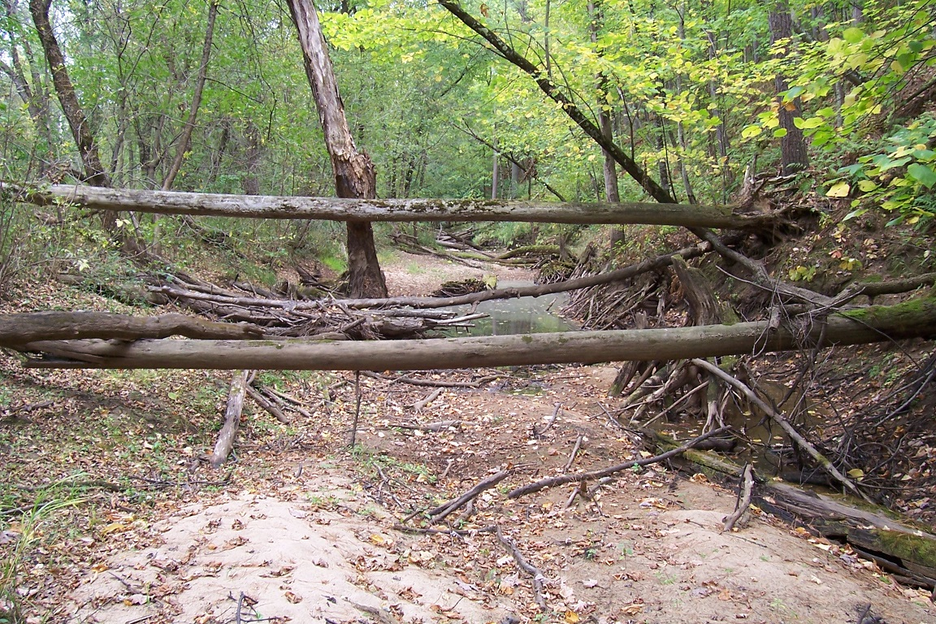
Figures 46 & 47. Edge of Earth Channel. If you look in the distance, it continues much the same.

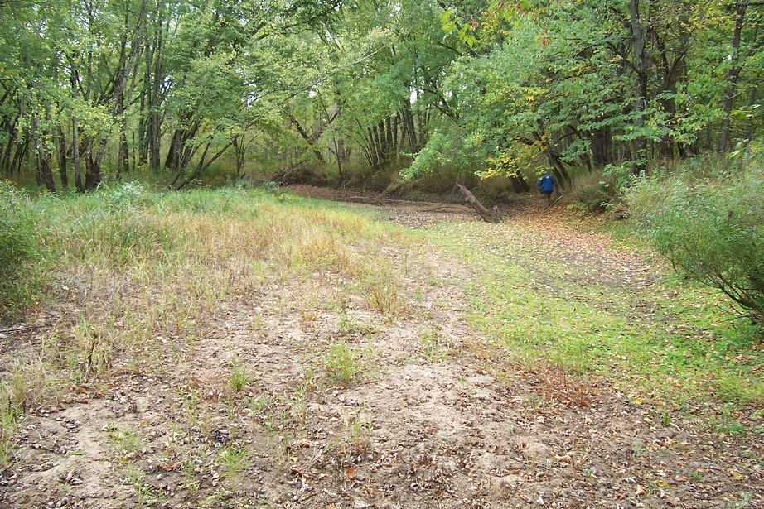

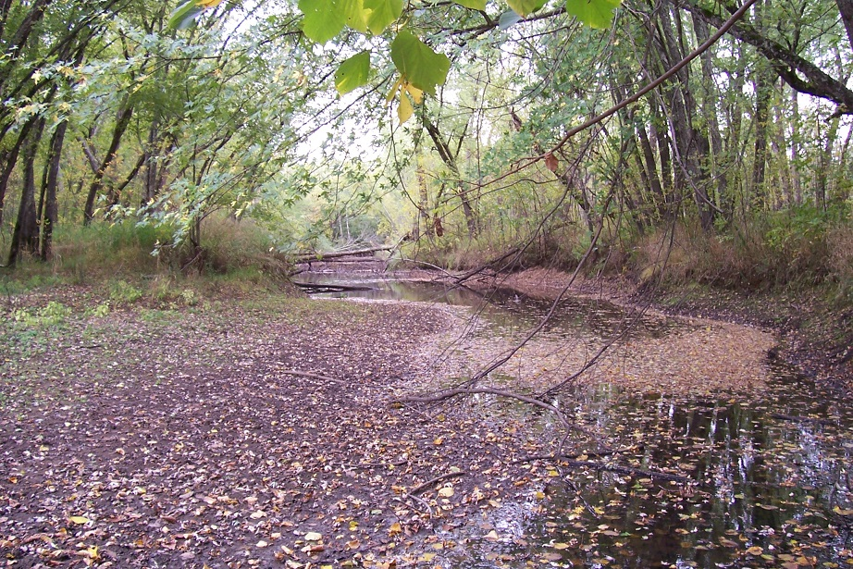
Figures 48 & 49 : Edge of Earth Channel where it comes nearer the main river channel. None of the other channels in the entire floodplain are this raw, kept this swept. Other channels have venerable old logs. There are no venerable old logs here. Top Photo: that’s Rod’s blue jacket in the distance, hard man to keep up with.
Project 15-RE Clear new logjams as they occur.

The lowest possible low-hanging fruit is to remove any and all new logjams as they occur. This maintenance activity can be cost free to the Lake Association if done by volunteers who accept liability for their own freely chosen actions and if done by hand labor with standing permission from the riparian owner. It is permit-free. It is also likely to be risk free as regards costly emptying of sediment traps because this action does not introduce disruptive change, it works to prevent disruption.

Removing new logjams on an ongoing basis as they occur is a common sense approach to management. One might easily forget to mention it. But it needs to be on the management list because it requires plausibly significant resources. It is anticipated that logjam clearing surveys should be made after the safe recession of every significant surge in river stage. What constitutes a significant surge in river stage is not yet known.

Closing Comment

There were issues shunted out of this report because they were not part of its scope of work. Many of the things to be done are truly difficult. Clearing several logjams such as seen below to open a single channel is not low-hanging fruit. Blockages such as this are somewhere up the food chain from low-hanging Fruit. There are a lot of such blockages.

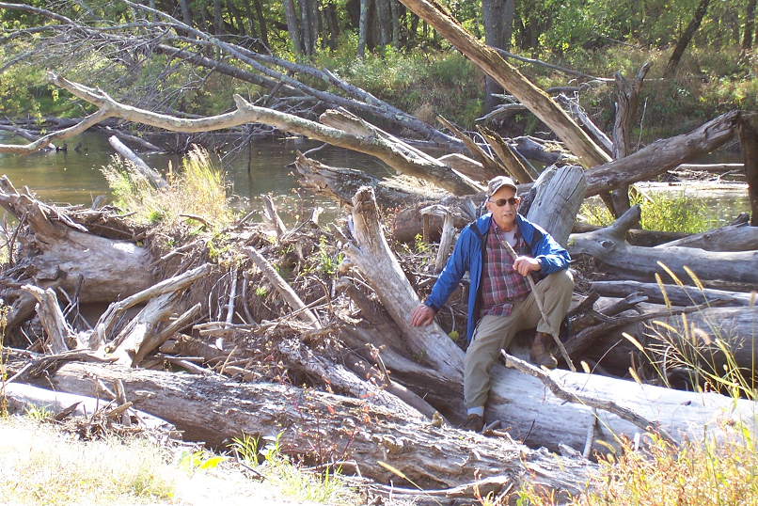 Figure 50 ; That’s Rod taking a well-deserved break at Herrick’s Hole in the Heavy Blockage Area (See Figure 51). Some Logjams in this 50 acre area are worse.

Selected Acreages within the East Meander Floodplain:

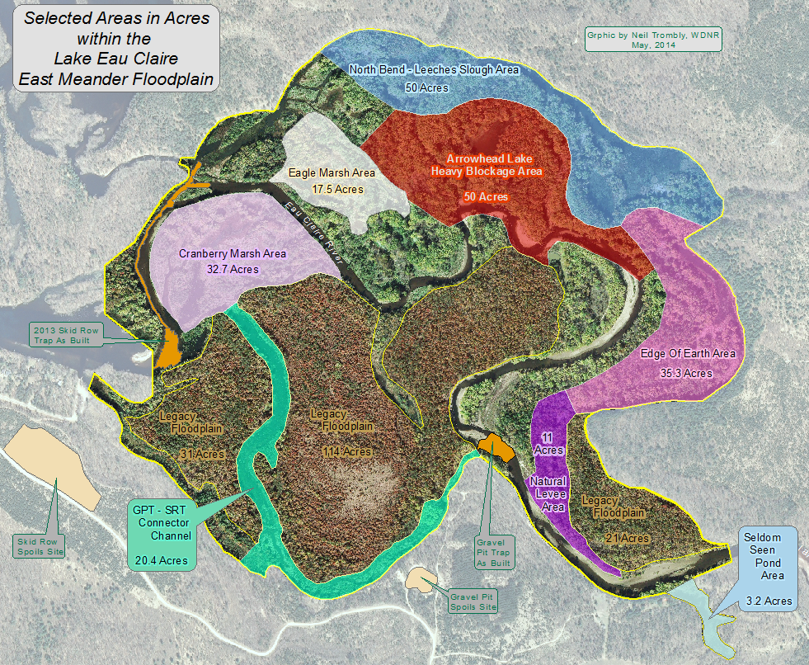
Figures 51 & 52 : Selected Acreages within the East Meander Floodplain.

Selected Target Name* | Reconnectivity Acres | Other Acreages
Cranberry Marsh Area | 32.7
Eagle Marsh Area | 17.5
Edge Of Earth Area | 35.3
GPT - SRT Connector Channel | 20.4
Natural Levee Area | 11
North Bend - Leeches Slough Area | 50
Seldom Seen Pond Area | 3.2
Total Acres | 170.1
Arrowhead Lake Heavy Blockage Area |  | 50
Legacy Floodplain - West |  | 31
Legacy Floodplain - Center |  | 114
Legacy Floodplain - East |  | 21
* Not all areas were selected or named
Appendix A:

The 1997 Ayers and Associates study for restoration and reconnectivity of riparian access and recreational use of the lake indicated the entire lake could use dredging. By their estimate, to restore the lake to its 1960 surface area and depth required removal of 3 million cubic yards at estimated cost of $17,000,000, including start-up aspects. To restore the lake to its original 1937 surface area and depth would require the removal of 6 million cubic yards at cost of $30,000,000 at $5 per cubic yard. This was a non-starter due to cost.

To understand these numbers, removing 6 million CY is equal to removing over 3 feet of sediment from the entire lake as well as recently filled-in floodplain areas. Lake Eau Claire’s bathymetry was subsequently carefully mapped by Wildlands School and there was no evidence of any 3 foot infilling of the entire lake. In retrospect, this makes perfect sense.

The bedload sand of the Eau Claire River does not spread out and disperse evenly over the entire lake. Instead, the bedload sand moves downriver in pulses. These underwater pulses of river bedload sand are actually subaqueous dunes and can be seen clearly in aerial photographs. Under most conditions, these subaqueous dunes migrate essentially intact, grain by surface grain, down the river channel and then merge with previously transported bedload sand when they reach a deep water drop off. Although the sand is clearly able to move, it does not disperse over large areas when it reaches deep water which is, in actual fact, the only reason that sediment traps work at all. When the sand encounters deeper water depths, whether over the crest of a subaqueous dune or over the steep edge of a sediment trap, the sudden deepening creates flow separation where sand can fall into a lower elevation of far slower moving water and settle to the bottom at an ‘angle of repose’ – the bedload sand piles up at an angle and, except for fine particles, spreads very little from the slip face of a subaqueous dune or the leading edge of a trap—much less spreading out over the entire lake.

However erroneous the report’s volume estimates appear to have been there is considerable merit in certain aspects of the Ayers report, one of which was the clarification of need for far greater financial resources which understanding contributed to the 2013 creation of a Lake District. Portions of the Ayers document are still highly relevant:

“Since the completion of the dam construction and filling of the reservoir in 1937, Lake Eau Claire has experienced significant sediment deposition. The inlets on the east end of the lake, including the Eau Claire River, Muskrat Creek, and Hay Creek, have seen the greatest impact. Sediment deposits have resulted in navigational restrictions and a loss of lake surface area. Accumulated sediment has resulted in loss of lake access for several property owners. The purpose of this report is to provide the Lake Eau Claire Association with data for use in future planning and project implementation. We developed a range of alternatives for restoring or partially restoring the lake to its original shoreline configuration and depth.”

In addition, the report mentions: “Sediment traps should be constructed to collect sediment before it enters the lake, reducing future dredging requirements,” which is one of several key things we are doing to accomplish cost-effective restoration and reconnectivity.

Guidance of Professor Rod Zika, University of Miami and edit by Patrick Sorge, WDNR, are gratefully acknowledged. All photographs in this report were taken by Neil Trombly, WDNR, in 2012 or during the spring flood of 2014. Please acknowledge if used. All maps and graphics in this report were made by Neil Trombly, WDNR. Base layer map images are USGS National Map Online, WROC 2010, Google, Bing and others.
See Appendix A The 1997 management plan by Ayers Associates expresses essentially the same objectives of restoration and reconnectivity but at far greater cost and some plausibly wrong basic assumptions.
Collins English Dictionary - Complete & Unabridged 10th Edition.
Concerning tree falls, do not proactively remove tree falls because they might contribute to a logjam. Tree falls still rooted or otherwise tethered to the river shoreline are valuable for fisheries and wildlife habitat because there is so little of this naturally occurring habitat still connected to Lake Eau Claire at this time.
Midstream river distance from Logjam Point to the mouth of Legacy Cut is 6070 feet. The new Logjam Point to Legacy Cut shortcut distance would be just 1520 feet. No matter the current river gradient between these two points, the new cutoff river gradient, by the math, would be 4x which would greatly increase water velocity.

